NokiaTSY
Design Document

Owner:  Function: | Janne Löf
Document ID | Not available yet
Version: | 5
Status: | Draft
Approver: | Jaakko Reijonen
Document Location

LotusNotes:
Lotus Notes Database:
Server:
Filename: <Database name>
< Database server>
< Database filename>

Synergy
Synergy 6.3 Engine Host : oucmsweh.nmp.nokia.com
Database: ou1cfspd
Database path: /nokia/ou_nmp/groups/gscm/dbs/ou1cfspd
Project: NokiaTSY/Doc

Copyright © 2006 Nokia. This material, including documentation and any related computer programs, is protected by copyright controlled by Nokia. All rights are reserved. Copying, including reproducing, storing, adapting or translating, any or all of this material requires the prior written consent of Nokia. This material also contains confidential information, which may not be disclosed to others without the prior written consent of Nokia.
Contents
1. Document control 4
1.1 Documentation conventions 4
1.2 Abbreviations 4
1.3 Definitions 4
2. General 5
2.1 Introduction 5
2.2 Subsystem environment 6
2.3 Services required 7
2.3.1 From Symbian OS subsystems 7
2.3.2 From Domestic OS subsystems 8
2.3.3 From HW 9
2.4 Services provided 9
2.4.1 UI 9
2.4.2 SW IF 9
3. Design 10
3.1 Class diagrams 10
3.1.1 Framework 10
3.1.2 Subsystem 11
3.1.2.1 Plugin API and Message routing between TSY layers 11
3.1.2.2 NokiaTSY data routing mechanism 11
3.1.2.3 NokiaTSY class diagram 13
3.1.3 Message Handlers 14
3.1.3.1 Sending messages 14
3.1.3.1.1 Using Phonet Sender to send ISI -messages 14
3.1.3.2 Receiving messages 16
3.1.3.2.1 Using Phonet Receiver to receive ISI -messages 16
3.1.3.2.2 Data handling when message has been received 17
3.1.4 Utility methods 19
3.1.4.1 Error handling 19
3.2 Class descriptions 21
3.2.1 API definitions 24
3.2.2 Structs, Type Definitions and Enumerations 24
3.2.3 Flag definitions 25
3.2.4 State diagrams 25
3.3 Operations 25
3.3.1 Nokia TSY Boot-up 25
3.3.2 Cell Broadcast Service (CBS) 28
3.3.3 Short Message Service (SMS) 30
3.3.3.1 MO SMS 30
3.3.3.2 MT SMS 32
3.3.3.3 SIM SMS Storage 37
3.3.3.4 SMS Parameters 44
3.3.4 USSD requests 46
3.3.4.1 MO USSD request 46
3.3.4.2 MT USSD request 52
3.3.5 Call Handling 59
3.3.5.1 Generic sequences for all call requests 59
3.3.5.2 Voice call interface 61
3.3.5.3 Video call interface 83
3.3.6 GPRS and CSD operations 83
3.3.7 Network operations 96
3.3.8 SIM PhoneBook Store operations 103
3.3.9 CustomAPI operations 113
3.3.10 CustomApiExt operations 119
3.3.11 Network Detection and Operator Namelist handling 122
3.3.11.1 Operator Namelist query / Manual Search fig. 20 A 124
3.3.11.2 Operator Namelist / Get Operator Name (network registration status) / NET_REG_STATUS_GET_REQ fig. 20 B 125
3.3.11.3 Operator Namelist / Get Operator Name (custom get operator name) / NET_REG_STATUS_GET_REQ fig. 20 C 126
3.3.11.4 Operator Namelist / Get Operator Name / NET_REG_STATUS_IND fig. 20 D 127
3.3.11.5 Operator Namelist/ Get Home NW + others fig. 20 E 128
3.3.11.6 Operator Namelist / Network Selection fig. 20 F 130
4. System resource usage 131
4.1 Files 131
4.2 Databases 131
4.3 Memory consumption 131
4.4 Task allocation 131
4.5 Performance 131
4.6 Timers 131
5. Exception handling 132
6. MaintainanceUsage 133
6.1 Building 133
6.2 User's Guide 133
7. References 134
8. Appendixes 136
8.1 Change History 136

Document control

Documentation conventions
Code is shown with Courier New font.

Abbreviations
API | Application Programming Interface
DOS | Domestic OS
EPOC | Old term for Symbian OS
ETel | EPOC Telephony Server
IPC | Inter Process Communication. Communication across thread and process boundaries.
ISA | Intelligent Software Architecture
ISI | Intelligent Service Interface
MCC | Mobile Country Code
MNC | Mobile Network Code
NOS | Nokia OS
OS | Operating System
SIM | Subscriber Identity Module
SAT | Sim Application Toolkit
SOS | Symbian Operating System
TSY | Symbian OS Telephony Subsystem
UI | User Interface
MO | Mobile Originated
MT | Mobile Terminated
SMS | Short Message Service
CBS | Cell Broadcast Service
DCS | Data Coding Scheme
SAT | Sim Application Toolkit
TPDU | Transfer Protocol Data Unit
TP | Transfer Protocol
RP | Relay Protocol
TP-PID | Transfer Protocol – Protocol Identifier
SC | Service Center

Definitions
Multimode ETel Custom API | Series 60 specific extension to ETel APIs

General
This document describes the design of Nokia TSY.

Introduction
Multimode TSY is an ETel extension module that handles the interaction between the ETel server and Domestic OS.
Series 60-based Nokia Multimode TSY is layered into two independent parts, Common TSY and Nokia TSY. Common TSY will be delivered to Series 60 licencees as part of the Series 60 delivery and it is designed to be independent of the Domestic OS. NokiaTSY implements Nokia -specific part of TSY functionality and it acts as a client for NOS.
One of the Nokia TSY’s main purposes is to communicate between Nokia Operating System (NOS) and TSY so that ETel API function calls are translated into message based format and messages from NOS are converted into format that can be understood by ETel clients. Messaging with NOS basis on resource requests and responses, event indications and notifications.
Communication to NOS is based on client / server type of communication (ISA). The ISA architecture is a system that divides the phone’s fundamental capabilities into logical groups or resources and they are contolled by ISA servers. An ISA Server provides an ISI Interface, which allows clients to use services of the server. Messages that are used between Symbian –side (client) and ISA (server) are called ISI messages.

Subsystem environment
ETel Server loads TSY and the whole TSY entity (CommonTSY and NokiaTSY) runs in a single thread with ETel Server. ETel server belongs to communications process of the Symbian OS. ETel loads CommonTSY as a dynamic DLL whereas Nokia –specific part is accessed via CommonTSY.
In Figure 1 the whole TSY entity is presented in its environment, NokiaTSY as a part of it. Nokia –spefic part contains NokiaTSY and SIM ATK TSY that communicates with ISA. SIM ATK TSY is a fully Nokia –specific DLL, and it does not use message routing based mechnanism between TSY layers. This document concerns only NokiaTSY, to get more info about SIM ATK TSY design, see SIM ATK TSY desing document [5].
NokiaTSY’s key dependency with other components consists of CommonTSY plugin API and ISA API. When CommonTSY receives requests via ETel server interface, plugin API interface is used to route requests to Nokia TSY and complete them back. Symbian and Series 60 customized IPC numbers are used to indentify specific requests and responses between Nokia- and Common TSY. ISA interface is used for ISA resource requests.
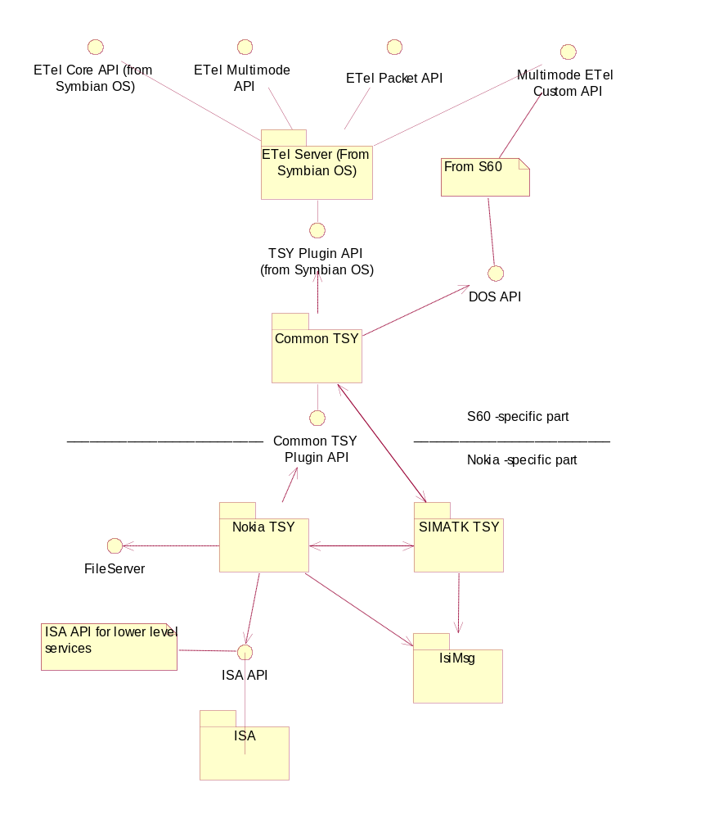
Figure 1 Nokia TSY as a part of TSY entity

Services required

From Symbian OS subsystems
Nokia TSY requires services from following Symbian OS subsystems:
- Comms server (establishing data calls)
- CommsDb (for datacall parameters and init strings)
- ISIMSG (ISI Messages)
- ISC API (for communication with CMT SW)
- File Logging interface
- File Server

From Domestic OS subsystems
CALL server
Call server provides call related features to clients, e.g., creating calls, releasing calls, call holding, swapping of calls and conference calls. Both speech and circuit-switched data call features are supported.
Call ID: Call server allocates a unique call ID for each call when the call is created. When a client requests creating of a call, the unique call ID is returned in the following response and indication messages. When Call server informs a client of an incoming call, the unique call ID is already allocated and it is delivered in the first indication message. The unique call ID shall be used throughout the existence of the call when referring to that specific call. Call IDs are reused after the call has been fully released. There are also generic call IDs that refer to a call at a certain status. Clients may use these call IDs.
However, the Call server uses always unique call IDs in the responses and indications when referring to a single call. Note: When operation concerns multiple calls, generic call IDs are used also by the server.
SS server
SS Server comprises only the call independent supplementary services, i.e. the supplementary services that are not related to any call:
- Line identification (CLIP, CLIR, CoLP, CoLR)
- Call offering (CFU, CFB, CFNRy, CFNRc)
- Call restriction (BAOC, BOIC, BOIC-exHC, BAIC, BIC-Roam)
- Unstructured supplementary service data (USSD)
- Name identification (CNAP)
Note: Some of the supplementary services (Line identification, Call completion, Name identification) have effect on Call Server, too.
NET server
Network select server is used to activate radio system, which the Mobile Station uses. Network select server gives indications whether Mobile Station is capable of finding the radio system it supports and whether it is capable of registrating there. Network select server supports searching for available networks. The server offers also possibility for client to choose any network for registration attempt. It is possible to switch off some radio system via network select server. In case of mobile station supporting several radio systems there will be a separate network select server for each radio system.
SMS server
Main features of SMS Server are sending and receiving of short messages. Also receiving of Cell Broadcast (CB) messages are supported.
SIM server
SIM services like, (U)SIM contacts, (U)SIM Application Toolkit, SWIM and class 2 SMS functionality.
CSD server
Circuit Switched Data server provides features for circuit switched/high speed circuit switched data call use.
GPDS server
Provides support for packet switched data.
Security server
Control of access codes, such as the PIN, PIN2, UPIN code and the security code. Intiates SIM PIN/PUK code promt.

From HW
This component has no direct HW interfaces.

Services provided

UI
Nokia TSY does not provide user interface.

SW IF
- See CommonTSY Plugin API /5/.

Design

Class diagrams
This chapter describes the framework and class diagram of NokiaTSY and some sequence diagrams are drawn in order to give some functional examples.

Framework
The following figure shows the classes that handle the main relationship between NokiaTSY and its dependency components. NokiaTSY is built as a static dll, and it runs in a same thread with CommonTSY and ETel server. The classes presented in a figure are used to establish a connection between NokiaTSY, CommonTSY and ISA, Figure 2 NokiaTSY .
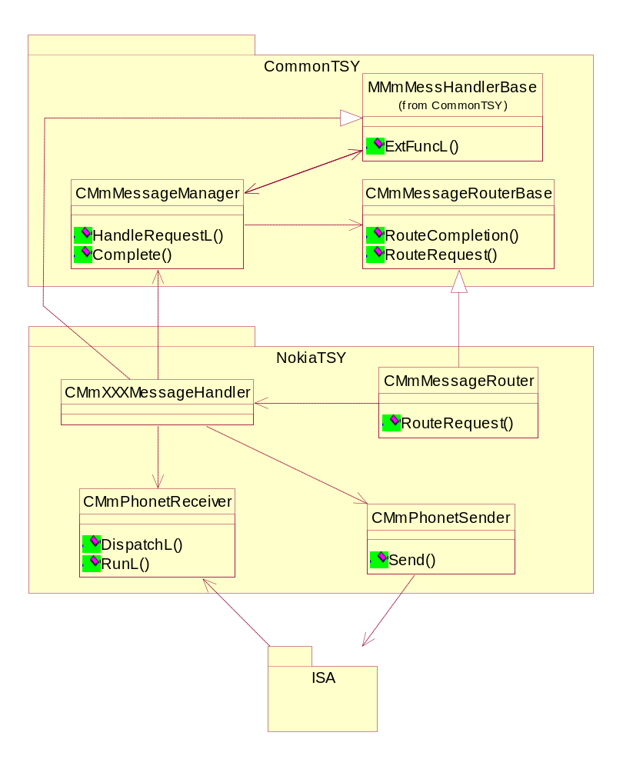
Figure 2 NokiaTSY main releationship

Subsystem

Plugin API and Message routing between TSY layers
Providing a specific router class TSY handles communication between CommonTSY and NokiaTSY. The Plugin API interfaces the Common TSY with direct function calls. The requests coming from CommonTSY to Nokia TSY can be requests of current values of ME’s (and related) states (e.g. getting network info), service requests (e.g. send SMS, dial) or notification requests (e.g. notify call events).
All Nokia TSY received function calls contains a unique IPC value for the request as a parameter. These values are basically Symbian –defined, but for TSY layering use, customized values are also defined. The IPC value supplied in ExtFunc provides a way to the specific Nokia TSY request. This information is required also when the original request is completed to the client. When a Nokia TSY function is called this IPC value is stored to a component (Phone, Line, Call etc.) message handler object of the Nokia TSY whose method has been called.
Message routing class dependency using Plugin API is presented in Figure 3. When a client does a request for NokiaTSY, this request is routed into corresponding message handler with the request specific IPC -value. And vice versa, when NokiaTSY completes client-originated request, it calls message manager’s Complete –method with the initial IPC –value.

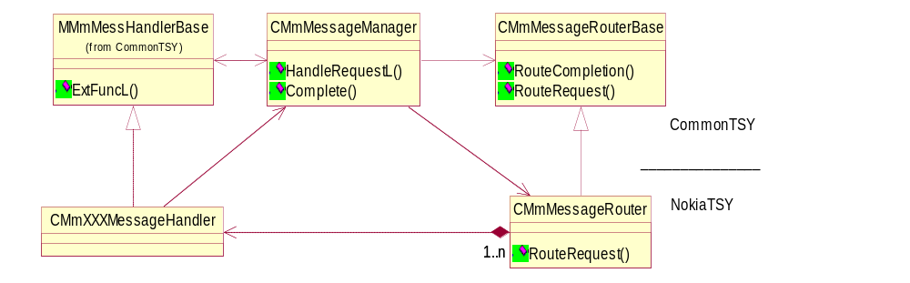
Figure 3 Plugin API between Common- and NokiaTSY

NokiaTSY data routing mechanism
CommonTSY calls CMmMessageRouter’s method RouteRequest in order to do functional requests for NokiaTSY and ISA. This method returns the pointer to corresponding messagehandler for CommonTSY that is meant to handle this request. This specific messagehandler’s mehdod ExtFuncL is then called with the request IPC value and packaged data that is type of CMmDataPackage. This package class is a template class and can contain any type of data for one or two objects. Figure 4 presents an exapmle how a VoiceCall request is routed into NokiaTSY.
For example, a request data for Nokia TSY may be a pointer; pointing to the CommonTSY reserved memory space where the requested value or values received from the ISA API should be handled. When e.g. phonebook cache has been requested from the Nokia TSY, Common TSY calls the appropriate function from the Nokia TSY object with the proprietary IPC value. The called function implementation copies all the phonebook entries to the cache array received as a function parameter and calls message manager’s complete -function. The Complete function is called with the IPC value as a parameter, which enables the NokiaTSY find the request corresponding CommonTSY object and call the correct completion method in it.
The status value is sent to the client(s) also when the request has been completed. The status value should be KErrNone if the request has been completed successfully, otherwise the error value must be used, and the value used is mapped from ISA error value to Symbian value.
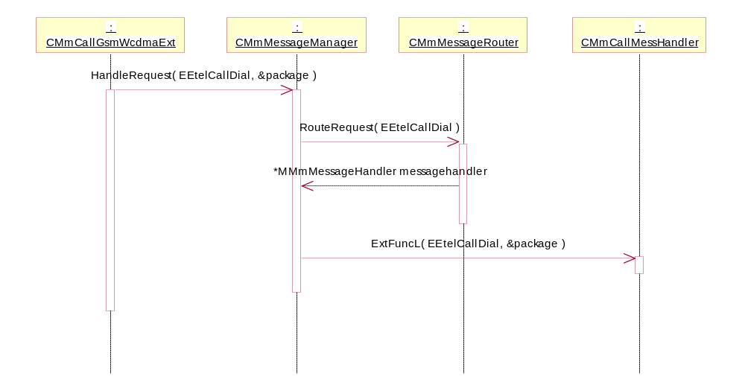
Figure 4 A VoiceCall as an example how to route message from CommonTSY to NokiaTSY
Figure 5 shows how response is routed to CommonTSY. CMmMessageManager’s method Complete is called with IPC –number, and CMmMessageRouterBase’s RouteCompletion -method routes reponse to the correct TSY – object using IPC –value again.

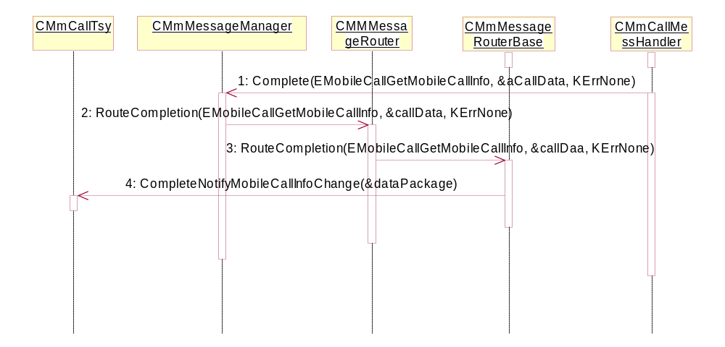
Figure 5 A VoiceCall CompleteNotifyMobileCallInfo used as an exaple how to route message from NokiaTSY to CommonTSY in a succesfull case

NokiaTSY class diagram
In Figure 6 is presented NokiaTSY class diagram. Some classes from CommonTSY are also included into figure to understand, how Common and Nokia –sides are linked together.
NokiaTSY has multiple message handler objects. These objects have a main role in NokiaTSY functionality, since they all handle the requests and responses to/from ISA -side. CMmMessageRouter creates and owns all message handler instances as well it opens a connection into ISA –side. For example, when a CMmMessageRouter is created, all the messagehandlers will be created and pointers to them are saved. When a client (some CommonTSY object) does a request with a specific IPC –value, CMmMessageRouter returns a correct message handler pointer to a client object to route the original request to ISA –side.
When CMmMessageRouter -object opens a connection to ISA –side, it creates also instances of CMmPhonetSender and CMmPhonetReceiver. These objects are used for send and receive requests and responses to/from ISA –side.
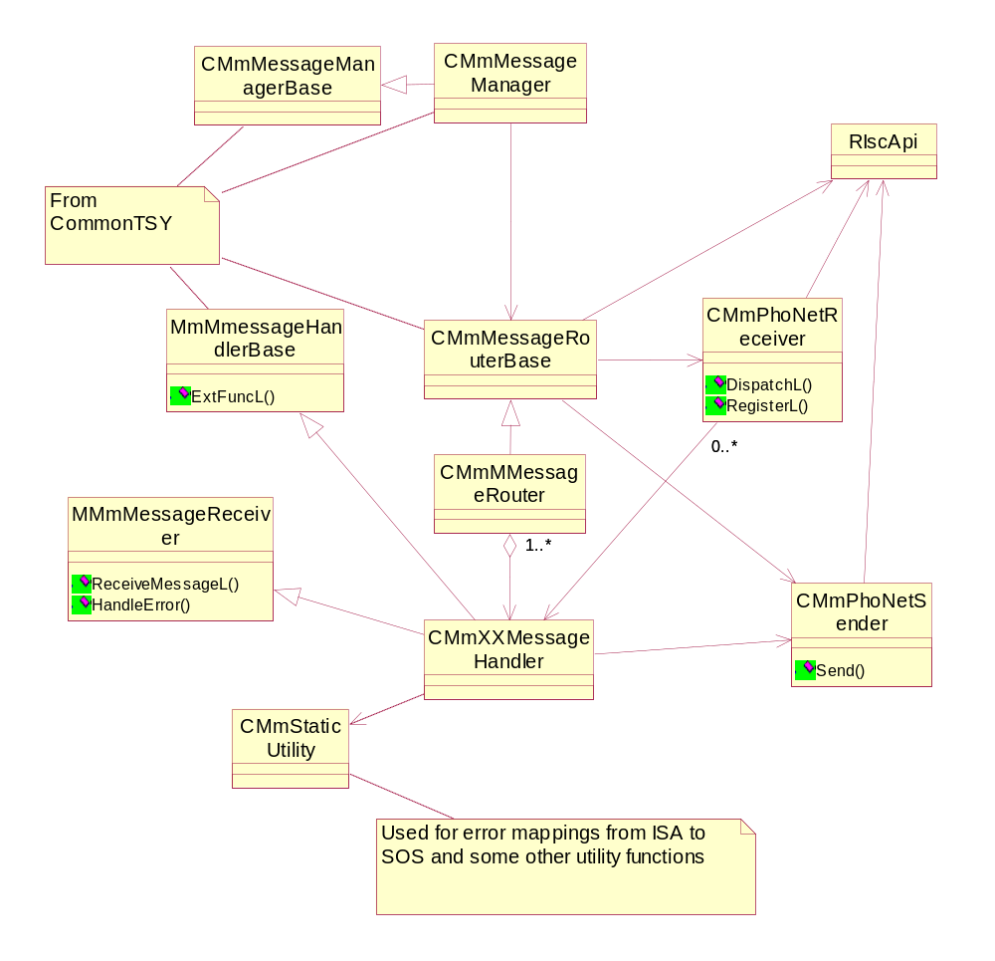
Figure 6 NokiaTSY class diagram

Message Handlers
MessageHandlers handle the ISI messages when an ISI message is sent to ISA or received from it.
During the bootup, all the message handlers are created in CMmMessageRouter. Messagerouter is a linker object between CommonTSY and message handlers.
All message handlers are derived from MMmMessageHandlerBase base class defined in CommonTSY.This mixed / pure abstract class contains only one method definition: ExtFuncL. This method is an interface to a specific message handler that is called from CommonTSY –side.
All message handlers are also derived from MMmMessageReceiver base class. This pure abstract class contains methods ReceiveMessageL and HandleError. These are called by CMmPhoNetReceiver to distribute received ISI messages to message handlers and allow error handling.

Sending messages

Using Phonet Sender to send ISI -messages
CMmPhonetSender is used to send ISI messages to ISA. ISI messages (defined in ISIMSG.dll) to be sent are constructed in message handlers. Every ISA server has its own ISI –message class (CNetIsiMsg, CCallIsiMsg, CSimIsiMsg...), and these ISA server specific classes are derived from base class CIsiMsg.
A preallocated buffer is used for sending ISI message to the ISC API. This means that dynamic memory allocation is not required. When ISI message is created in message handler, constructed message is copied into message buffer and message is then sent.
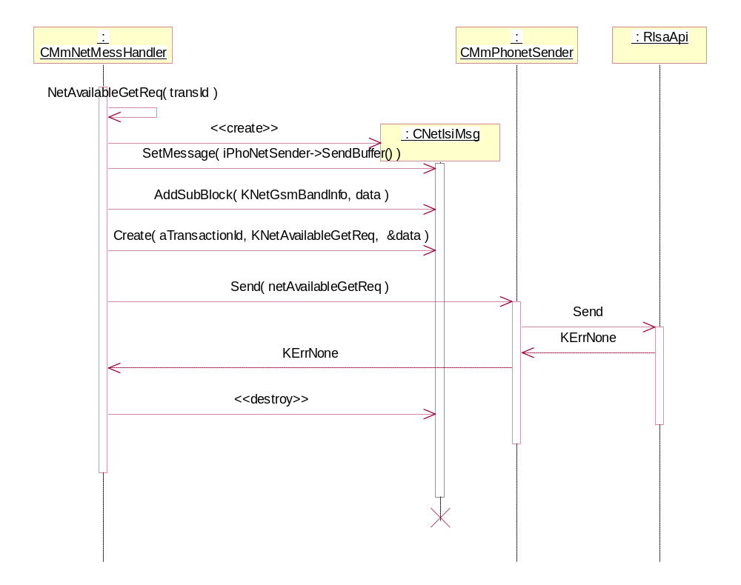
Figure 7Example of sending an ISI message, NetAvailableGetReq used as an example.
In this example presented, NetAvailableGetReq is created with subblock. Following text explains how ISI –message is created and sent on detail level:
- ISI –message creation:
CNetIsiMsg netAvailableGetReq;
- Set message to point to message buffer
netAvailableGetReq.SetMessage( iPhoNetSender->SendBuffer() );
- Create buffer for the data. Append data into message with ISI message required values
TBuf8<1> data;
data.Append( KNetGsmBandAllSupportedBands );
- Create subblock belonging into this request
netAvailableGetReq.AddSubBlock( KNetGsmBandInfo, data );
- Create service request message
netAvailableGetReq.Create( aTransactionId, KNetAvailableGetReq, &data );
- Send ISI –message to ISA
return iPhoNetSender->Send( netAvailableGetReq );
When the client uses the Create-function with the transaction id and the message id, the message header data itself is created automatically by CIsiMsg -class.

Receiving messages

Using Phonet Receiver to receive ISI -messages
CMmPhonetReceiver is used to receive ISI –messages. CMmPhonetReceiver is an active object that makes possible to receive messages asynchronically from ISA –servers.
A preallocated buffer is used when receiving ISI message from the ISA API. This means that dynamic memory allocation is not required. Phonet configuration for message buffer lenght is defined in CMmPhonetReceiver.h and following value is used:
//Incoming phonetmessage buffer size.
//Allocate memory for incoming message. Length of iPhoNetMsg
const TUint KMaxPhonetMessageSize = 16384; // 16k
If larger message than this is received CMmPhoneReceiver temporarily increases buffer size to receive it.

When ISI message receiving is completed, CMmPhoNetReceiver’s RunL is called and message is delivered for the correct message handler by calling DispatchL –method.
If leave happens when received message is handled, CMmPhonetReceiver then handles the execution exception using active object exception handling mechanism. CMmPhonetReceiver::RunError calls DispatchError which in turn calls specific messagehandler’s error handling method HandleError.

In practice, when DispatchL delivers received ISI -message to message handler, the received ISI -message is first copied into the preallocated buffer. After that, DispatchL goes through registered message handlers in order to find out the correct message handlers for the received message. If message handler is registered to receive this ISI message, DispatchL will call message handlers ReceiveMessageL –method.
It must be noticed, that one or more message handlers can use the same ISI message.
Only exception to this is SAT message handling, which doesn’t used registration,
If SAT message handler is initialized, then all received ISI messages are also passed to SAT message handler. If SAT message handler is not initialized DispatchL will store last received SIM ATK server message and deliver it to SAT message handler when SIM_ATK_TSY is initialized.

In Figure 8 active object CMmPhonetReceiver has received a message. In this sequence diagram, CallCreateResp ISI –message is used as an example.
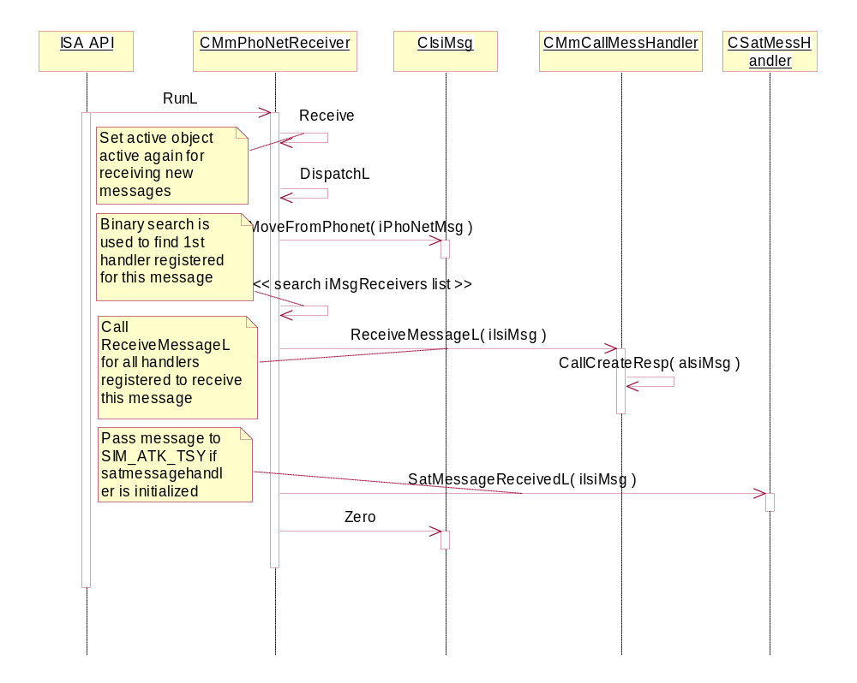
Figure 8Example of receiving a message through PhonetReceiver, CallCreateResp used as an example.

Data handling when message has been received
When received message is handled in message handler, message handler first checks from which ISA server the message is from. If the ISA server is such that this Message Handler is interested in its messages, the message ID is checked. If message ID is such that this Message handler should interpret the received ISI message, corresponding method will be called.
When received ISI message is handled, following procedure is done:
- (Transaction ID is checked. NOTE: This information is not always needed, only some message handlers needs this to separate the messages where same resource id and message id are used.)
- Next the subblocks are interpreted (if there are any).
- If subblock exists get data elements from the subblock.
- If the ISI message contained information that should be routed up to the clients, call Complete –method from MessageManager object.
:
: CMmXXXMessHandler
: CMmPhoneMessHandler
: CMmMessageRouter
: CommonTSY
CMmCallMessHandler, CMmCsdMessHandler etc...
Create other message handlers:
ConstructL
ConstructL
ConstructL
SetXXXMessHandler
CustomFunction( EIscNokiaEventSubscribe, events )
SubscribeEvents
SubscribeEventsFromPhoNet
ConstructL
NewL
NewL
Receive
Receive
NewL
NewL
Open
new
ConstructL
NewL
: RIscApi
CMmPhoNetReceiver
:
CMmPhoNetSender
:
: CMmXXXMessHandler
: CMmPhoneMessHandler
: CMmMessageRouter
: CommonTSY
Figure 9 Message handling when corresponding method for the received message has been found.In this example, CallAnswerResp used as an example.
In this example presented, CallAnswerResp is called with a pointer to the received ISI –message. Here is explained, how ISI -message handling is done on detail level in this particular example:
- Create response message
CCallIsiMsg callAnswerResp;
- Copy received message into created response message
aIsiMsg->CopyAndNull( &callAnswerResp );
- Create call related subblock
CCallSubBlock causeSubBlock;
- Get the subblock if exist, return value to indicate this
TInt retValue = callAnswerResp.SubBlockById( &causeSubBlock, KCallCause );
- Handle received ISI response, validate and handle all the data that is exptected to receive. Set error value for CommonTSY, if error is occurred, StaticUtility –class can be used to turn ISA error value into Symbian value.
//map error value
TInt result = CMmStaticUtility::CSCauseToEpocError ( PN_CALL, causeType, causeValue );
- Get data from subblock
//Get Cause Type
TUint8 causeType = causeSubBlock.GetShortInfo( ECauseType );
//Get Cause Value
TUint8 causeValue = causeSubBlock.GetShortInfo( ECauseValue );
- Complete asyncronous request, originated by CommonTSY
//create call package
CCallDataPackage callData;
//pack the data for sending to the manager
callData.SetCallIdAndMode( callId, RMobilePhone::EVoiceService );
//complete failed request
iMessageManager->Complete( EEtelCallAnswer, &callData, result );

Utility methods
CMmStaticUtility is used to define and implement the utility methods and functionality for NokiaTSY. As the name of the class specifies, this utility class contains mainly static -defined methods for NokiaTSY objects use.

Error handling
CMmStaticUtility’s one main task is to handle and map ISA error values into the values that Symbian -side can understand. The values to be mapped are defined in ISI –specifications for each ISA –server. When a message handler provides a result of a request for the CommonTSY, corresponding request will be then completed with KErrNone or an error value.
NokiaTSY checks status values from ISI response messages. If this status value contains error that must be forward or completed onwards to CommonTSY, the error value is then handled by using CMmStaticUtility –class. This class contains the CSCauseToEpocError() function and its task is to convert ISI status/cause value into Symbian value to be used in completion. This method takes a resource Id, ISI cause type, ISI cause value (and in some cases specific RF state) as parameters and with those values the actual error convertion is done. The conversion method goes through the internal switch cases, where proper error value is searched with those function parameters provided. If the error value is not found, then the default values are used. In most cases, they are defined KErrGeneral and KErrNotFound.
Converted error values are turned into extented types. Extented error value consists of 16-bit core and 16-bit extented value so that the total value is built up into 32-bit value. The core value is located into lower part where as the extented value is put into upper part of 32-bit construction. The actual core- and extented error value storing is handled in CMmStaticUtility::EpocErrorCode –method. Following sequence shows how error value is built up in NokiaTSY with specific values got from ISI -message.
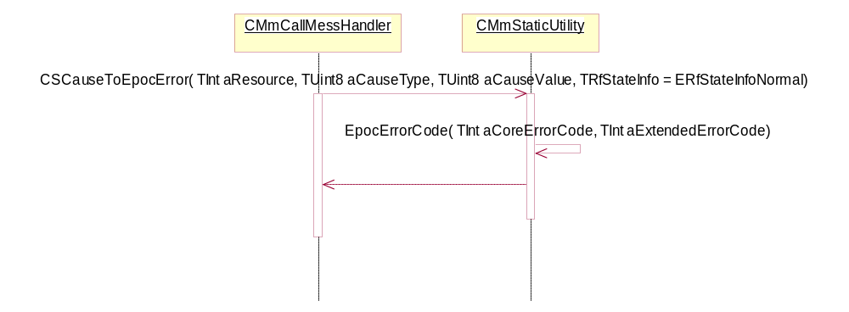
Figure 10 Example, how 32-bit error value is constructed with specific resource ID, error type and error value.
It is possible to call EpocErrorCode –method straight from some message handler. In this case the error value to be returned is not actually mapped but the messagehandler knows the core and extented values beforehand so that the combination of core- and extented error values are only needed.
Symbian has definded header files that provide extented library for various sets of errors. These values can be found from header files: ETELMMERR.H, EXTERROR.H. The usage of those values is defined in [2]. In addition of Symbian provided values, there is also CommonTSY maintained header file GsmError.h that defines some extra values that can be used.

Class descriptions
This section lists all the classes belonging in NokiaTSY. General classes are listed in Table 1, message handler classes are listed in Table 2 and their helper classes in Table 3.

Class | Description | Header file
CMmMessageRouter | Routes requests from Common Tsy objects to Message Handler objects. | Cmmmessagerouter.h
CMmPhoNetReceiver | Used for receiving ISI messages from ISA IF and dispatching them to message handlers. | Cmmphonetreceiver.h
CMmPhoNetSender | Used for sending ISI messages to ISA IF. | Cmmphonetsernder.h
MMmMessageReceiver | Message receiver interface | Cmmphonetreceiver.h
CMmStaticUtility | Contains commonly used static utility functions | Cmmstaticutility.h
CMmCustomNokiaExt | Implements Nokia spesific IPCs | Cmmcustomnokiaext.h
Table 1

Class | Description | Header file
CMmBroadMessHandler | Cell Broadcast-related message handler functionality | cmmbroadmesshandler.h
CMmCallMessHandler | Call-related message handler functionality | cmmcallmesshandler.h
CMmConferenceCallMessHandler | Conference call-related message handler functionality | cmmconferencecallmesshandler.h
CMmCsdMessHandler | CSD call related message handler functionality | Cmmcsdmesshandler.h
CMmCustomMessHandler | Used to create and send GSM specific custom ISI messages. | Cmmcustommesshandler.h
CMmPhoneBookStoreMessHandler | Phonebook message handling | Cmmphonebookstoremesshandler.h
CMmPhoneMessHandler | Used to create and send phone ISI messages | Cmmphonemesshandler.h
CMmCustomSecurityMessHandler | Used to create and send mode-independent Security Server interface ISI-messages | Cmmcustomsecuritymesshandler.h
CMmDtmfMessHandler | Used for sending and receiving DTMF ISI messages | Cmmdtmfmesshandler.h
CMmENStoreMessHandler | Emergency number store related message handler functionality | Cmmenstroremesshandler.h
CMmNetMessHandler | Used for creating and sending NET server's ISI messages | Cmmnetmesshandler.h
CMmONStoreMessHandler | Own number store related message handler functionality | Cmmonstoremesshandler.h
CMmPacketContextMessHandler | Used to create and send packet context ISI messages | Cmmpacketcontextmesshandler.h
CMmPacketQoSMessHandler | Used to create and send packet context ISI messages | Cmmpacketqosmesshandler.h
CMmPacketServiceMessHandler | Used to create and send packet service ISI messages | Cmmpacketservicemesshandler.h
CMmSecurityMessHandler | Used for creating and sending security ISI messages | Cmmsecuritymesshandler.h
CMmSmsMessHandler | Used to create and send SMS ISI messages. | Cmmsmsmesshandler.h
CMmSupplServMessHandler | Used for creating and sending SS ISI messages | Cmmsupplservmesshandler.h
CMmUssdMessHandler | Used to create and send USSD ISI messages | Cmmussdmesshandler.h
Table 2

Class | Description | Header file | User
CDataPortReader | Dataport reader Active object for reading AT commands and responses from modem | cmmdatautility.h | CMmDataPortHandler
CDataPortWriter | Dataport writer Active object for writing AT commands to modem | cmmdatautility.h | CMmDataPortHandler
CMmDataPortHandler | Used to receive responses to AT commands from CMmDataPortReader active object (see utility) and route the responses to either Data line or active call object. | Cmmdataporthandler.h | CMmCallMessHandler
CMmPacketContextMesshandlerList | Contains information list for Packet Context DOS TSY context objects.  This class provides the methods for the Packet Context Message Handler List object (CMmPacketContextList class) to keep track of opened contexts. | Cmmpacketmesshandlercontextlist.h | CMmPacketContextMessHandler
CMmPipeControl | Used to create and send pipe control ISI messages | Cmmpipecontrol.h | CMmPacketServiceMessHandler
CMmSmsCache | Used to cache SMS messages stored to SIM | Cmmsmsmesshandler.h | CMmSmsMessHandler
CMmSmsGsmAddress | Makes GSM 03.40 and 04.11 address conversions | Cmmsmsgsmaddress.h | CMmSmsMessHandler
TGsmLibConv | Struct holding a pair of GSM 7-Bit character and Unicode character | Cmmsmsgsmaddress.h | CMmSmsGsmAddress
COperatorNameList | Operator name list reading and MCC/MNC mapping to operator name. | Cmmstaticutility.h | CMmNetMessHandler
Table 3

API definitions
Nokia TSY does not provide any API’s. It uses ISA API [ ] for sending and receiving ISI messages and is connected to Common TSY via Common TSY plug-in API [].

Structs, Type Definitions and Enumerations
CMmDataPackage | Description

Flag definitions
This Subchapter specifies the flags (feature, debug etc. flags) used by the subsystem, and clarify their usage for the reader. Temporary RnD flags are not included here.
Flag | Description
__WINS__ | Flags emulator specific code
_DEBUG | Debug flag
TF_LOGGING_ENABLED | Defined if logging is enabled
TF_LOGGING_METHOD | Select logging method, defined in CommonTSY header tflogger.h  0 = No logging  1 = Flogger  2 = RDebug
__DRIVE_MODE | S60 feature flag
__CS_VIDEO_TELEPHONY | S60 feature flag
AFF_VT_LOOPBACK
AFF_DATAPORT_ADDITIONAL_PORTS_IN_USED
AFF_LAYERED_SIMATK_TSY_SUPPORTED | Defined NokiaTSY is to be used with layered SIM ATK TSY.
DUMMY_NIF_PEP_FOR_PACKET_DATA_TESTIN_DOS | Packed data testing/debug flag.

State diagrams
Call related state diagrams can be found from EtelMM API Design Document.

Operations

Nokia TSY Boot-up

Opening of Nokia TSY:
Common TSY opens Nokia TSY by calling CMmMessageRouter::NewL method from Nokia TSY. After this Nokia TSY creates CmmPhoNetReceiver and CmmPhoNetSender objects for sending and receiving ISI messages to and from CMT side. Then connection to ISA API is opened and message handlers are created. CmmPhoneMessHandler message handler subscribes indication ISI messages from ISA server by sending EiscNokiaEventSubscribe request to the ISA API. EiscNokiaEventSubscribe request contains list contains list of indication ISI messages that Nokia TSY wants to receive.
: CommonTSY
: CMmMessageRouter
: CMmPhoneMessHandler
: CMmXXXMessHandler
:
CMmPhoNetSender
:
CMmPhoNetReceiver
: RIscApi
NewL
ConstructL
new
Open
NewL
NewL
Receive
Receive
NewL
NewL
ConstructL
SubscribeEventsFromPhoNet
SubscribeEvents
CustomFunction( EIscNokiaEventSubscribe, events )
SetXXXMessHandler
ConstructL
ConstructL
ConstructL
Create other message handlers:
CMmCallMessHandler, CMmCsdMessHandler etc...
Figure 11 Opening of Nokia TSY.
Reading of SIM data:
TSY reads SIM related information from CMT side to it’s internal memory while phone is booting up. Reading of data from SIM card is time consuming so main reason for TSY SIM info cache is to speed up phone boot-up phase. Reading operation starts when SIM server sends SIM_IND indication which tells that SIM server is ready. SIM ready information is delivered to the Common TSY. After this Common TSY makes read SIM data requests to the Nokia TSY. Nokia TSY contructs ISI message requests and send them to the SIM server. Common TSY’s requests are completed after receiving server responses.
Nokia TSY reads following SIM data from SIM server in boot-up:
- HPLMN info (SIM_NETWORK_INFO_REQ/ SIM_NETWORK_INFO_RESP
- PIN code request info (SIM_TABLE_READ_REQ/ SIM_TABLE_READ_RESP)
- SIM type (2G or 3G) (SIM_ICC_TYPE_REQ/ SIM_ICC_TYPE_RESP)
- Viag Home Zone parameters (SIM_VIAG_HOME_ZONE_REQ/ SIM_VIAG_HOME_ZONE_RESP)
- Is ALS supported or not by SIM card (SIM_DYNAMIC_FLAGS_REQ/ SIM_DYNAMIC_FLAGS_RESP)

: CommonTSY
: CMmMessageRouter
: CMmPhoneMessHandler
: CMmXXXMessHandler
:
CMmPhoNetSender
:
CMmPhoNetReceiver
: RIscApi
Read HPLMN info from SIM.
Is ALS line supported by SIM?
Is PIN request enabled?
Get SIM type: 2G or 3G.
Read Viag Home Zone parameters if client is
waiting parameters.
HPLMN info from SIM.
PIN request info.
SIM type info.
Viag Home Zone parameters from
SIM.
SIM_IND(SIM is ready)
CMmSecurityMessHandler::SecurityMessageReceived( isiMsg )
CMmSecurityMessHandler::SimInd( isiMsg )
CMmMessageManager::Complete( EMmTsyBootNotifySimStatusReadyIPC )
RouteCompletion( ipc, data, result )
CMmPhoneTsy::CompleteNotifySimStatusReady
ExtFuncL( EMobilePhoneGetALSLine, dataPackage )
SimDynamicFlagsReq
Send( isimsg )
SIM_DYNAMIC_FLAGS_REQ
CMmSIMMessHandler::ExtFuncL( EReadViagHomeZoneParamsIPC, dataPackage )
ReadVIAGHomeZoneParametersReq
Send( isimsg )
SIM_VIAG_HOME_ZONE_REQ
CMmSecurityMessHandler::ExtFuncL( EMmTsySimGetICCType, dataPackage )
SimICCTypeReq
Send( isimsg )
SIM_ICC_TYPE_REQ
ExtFuncL( EMmTsyPhoneGetPin1DisableSupportedIPC, dataPackage )
SimReadTableReq
Send( isimsg )
SIM_TABLE_READ_REQ
CMmNetMessHandler::ExtFuncL( EMobilePhoneGetHomeNetwork, dataPackage )
SimNetworkInfoReq
Send( isimsg )
SIM_NETWORK_INFO_REQ
SIM_NETWORK_INFO_RESP
CMmNetMessHandler::NetMessageReceived( aIsiMsg )
CMmNetMessHandler::SimNetworkInfoResp( isiMsg )
CMmMessageManager::Complete( EMobilePhoneGetHomeNetwork, dataPackage, KErrNone )
SIM_TABLE_READ_RESP
SpecificPhoneMessageReceivedL( isimsg )
CMmMessageManager::Complete( EMmTsyPhoneGetPin1DisableSupportedIPC, dataPackage, KErrNone )
SimReadTableRespL
SIM_ICC_TYPE_RESP
CMmSecurityMessHandler::SecurityMessageReceived( isimsg )
CMmMessageManager::Complete( EMmTsySimGetICCType, dataPackage, KErrNone )
SimICCTypeResp
SIM_VIAG_HOME_ZONE_RESP
CMmSIMMessHandler::MessageReceivedL
ReadViagHomeZoneParamsRespL
CMmMessageManager::Complete( EReadViagHomeZoneParamsIPC, dataPackage, KErrNone )
Figure 12 Reading of SIM data.
Cache of SIM phone book entries:
During boot-up TSY makes a “cache ADN phone book entries” request to the Nokia TSY, if client has opened ADN phone book object. Please see more info about reading phone book entries from chapter 3.3.8.
Cache SIM SMS messages:
When SIM is ready, TSY reads and caches SIM SMS messages. First TSY requests SIM SMS storage size and then reads SMS messages from SIM one by one.
Read battery info:
While boot-up TSY request battery info and charger status from energy server to update internal battery info and charger status state.

Boot state flags and other updated state: <<näistä bootin aikaisista tiloista mitä pitää päivittää voisi olla enemmän juttua>>
  - rf status
  - security ready
  - pin verified

Cell Broadcast Service (CBS)
NokiaTSY supports reception of CBS messages in GSM networks (section 9.4.1 of /6/) and in UMTS networks (section 9.4.2 of /6/). The main difference is that a UMTS CBS message can contain up to 15 pages (in one SMS_GSM_CB_MESSAGE sub block per page), whereas a GSM CBS message contains only one page. Both types of messages are received in SMS_GSM_CB_ROUTING_NTF notifications from ISI SMS Server, when reception has been activated beforehand.
[To do: NokiaTSY also supports reading and deleting Cell Broadcast topics in the EF_{CBMI} file on SIM.]

GSM CBS message reception
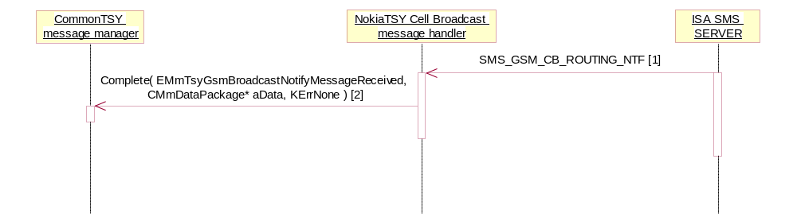
[1] CIsiMsg*
SubBlock: SMS_GSM_CB_MESSAGE
info length = Ignored (0xFF)
[2] aData.iPtr1: TGsmCbsMsg

UMTS CBS message reception
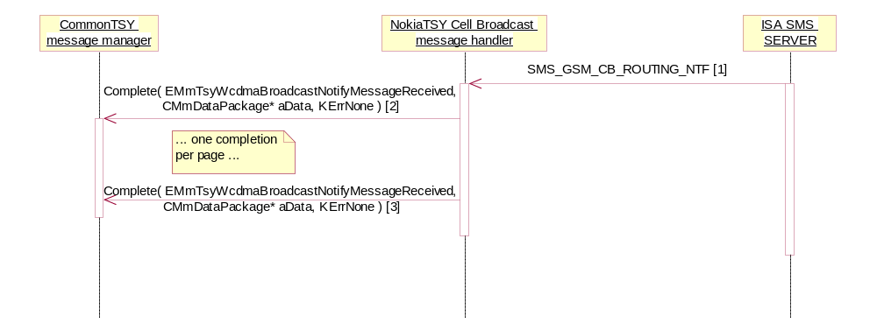
[1] CIsiMsg*
SubBlock: SMS_GSM_CB_MESSAGE
info length != Ignored (0xFF)
[2] aData.iPtr1: TWcdmaCbsMsg (first page)
[3] aData.iPtr1: TWcdmaCbsMsg (last page)

CBS messages are only received from ISI SMS Server when reception has been activated. NokiaTSY does not support filtering of CBS messages by topic or language, i.e. either all or no CBS messages are received. Reception is switched on/off with SMS_GSM_CB_ROUTING_REQ.SMS_ROUTING_SET resp. SMS_GSM_CB_ROUTING_REQ.SMS_ROUTING_RELEASE requests to ISI SMS Server. After startup, reception is off by default.
Routing activation
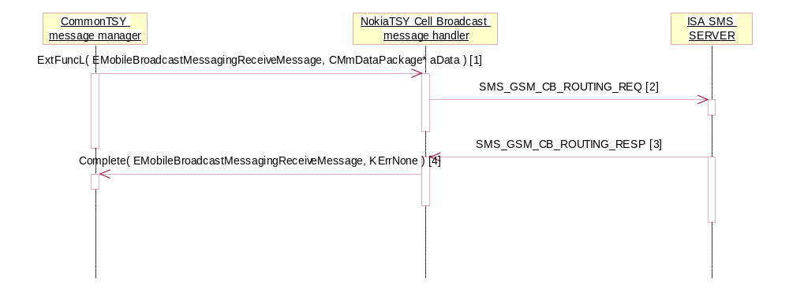
[1] aData.iPtr1: TCbsCbmiAndLangAndFilter
[2] TransactionId=EBroadcastMessagingReceiveMessage
RoutingCommand=SMS_ROUTING_SET
RoutingMode=SMS_GSM_ROUTING_MODE_ALL
[3] TransactionId=EBroadcastMessagingReceiveMessage
Cause=SMS_OK
Routing deactivation
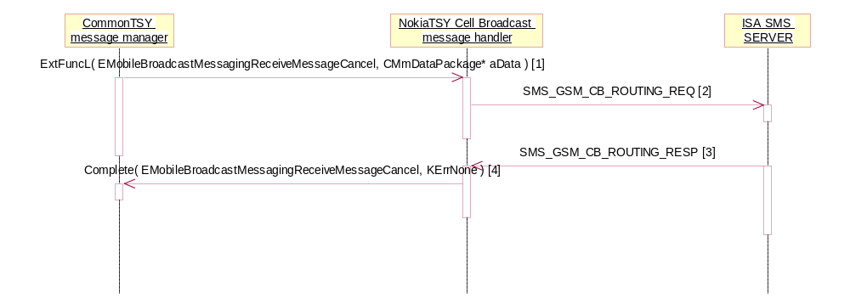
[1] aData.iPtr1: TCbsCbmiAndLangAndFilter
[2] TransactionId=EBroadcastMessagingReceiveMessageCancel
RoutingCommand=SMS_ROUTING_RELEASE
RoutingMode=SMS_GSM_ROUTING_MODE_ALL
[3] TransactionId=EBroadcastMessagingReceiveMessageCancel
Cause=SMS_OK

Short Message Service (SMS)
NokiaTSY SMS Message Handler implements the following SMS-related features:
- Sending and receiving Short Messages
- Managing Short Messages in the EF_{SMS} file on (U)SIM
- Managing SMS Parameters in the EF_{SMSP} file on (U)SIM

MO SMS
Send SMS
NokiaTSY’s main responsibility is to pass the TPDU data (constructed in Symbian SMS components) to ISI SMS Server. Note that sending might take a while, and there may be no overlapping SMS_MESSAGE_SEND_REQ requests. This is already ensured in CommonTSY.
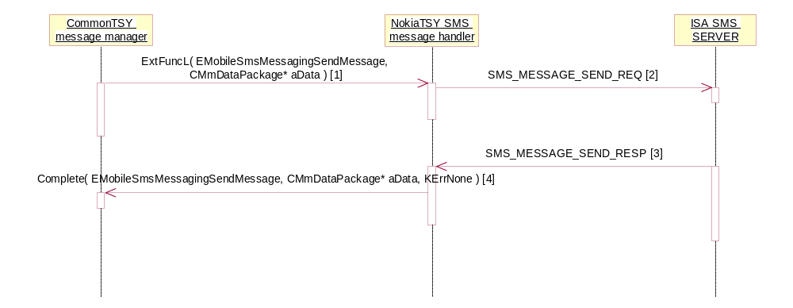
[1] aData.iPtr1: TSendSmsDataAndAttributes
[2] TransactionId=ESmsMessagingSendMessage
Possible SubBlocks (depending on TP-MTI value) are SMS_GSM_SUBMIT and SMS_GSM_COMMAND
[3] CIsiMsg*
TransactionId=ESmsMessagingSendMessage
SubBlock:SMS_GSM_REPORT
SMS cause = SMS_OK
[4] aData.iPtr1:TUint16 (message reference)
aData.iPtr2:TBuf8<RMobileSmsMessaging::KGsmTpduSize> (contains the SUBMIT_REPORT)

Send SAT-originated SMS
Same sequence diagram as above, but:
[2] transaction id = ESmsMessagingSendSatMessage
sender type=SIM_ATK (prevents FDN check)
[4] No message reference and no SUBMIT_REPORT included

Set Bearer
ISI SMS Server needs to know whether SMS should be sent preferably over a circuit switched connection or over a packet data connection. This setting also affects the RP-SMMA (resume SMS reception after memory full) message.
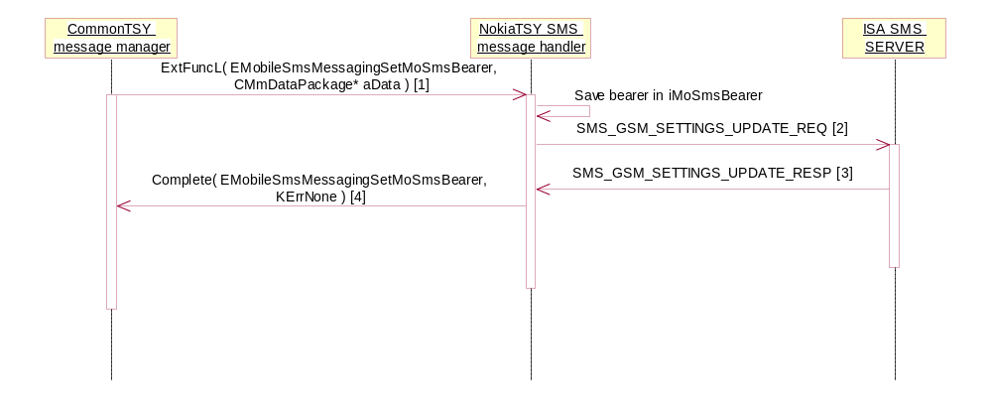
[1] aData.iPtr1: RMobileSmsMessaging::TMobileSmsBearer
[2] in SMS_GSM_SETTINGS sub block, "GPRS Allowed" field is set 'valid'. Value is TRUE for ESmsBearerPacketOnly and ESmsBearerPacketPreferred, else FALSE.

MT SMS
Routing activation
ISI SMS Server is asked to route all incoming SMS to NokiaTSY.
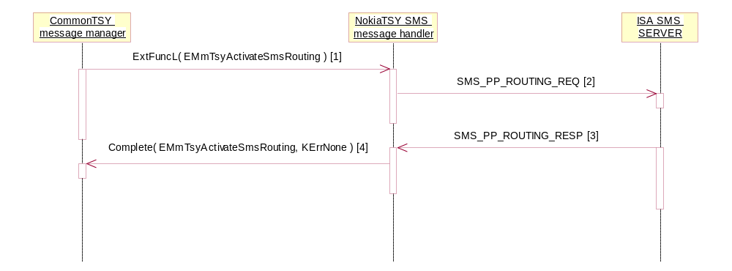
[2] Routing Type=SMS_GSM_TPDU_ROUTING
SMS Message Type=SMS_GSM_MT_ALL_TYPE
Routing Command=SMS_ROUTING_SET

Routing deactivation
NokiaTSY asks ISI SMS Server not to route incoming SMS anywhere, i.e. reject them immediately. Same sequence as above, but IPC=EMmTsyDeactivateSmsRouting, Routing Command=SMS_ROUTING_RELEASE.

Receive SMS
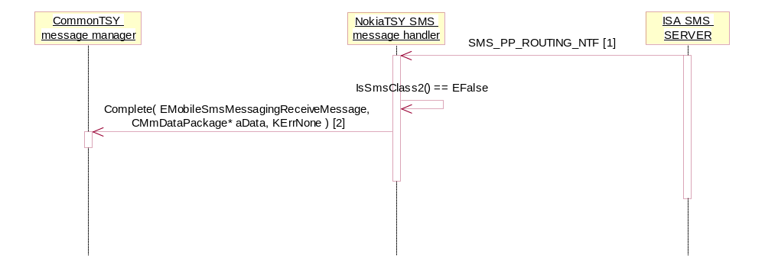
[1] CSmsIsiMsg*
SubBlock:SMS_GSM_TPDU
SMS is not Class 2 (DCS is not binary 00x10010 or 11110010)
[2] aData.iPtr1: TBool <ignore>
aData.iPtr2: TSmsMsg* (message data)

Special case: Receive Class 2 SMS
Class 2 messages have to be stored on SIM (see /8/, section 4 “Data Coding Scheme”). Before delivering a received Class 2 message to CommonTSY, it is stored on SIM (into the first free empty record) and added to the SMS Cache.
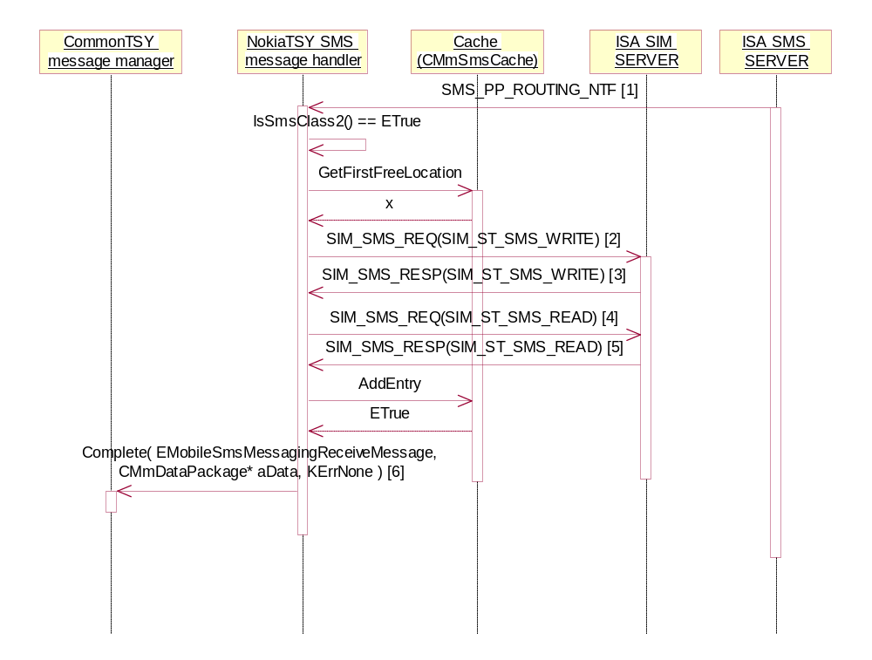
[1] CSmsIsiMsg*
SubBlock:SMS_GSM_TPDU
SMS is Class 2 (DCS is binary 00x10010 or 11110010)
[2]
TransactionId=EWriteReceivedClass2Sms
Location=x
Sub Block: SIM_SB_SMS_DELIVER
[3] CIsiMsg*
Status=SIM_STA_OK
TransactionId=EWriteReceivedClass2Sms
[4]
TransactionId=EWriteReceivedClass2Sms
Location=x
[5] CIsiMsg*
Status=SIM_STA_OK
TransactionId=EWriteReceivedClass2Sms
Sub Block: SIM_SB_SMS_DELIVER
[6] aData.iPtr1: TBool <ignore>
aData.iPtr2: TSmsMsg* (message data)

Special case: Receive Class 2 SMS, SIM full
If there are no more free locations on SIM, NokiaTSY notifies ISI SMS Server that this message could not be stored (RP-ERROR “protocol error”).

Special case: Receive Class 2 SMS with “Replace Type” Protocol ID
If the Protocol Identifier of a received Class 2 message has a value between 0x41 and 0x47, it is a so-called “Replace Type” message (see /7/, section 9.2.3.9 "TP Protocol Identifier (TP PID)). In this case, it is not immediately saved into the first free location, but overwrites an existing message with the same TP-PID, same originating address, and same originating SC. If no such message is found in the SMS Cache, it is stored in the normal way.

Special case: Receive CPHS Message Waiting Indicator SMS
If the originating address of a received SMS consists of two characters which are binary x001000x x000000x, then the SMS is a “Message Waiting Indicator” according to /10/. These are functionally comparable to “Message Waiting Indication” messages according to /8/ (where the message status is coded in the Data Coding Scheme, and which cause no special handling in TSY), with the following exception: A CPHS “Message Waiting Indicator” SMS with a User Data content of exactly a single space character must not be saved on SIM, regardless of its Data Coding Scheme.

Special case: Receive PP Data Download SMS
NokiaTSY asks for routing of MT SMS (typically in boot) with parameters “all MT message types, TPDU routing”. SimAtkTsy asks for routing of MT SMS with parameters “PP Data download messages only, Deliver routing”. When a message is received in a SMS_PP_ROUTING_NTF, NokiaTSY simply ignores those messages without a SMS_GSM_TPDU sub block, and SimAtkTsy ignores those without a SMS_DELIVER sub block.
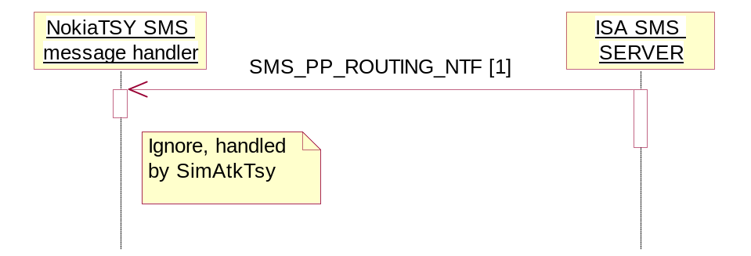
[1] CSmsIsiMsg*
SubBlock:SMS_GSM_DELIVER

Acknowledge received SMS
Sends an RP-ACK towards the network.
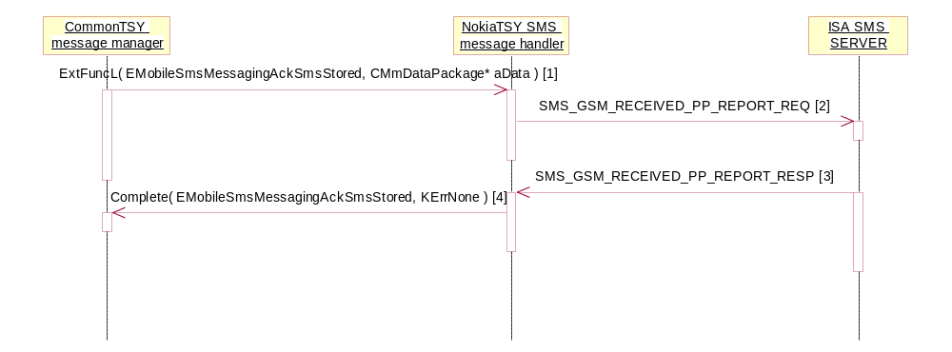
[1] aData.iPtr1: TDesC8* (can contain a TPDU with SMS-DELIVER-REPORT data)
[2] TransactionId=ESmsMessagingAckSmsStored
Cause=SMS_OK
Possible SubBlock:SMS_GSM_DELIVER_REPORT
[3] TransactionId=ESmsMessagingAckSmsStored
Cause=SMS_OK

Reject received SMS
Sends an RP-ERROR towards the network.
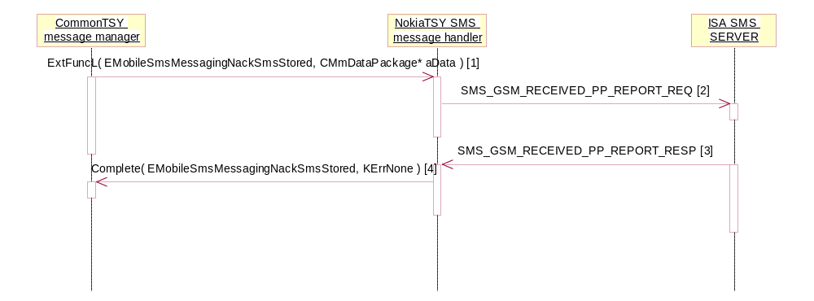
[1] aData.iPtr1: TDesC8* (can contain a TPDU with SMS-DELIVER-REPORT data)
aData.iPtr2: TInt (Symbian error value)
[2] TransactionId=ESmsMessagingNackSmsStored
Cause=(Symbian error value mapped to ISA error value)
Possible SubBlock:SMS_GSM_DELIVER_REPORT
[3] TransactionId=ESmsMessagingNackSmsStored
Cause=SMS_OK

Resume reception
Sends an RP-SM-MEMORY-AVAILABLE towards the network.
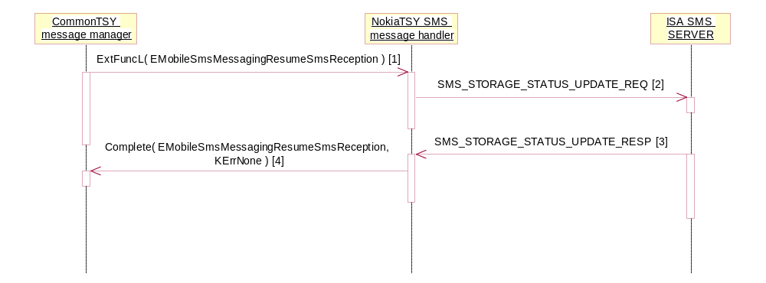
[2] StorageStatus=SMS_STORAGE_AVAILABLE
[3] CIsiMsg*
Cause=SMS_OK

SIM SMS Storage
NokiaTSY manages the content of the EF_{SMS} elementary file on SIM (see /9/, section 4.2.25 “EF_{SMS} (Short messages)”). In order to improve performance, a full cache in RAM is implemented.
Cache initialization
When the SIM is notified to be ready, first the length of EF_{SMS} is read, and then the whole file is read and cached in a loop.
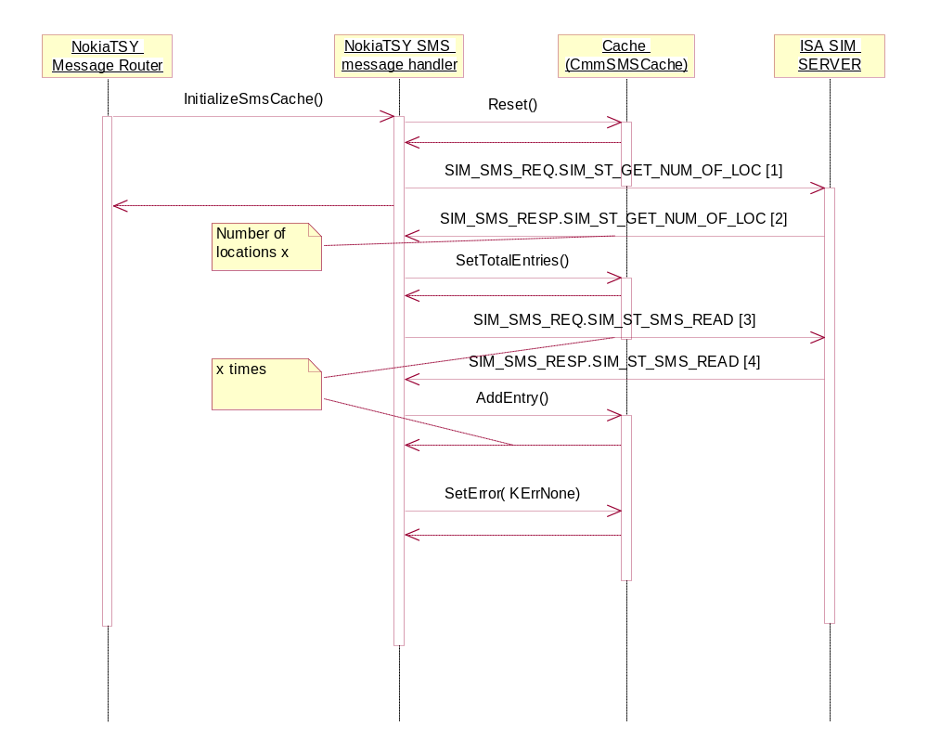
[1] - [4] : TransactionId = ESms2Cache

Store information

Information about the maximum and actually used number of entries in EF_{SMS}.
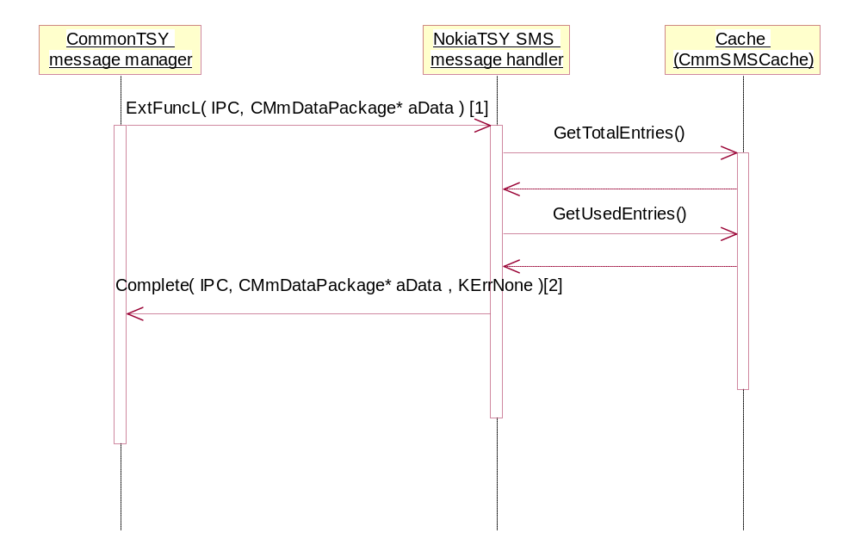
IPC can be EMobileSmsMessagingGetMessageStoreInfo or EMobilePhoneStoreGetInfo.
[1] aData is empty
[2] aDataPackage.iPtr1: TUint8 (total entries)
aDataPackage.iPtr2: TInt (used entries)

Reading SMS
SMS are cached in NokiaTSY, so reading a message does not cause an ISI request.
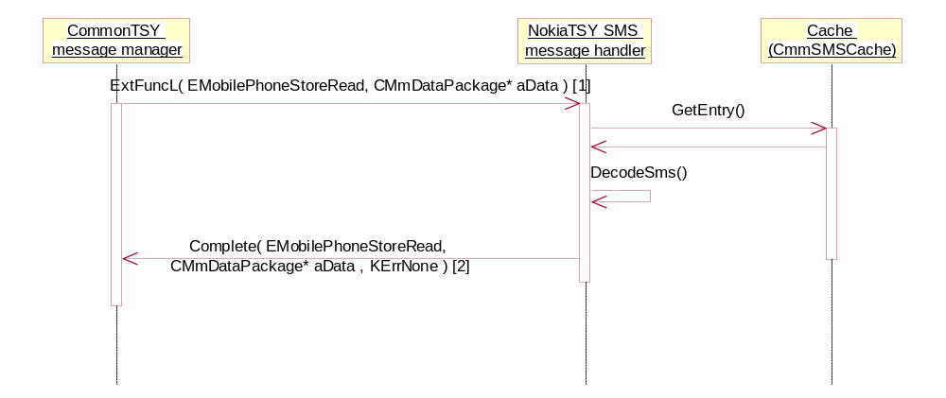
[1]aDataPackage.iPtr1: TInt (index)
[2] aDataPackage.iPtr1:TSmsMsg*

Reading all SMS
SMS are cached in NokiaTSY, so reading all messages does not cause an ISI request.
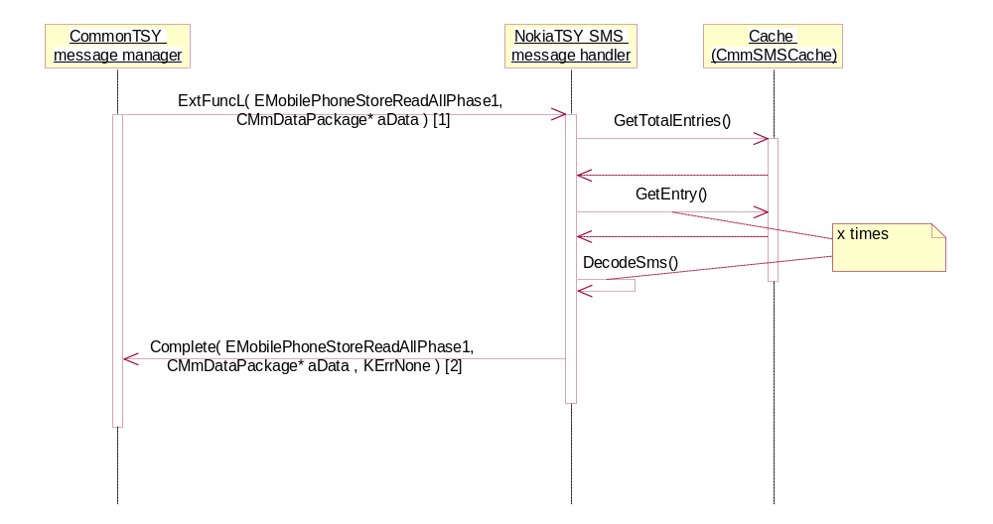
[1] aDataPackage is empty
[2] aDataPackage.iPtr1:CArrayPtrFlat<TSmsMsg>*
aDataPackage.iPtr2:TBool

Writing SMS
An SMS is written into EF_{SMS}, read again (as the SIM application might have modified the content), and then stored in the cache.
A special case is index=-1, which means “save into the first free location”.
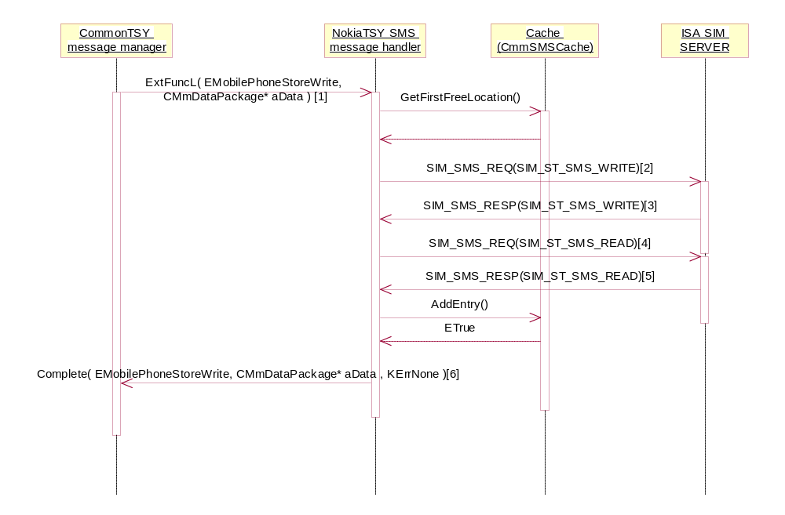
[1]
aDataPackage.iPtr1: DesC8 (the SMS package)
aDataPackage.iPtr2: TInt(the entry index. The special case index =-1 means that NokiaTSY shall save the message to the first free slot)
[2] Transaction ID= EPhoneStoreWrite
Location = x
SubBlock=SmsGsmTpdu
[3]CIsiMsg*
Status=SIM_STA_OK
Transaction ID= EPhoneStoreWrite
[4] TransactionId=EPhoneStoreWrite
Location=x
[5] CIsiMsg*
Status=SIM_STA_OK
TransactionId=EPhoneStoreWrite
[6]
aDataPackage.iPtr1:TUint8 (the slot location in the SIM)
aDataPackage.iPtr2:TBool

Deleting SMS
Deleting one message is a straightforward ISI request. Afterwards, the cache is updated.
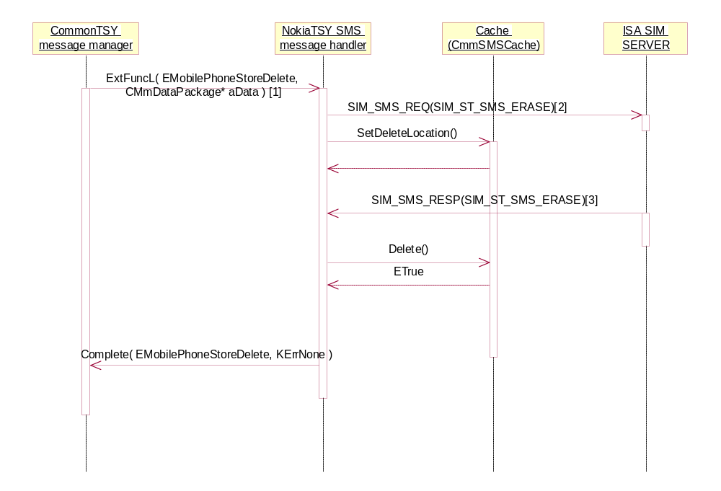
[1] aDataPackage.iPtr1:TInt* (index)

[2]TransactionID= EPhoneStoreDelete
Location= x
[3]CIsiMsg*
Status= SIM_STA_OK
Transaction ID= EPhoneStoreDelete

Deleting all SMS
Deleting all messages is done with one ISI request. Afterwards, the cache is updated.
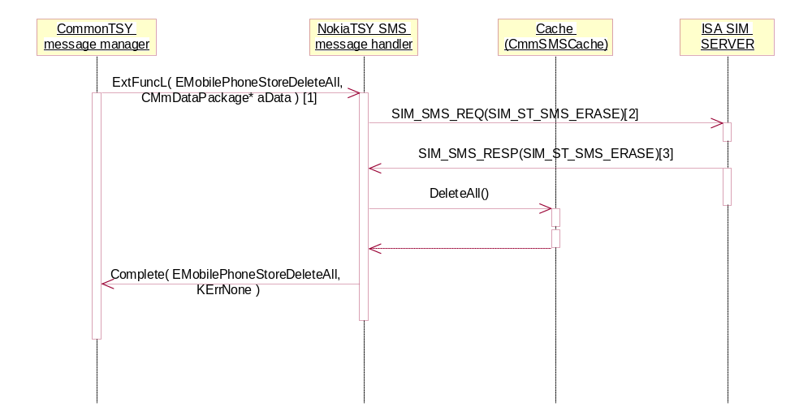
[1] aDataPackage is empty
[2]TransactionID= EPhoneStoreDeleteAll
Location= 0
[3]CIsiMsg*
Status= SIM_STA_OK
Transaction ID= EPhoneStoreDeleteAll

Setting message status to ‘read’
When the user opens a received message, the status on SIM must be updated from “unread” to “read”.
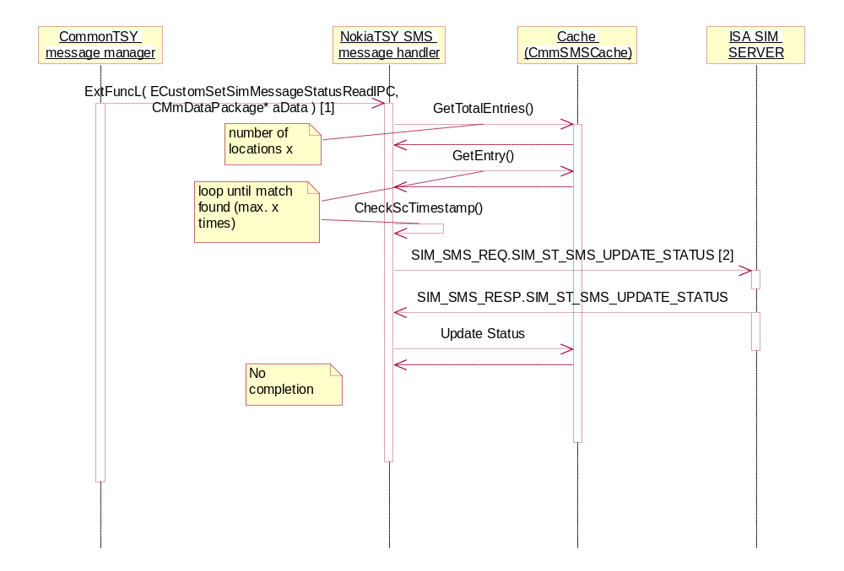
[1] aData.iPtr1: TTime (SC timestamp)
aData.iPtr2: TInt (timezone difference)
[2] location=location of matching SMS

SMS Parameters
NokiaTSY manages the content of the EF_{SMSP} elementary file on SIM (see /9/, section 4.2.27 “EF_{SMSP} (Short message service parameters)”). Data is not cached in NokiaTSY.
SMS Parameters: Read all
SMS parameters are read from ISI SMS Server. First the number of parameter sets is determined, then all sets are read in a loop, and then completed to CommonTSY.
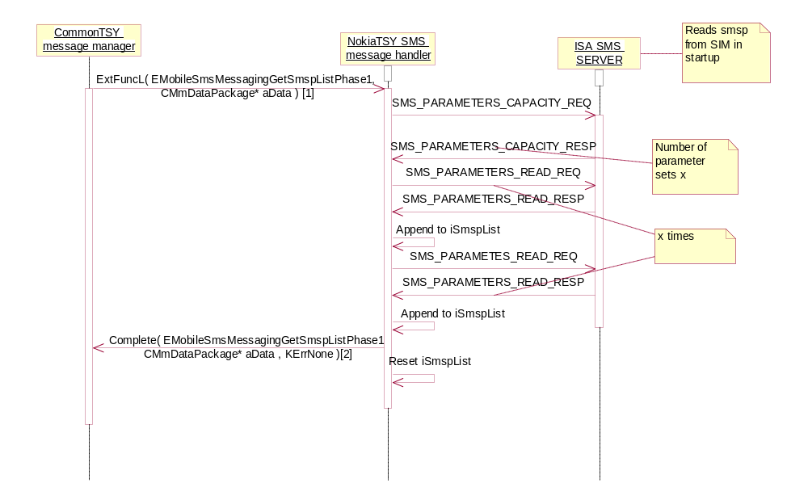
[1] aData is empty
[2] aData.iPtr1: CArrayPtrFlat< TSmsParameters >

SMS Parameters: Store
This functionality updates only one SMS parameter set at a time (and CommonTSY calls it in a loop for all parameter sets).
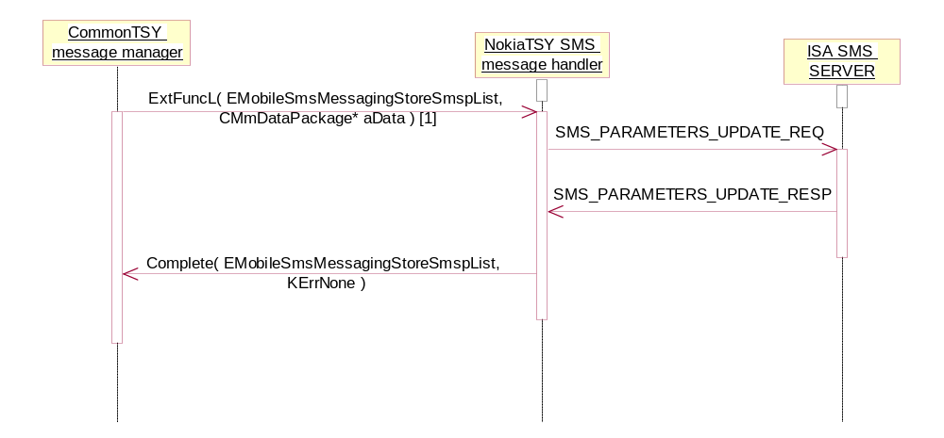
[1] aData.iPtr1: TMobileSmsMessaging::TMobileSmspEntryV1

USSD requests

MO USSD request
Sequence for making the mobile oriented USSD.
Operation | Serving ETel API Request
Preconditions | TSY is loaded.
Description | There is four different MO USSD sequences. Single USSD and Multiple USSD are cases where network replies to clients request. SendRelease is for canceling the session, and Notify is a situation in which client receives a notification from the network after receiving the response.
Inputs | The message data and attributes received from the client. The message attribute types are mapped the following way:  RMobileUssdMessaging::EUssdMORequest -> KSsGsmUssdCommand  RMobileUssdMessaging::EUssdMOReply -> KSsGsmUssdMtReply  RMobileUssdMessaging::EUssdMOAcknowledgement -> KSsGsmUssdNotify
Modifies | NA
Outputs | USSD string
Postconditions | Request is served
Related To | CMmUssdTsy, CmmMessageManagerBase, CMmMessageRouterBase, CMmMessageRouter, CMmUssdMessageHandler
Related Event | NA
Exceptions | The request fails. Client is notified about this

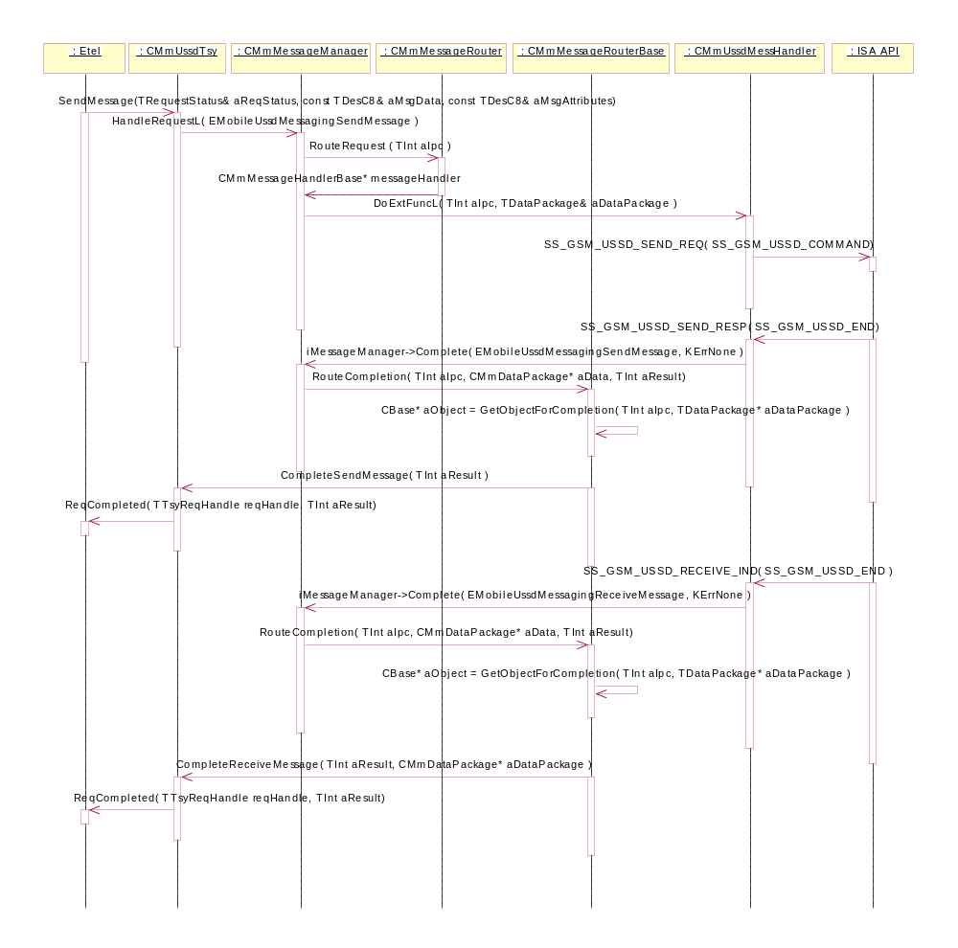
Figure 10. Single MO USSD

There is no separate chart for Multiple MO USSD, since the behaviour is exactly the same as in Single MO USSD. The only difference is, that SS_GSM_USSD_SEND_RESP( SS_GSM_USSD_COMMAND ) is sent instead of SS_GSM_USSD_SEND_RESP( SS_GSM_USSD_END ) if the server still has data to be sent. The additional data is sent via indications; SS_GSM_USSD_RECEIVED_IND( SS_GSM_USSD_COMMAND ).

Requests and request parameters:
- SendMessage( TRequestStatus& aStatus, const TDesC8& aMsgData, TDesC8& aMsgAttributes )
  - TRequestStatus& aStatus is the status of the asynchronous request
  - const TDesC8& aMsgData is the USSD string message data
  - TDesC8& aMsgAttributes is a packaged instance of the RMobilePhone::TmobileUssdAttributesV1 class

IPC values and related package parameters:
- EMobileUssdMessagingSendMessage is the IPC value for sending a USSD message. It is defined in Symbian's ETel server's ETELMMCS.H file.
  - aDataPackage.iPtr1: aMsgData
  - aDataPackage.iPtr2: aMsgAttributes
- EmobileUssdMessagingReceiveMessage is the IPC value for receiving a USSD message indication. It is defined in Symbian's ETel server's ETELMMCS.H file.
  - aDataPackage.iPtr1: aMsgData
  - aDataPackage.iPtr2: aMsgAttributes
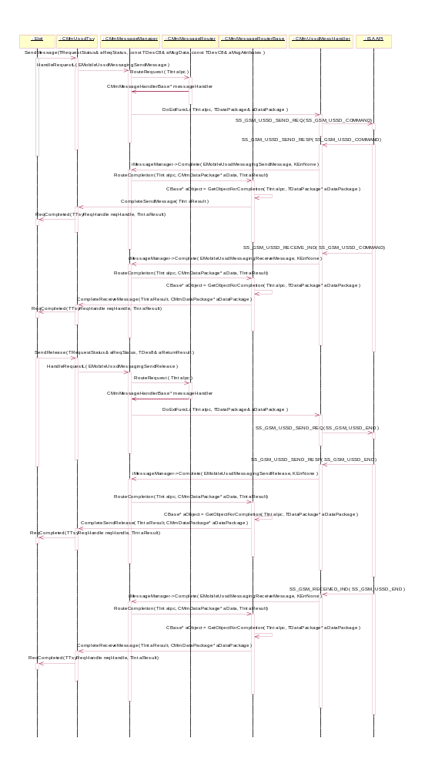
Figure 11 MO USSD SendRelease
SendRelease request can be cancelled normally by canceling the outstanding asynchronous request.

Requests and request parameters:
    - SendMessage( TRequestStatus& aStatus, const TDesC8& aMsgData, TDesC8& aMsgAttributes )
  - TRequestStatus& aStatus is the status of the asynchronous request
  - const TDesC8& aMsgData is the USSD string message data
  - TDesC8& aMsgAttributes is a packaged instance of the RMobilePhone::TmobileUssdAttributesV1 class
- SendRelease( TRequestStatus& aReqStatus, TDes8& aReturnResult )
  - TRequestStatus& aStatus is the status of the asynchronous request
  - const TDes8& aReturnResult is a packaged instance of the RMobilePhone:: TMobilePhoneSendSSRequestV3 class

IPC values and related package parameters:
- EMobileUssdMessagingSendMessage is the IPC value for sending a USSD message. It is defined in Symbian's ETel server's ETELMMCS.H file.
  - aDataPackage.iPtr1: aMsgData
  - aDataPackage.iPtr2: aMsgAttributes
- EMobileUssdMessagingSendRelease is the IPC value for canceling the USSD session. It is defined in Symbian's ETel server's ETELMMCS.H file.
  - aDataPackage.iPtr1: aReturnResult
- EmobileUssdMessagingReceiveMessage is the IPC value for receiving a USSD message indication. It is defined in Symbian's ETel server's ETELMMCS.H file.
  - aDataPackage.iPtr1: aMsgData
  - aDataPackage.iPtr2: aMsgAttributes

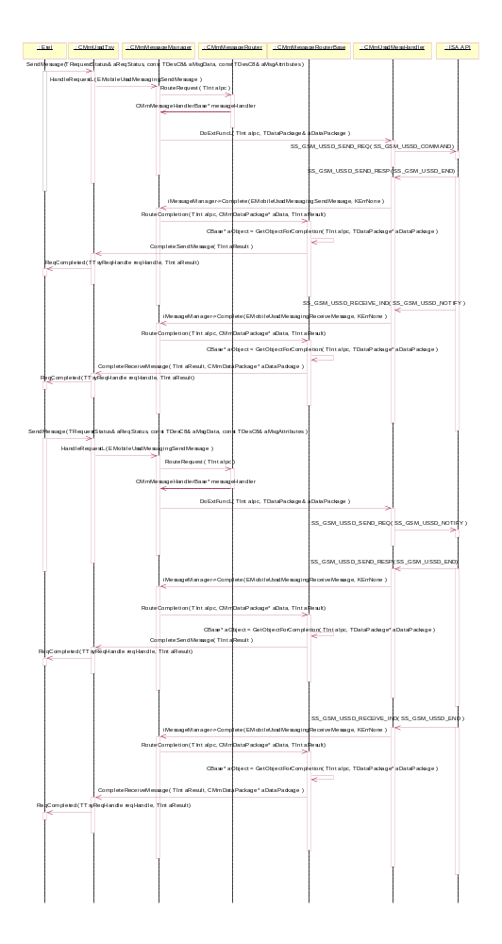
Figure 12 MO USSD where network answers with Notify

Request parameters:
SendMessage( TRequestStatus& aStatus, const TDesC8& aMsgData, TDesC8& aMsgAttributes )
- TRequestStatus& aStatus is the status of the asynchronous request
- const TDesC8& aMsgData is the USSD string message data
- TDesC8& aMsgAttributes is a packaged instance of the RMobilePhone::TmobileUssdAttributesV1 class

IPC values:
- EMobileUssdMessagingSendMessage is the IPC value for sending a USSD message. It is defined in Symbian's ETel server's ETELMMCS.H file.
  - aDataPackage.iPtr1: aMsgData
  - aDataPackage.iPtr2: aMsgAttributes
- EmobileUssdMessagingReceiveMessage is the IPC value for receiving a USSD message indication. It is defined in Symbian's ETel server's ETELMMCS.H file.
  - aDataPackage.iPtr1: aMsgData
  - aDataPackage.iPtr2: aMsgAttributes

MT USSD request
Sequence for making the mobile terminated USSD.
Operation | Serving ETel API Request
Preconditions | TSY is loaded. Client has subscription to KssGsmUssdReceiveInd.
Description | There is four different MT USSD sequences. Single USSD and Multiple USSD are cases where network sends a notification to the client via indication. SendRelease is for canceling the session, and Notify is a situation in which client receives a notification from the network after receiving the response.
Inputs | The message data and attributes received from the network. The message attribute types are mapped the following way:  KssGsmUssdRequest -> RMobileUssdMessaging::EUssdMTRequest  KssGsmUssdCommand -> RMobileUssdMessaging::EUssdMTRequest  KssGsmUssdMtReply -> RMobileUssdMessaging::EUssdMTReply  KssGsmUssdEnd -> RMobileUssdMessaging::EUssdMTReply  KssGsmUssdNotify -> RMobileUssdMessaging::EUssdMTNotify;
Modifies | NA
Outputs | USSD string
Postconditions | Request is served.
Related To | CMmUssdTsy, CmmMessageManagerBase, CMmMessageRouterBase, CMmMessageRouter, CMmUssdMessageHandler
Related Event | NA
Exceptions | The request fails. Client is notified about this.
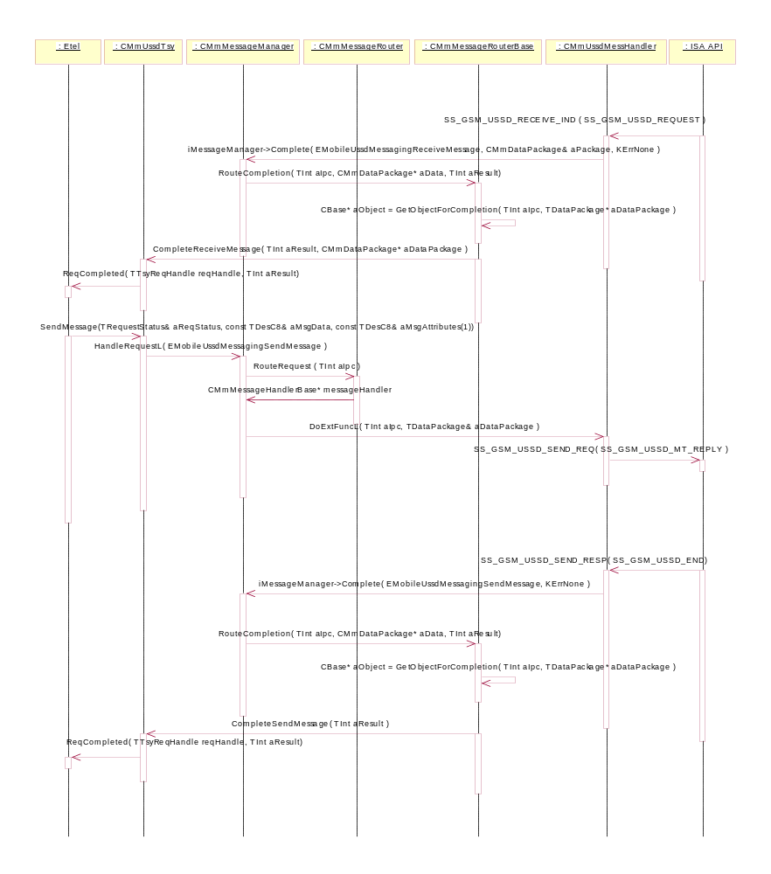
Figure 13 Single MT USSD

There is no separate chart for Multiple MT USSD, since the behaviour is exactly the same as in Single MT USSD. The only difference is, that SS_GSM_USSD_SEND_RESP( SS_GSM_USSD_COMMAND ) is sent instead of SS_GSM_USSD_SEND_RESP( SS_GSM_USSD_END ) till all the indications are being sent.
Requests and request parameters:
    - SendMessage( TRequestStatus& aStatus, const TDesC8& aMsgData, TDesC8& aMsgAttributes )
  - TRequestStatus& aStatus is the status of the asynchronous request
  - const TDesC8& aMsgData is the USSD string message data
  - TDesC8& aMsgAttributes is a packaged instance of the RMobilePhone::TmobileUssdAttributesV1 class

IPC values and related package parameters:
- EMobileUssdMessagingSendMessage is the IPC value for sending a USSD message. It is defined in Symbian's ETel server's ETELMMCS.H file.
  - aDataPackage.iPtr1: aMsgData
  - aDataPackage.iPtr2: aMsgAttributes
- EmobileUssdMessagingReceiveMessage is the IPC value for receiving a USSD message indication. It is defined in Symbian's ETel server's ETELMMCS.H file.
  - aDataPackage.iPtr1: aMsgData
  - aDataPackage.iPtr2: aMsgAttributes
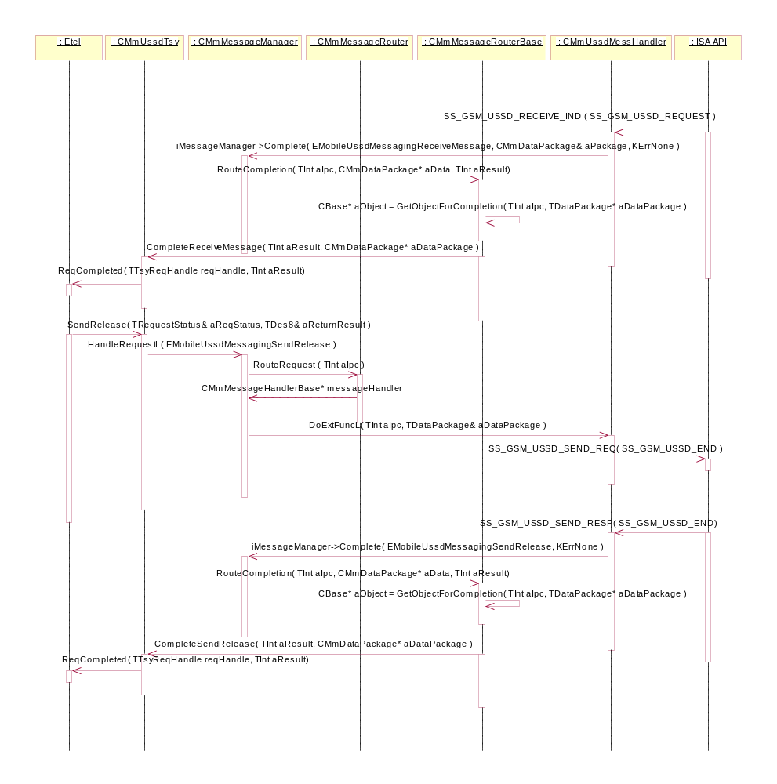
Figure 14 MT USSD SendRelease

Requests and request parameters:
    - SendMessage( TRequestStatus& aStatus, const TDesC8& aMsgData, TDesC8& aMsgAttributes )
  - TRequestStatus& aStatus is the status of the asynchronous request
  - const TDesC8& aMsgData is the USSD string message data
  - TDesC8& aMsgAttributes is a packaged instance of the RMobilePhone::TmobileUssdAttributesV1 class
- SendRelease( TRequestStatus& aReqStatus, TDes8& aReturnResult )
  - TRequestStatus& aStatus is the status of the asynchronous request
  - const TDes8& aReturnResult is a packaged instance of the RMobilePhone:: TMobilePhoneSendSSRequestV3 class

IPC values and related package parameters:
- EMobileUssdMessagingSendMessage is the IPC value for sending a USSD message. It is defined in Symbian's ETel server's ETELMMCS.H file.
  - aDataPackage.iPtr1: aMsgData
  - aDataPackage.iPtr2: aMsgAttributes
- EMobileUssdMessagingSendRelease is the IPC value for canceling the USSD session. It is defined in Symbian's ETel server's ETELMMCS.H file.
  - aDataPackage.iPtr1: aReturnResult
- EmobileUssdMessagingReceiveMessage is the IPC value for receiving a USSD message indication. It is defined in Symbian's ETel server's ETELMMCS.H file.
  - aDataPackage.iPtr1: aMsgData
  - aDataPackage.iPtr2: aMsgAttributes
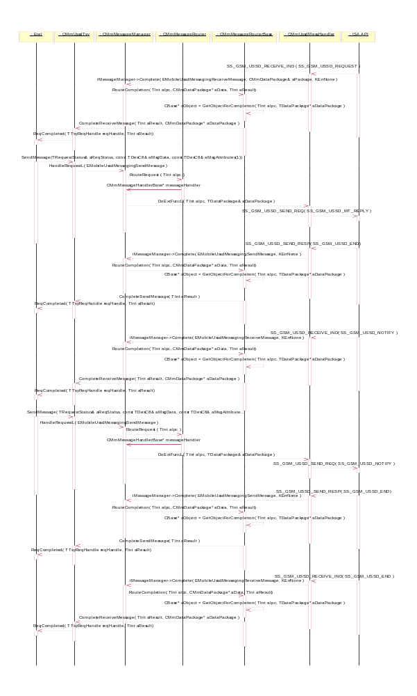
Figure 15 MT USSD where network answers with Notify

Request parameters:
SendMessage( TRequestStatus& aStatus, const TDesC8& aMsgData, TDesC8& aMsgAttributes )
- TRequestStatus& aStatus is the status of the asynchronous request
- const TDesC8& aMsgData is the USSD string message data
- TDesC8& aMsgAttributes is a packaged instance of the RMobilePhone::TmobileUssdAttributesV1 class

IPC values:
- EMobileUssdMessagingSendMessage is the IPC value for sending a USSD message. It is defined in Symbian's ETel server's ETELMMCS.H file.
  - aDataPackage.iPtr1: aMsgData
  - aDataPackage.iPtr2: aMsgAttributes
- EmobileUssdMessagingReceiveMessage is the IPC value for receiving a USSD message indication. It is defined in Symbian's ETel server's ETELMMCS.H file.
  - aDataPackage.iPtr1: aMsgData
  - aDataPackage.iPtr2: aMsgAttributes

Call Handling

Generic sequences for all call requests
Call status change
The mobile call status change sequence is common for all call use cases. Mobile call information should be delivered to Common TSY before status change information.
Precondition: A call is in any state and CALL_STATUS_IND message is received with one of following ISA statuses (other statuses are mapped to Symbian status RMobileCall::EstatusUnknown and are not delivered to Common TSY):
- KcallStatusIdle => RMobileCall:: EStatusIdle
- KCallStatusCreate => RMobileCall:: EStatusDialling
- KCallStatusMoAlerting => RMobileCall:: EStatusConnecting
- KCallStatusWaiting => RMobileCall:: EStatusRinging
- KCallStatusMtAlerting => RMobileCall:: EStatusRinging
- KCallStatusAnswered => RMobileCall:: EStatusAnswering
- KCallStatusActive => RMobileCall:: EStatusConnected
- KCallStatusMoRelease => RMobileCall:: EStatusDisconnecting
- KCallStatusMtRelease => RMobileCall:: EStatusDisconnecting
- KcallStatusHold => RMobileCall:: EStatusHold

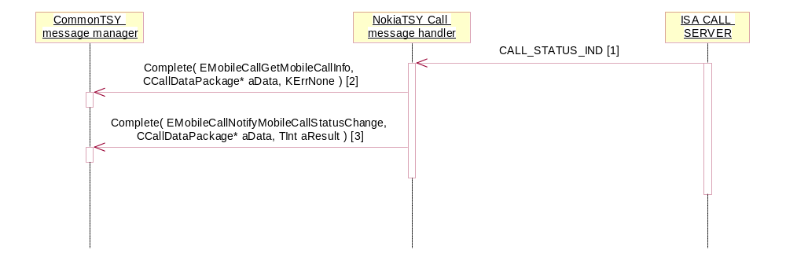
[1] CIsiMsg*
Call Id = x
Sub Block: CALL_STATUS
Sub Block: CALL_MODE
+ Additional Sub Blocks
[2] CCallDataPackage*
aData.iCallId: x
aData.iCallMode:
MobilePhone::EVoiceService,
RMobilePhone::EAuxVoiceService,
RMobilePhone::ECircuitDataService or
RMobilePhone::EFaxService
aData.iPtr1: RMobileCall::TMobileCallInfoV1*
[3] CCallDataPackage*
aData.iCallId: x
aData.iCallMode:
MobilePhone::EVoiceService,
RMobilePhone::EAuxVoiceService,
RMobilePhone::ECircuitDataService or
RMobilePhone::EFaxService
aData.iPtr1: RMobileCall::TMobileCallStatus*
TInt aResult = KErrNone / core error and extended error

Voice call interface
Creating a voice call
Precondition: The phone MS is in the Idle state and connected to a network. There are no other calls.
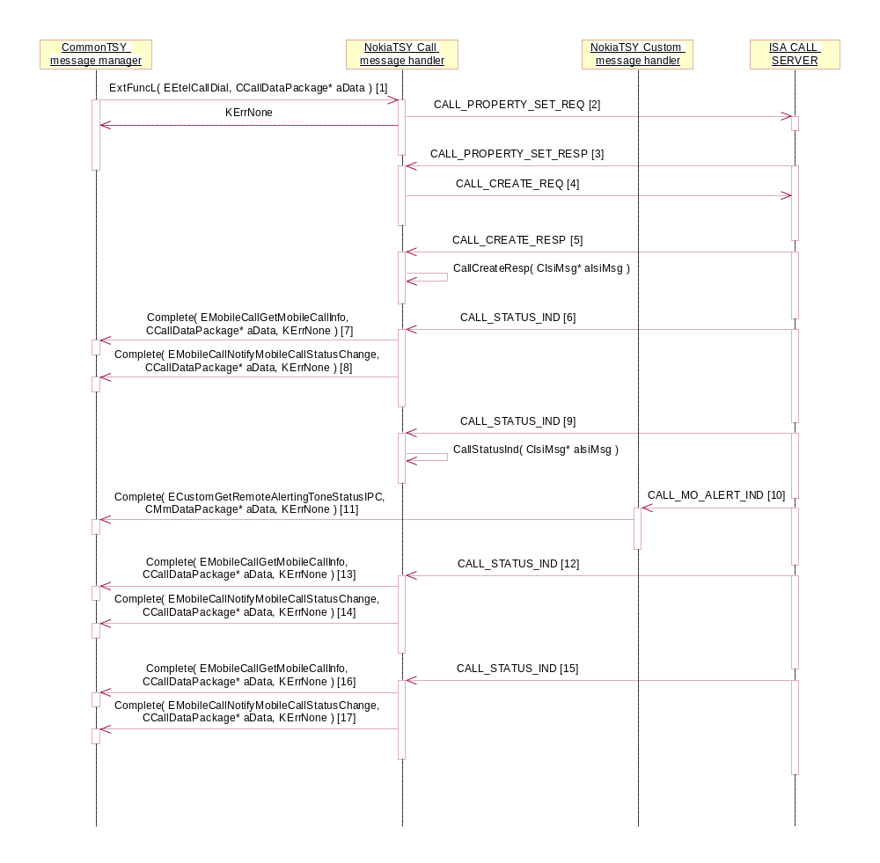
[1] CCallDataPackage*
aData.iCallId: x
aData.iCallMode: RMobilePhone::EVoiceService
aData.iPtr1: RMobileCall::TMobileCallParamsV1Pckg*
aData.iPtr2: RMobileCall::TMobileCallInfoV1*
[2] CCallIsiMsg*
Sub Block: CALL_GSM_CUG_INFO
Sub Block: CALL_PROPERTY_INFO
- CALL_GSM_PROP_CUG_INFO = 0x00
[3] CIsiMsg*
Sub Block: CALL_GSM_CUG_INFO
Sub Block: CALL_PROPERTY_INFO
- CALL_GSM_PROP_CUG_INFO = 0x00
[4] CCallIsiMsg
Call Id = KCallIdNone
Sub Block: CALL_MODE = KCallGsmModeAlsLine1
Sub Block: CALL_DESTINATION_ADDRESS
+ Additional Sub Blocks:
- CALL_ORIGIN_INFO
- CALL_DESTINATION_POST_ADDRESS
- CALL_DESTINATION_PRE_ADDRESS
[5] CIsiMsg*
Call Id = x
[6] CIsiMsg*
Call Id = x
Sub Block: CALL_STATUS = KCallStatusCreate
Sub Block: CALL_MODE = KCallModeSpeech
+ Additional Sub Blocks
[7] CCallDataPackage*
aData.iCallId: x
aData.iCallMode: RMobilePhone::EVoiceService
aData.iPtr1: RMobileCall::TMobileCallInfoV1*
[8] CCallDataPackage*
aData.iCallId: x
aData.iCallMode: RMobilePhone::EVoiceService
aData.iPtr1: RMobileCall::TMobileCallStatus* = RMobileCall::EStatusDialling
[9] CIsiMsg*
Call Id = x
Sub Block: CALL_STATUS = KCallStatusProceeding
Sub Block: CALL_MODE = KCallModeSpeech
+ Additional Sub Blocks
[10] CIsiMsg*
Call Id = x
Additional Sub Block: CALL_ALERTING_INFO
[11] CMmDataPackage*
aData.iPtr1: TBool*
[12] CIsiMsg*
Call Id = x
Sub Block: CALL_STATUS = KCallStatusMoAlerting
Sub Block: CALL_MODE = KCallModeSpeech
+ Additional Sub Blocks
[13] CCallDataPackage*
aData.iCallId: x
aData.iCallMode: RMobilePhone::EVoiceService
aData.iPtr1: RMobileCall::TMobileCallInfoV1*
[14] CCallDataPackage*
aData.iCallId: x
aData.iCallMode: RMobilePhone::EVoiceService
aData.iPtr1: RMobileCall::TMobileCallStatus* = RMobileCall::EStatusConnecting
[15] CIsiMsg*
Call Id = x
Sub Block: CALL_STATUS = KCallStatusActive
Sub Block: CALL_MODE = KCallModeSpeech
+ Additional Sub Blocks
[16] CCallDataPackage*
aData.iCallId: x
aData.iCallMode: RMobilePhone::EVoiceService
aData.iPtr1: RMobileCall::TMobileCallInfoV1*
[17] CCallDataPackage*
aData.iCallId: x
aData.iCallMode: RMobilePhone::EVoiceService
aData.iPtr1: RMobileCall::TMobileCallStatus* = RMobileCall::EstatusConnected

Creating an emergency call
Precondition: The phone MS is in the Idle state and connected to a network.
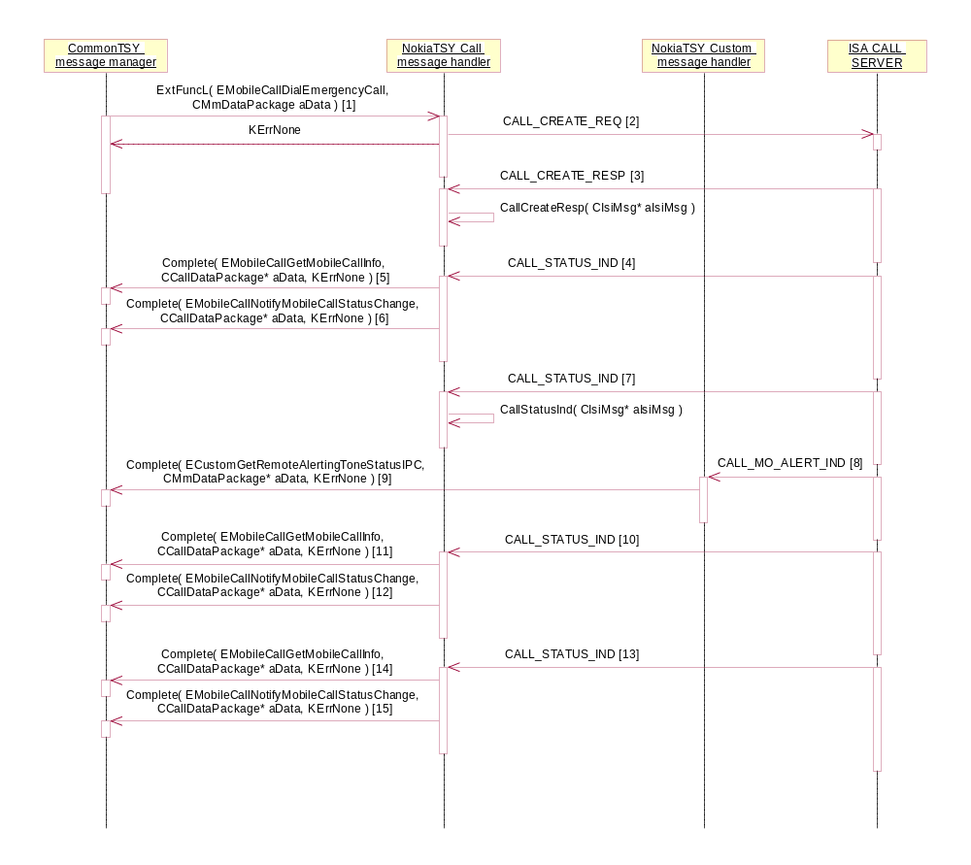
[1] CMmDataPackage*
aData.iPtr1: TDesC*
[2] CCallIsiMsg
Call Id = KCallIdNone
Sub Block: CALL_MODE = KCallModeEmergency
[3] CIsiMsg*
Call Id = x
[4] CIsiMsg*
Call Id = x
Sub Block: CALL_STATUS = KCallStatusCreate
Sub Block: CALL_MODE = KCallModeEmergency
+ Additional Sub Blocks
[5] CCallDataPackage*
aData.iCallId: x
aData.iCallMode: RMobilePhone::EVoiceService
aData.iPtr1: RMobileCall::TMobileCallInfoV1*
[6] CCallDataPackage*
aData.iCallId: x
aData.iCallMode: RMobilePhone::EVoiceService
aData.iPtr1: RMobileCall::TMobileCallStatus* = RMobileCall::EStatusDialling
[7] CIsiMsg*
Call Id = x
Sub Block: CALL_STATUS = KCallStatusProceeding
Sub Block: CALL_MODE = KCallModeEmergency
+ Additional Sub Blocks
[8] CIsiMsg*
Call Id = x
Additional Sub Block: CALL_ALERTING_INFO
[9] CMmDataPackage*
aData.iPtr1: TBool*
[10] CIsiMsg*
Call Id = x
Sub Block: CALL_STATUS = KCallStatusMoAlerting
Sub Block: CALL_MODE = KCallModeEmergency
+ Additional Sub Blocks
[11] CCallDataPackage*
aData.iCallId: x
aData.iCallMode: RMobilePhone::EVoiceService
aData.iPtr1: RMobileCall::TMobileCallInfoV1*
[12] CCallDataPackage*
aData.iCallId: x
aData.iCallMode: RMobilePhone::EVoiceService
aData.iPtr1: RMobileCall::TMobileCallStatus* = RMobileCall::EStatusConnecting
[13] CIsiMsg*
Call Id = x
Sub Block: CALL_STATUS = KCallStatusActive
Sub Block: CALL_MODE = KCallModeEmergency
+ Additional Sub Blocks
[14] CCallDataPackage*
aData.iCallId: x
aData.iCallMode: RMobilePhone::EVoiceService
aData.iPtr1: RMobileCall::TMobileCallInfoV1*
[15] CCallDataPackage*
aData.iCallId: x
aData.iCallMode: RMobilePhone::EVoiceService
aData.iPtr1: RMobileCall::TMobileCallStatus* = RMobileCall::EStatusConnected

Incoming voice call
Precondition: The MS is in the Idle state and connected to a network.
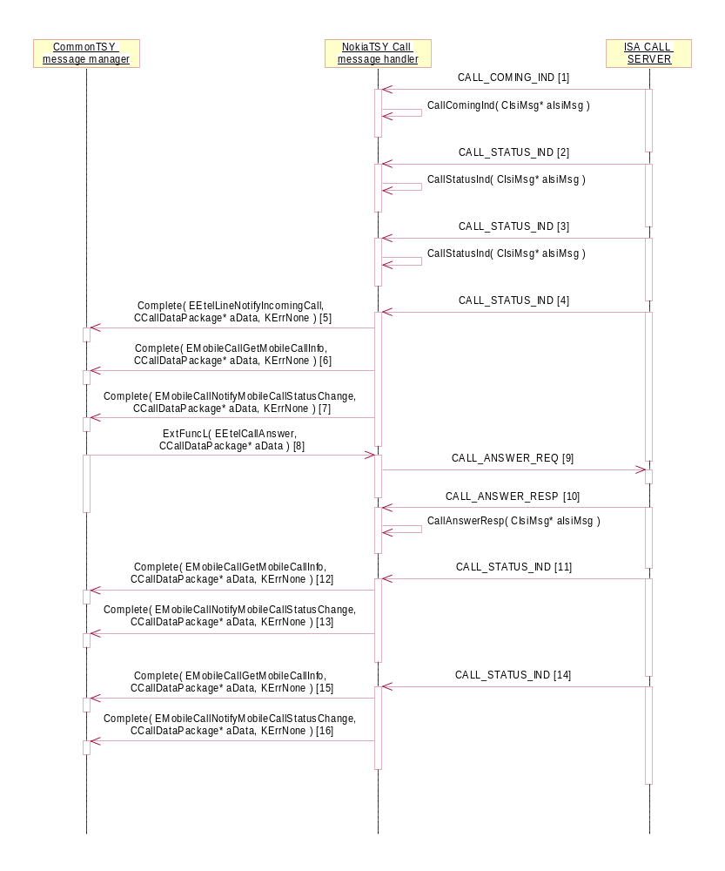
[1] CIsiMsg*
Call Id = x
Sub Block: CALL_MODE = KCallModeSpeech
Sub Block: CALL_ORIGIN_ADDRESS
+ Additional Sub Blocks
[2] CIsiMsg*
Call Id = x
Sub Block: CALL_STATUS = KCallStatusComing
Sub Block: CALL_MODE = KCallModeSpeech
Sub Block: CALL_ORIGIN_ADDRESS
+ Additional Sub Blocks
[3] CIsiMsg*
Call Id = x
Sub Block: CALL_STATUS = KCallStatusProceeding
Sub Block: CALL_MODE = KCallModeSpeech
+ Additional Sub Blocks
[4] CIsiMsg*
Call Id = x
Sub Block: CALL_STATUS = KCallStatusMtAlerting
Sub Block: CALL_MODE = KCallModeSpeech
+ Additional Sub Blocks
[5] CCallDataPackage*
aData.iCallId: x
aData.iCallMode: RMobilePhone::EVoiceService
aData.iPtr1: RMobileCall::TMobileCallInfoV1*
[6] CCallDataPackage*
aData.iCallId: x
aData.iCallMode: RMobilePhone::EVoiceService
aData.iPtr1: RMobileCall::TMobileCallInfoV1*
[7] CCallDataPackage*
aData.iCallId: x
aData.iCallMode: RMobilePhone::EVoiceService
aData.iPtr1: RMobileCall::TMobileCallStatus*
[8] CCallDataPackage*
aData.iCallId: x
aData.iCallMode: RMobilePhone::EVoiceService
[9] CCallIsiMsg*
Call Id = x
[10] CIsiMsg*
Call Id = x
[11] CIsiMsg*
Call Id = x
Sub Block: CALL_STATUS = KCallStatusAnswered
Sub Block: CALL_MODE = KCallModeSpeech
+ Additional Sub Blocks
[12] CCallDataPackage*
aData.iCallId: x
aData.iCallMode: RMobilePhone::EVoiceService
aData.iPtr1: RMobileCall::TMobileCallInfoV1*
[13] CCallDataPackage*
aData.iCallId: x
aData.iCallMode: RMobilePhone::EVoiceService
aData.iPtr1: RMobileCall::TMobileCallStatus* = RMobileCall::EStatusAnswering
[14] CIsiMsg*
Call Id = x
Sub Block: CALL_STATUS = KCallStatusActive
Sub Block: CALL_MODE = KCallModeSpeech
+ Additional Sub Blocks
[15] CCallDataPackage*
aData.iCallId: x
aData.iCallMode: RMobilePhone::EVoiceService
aData.iPtr1: RMobileCall::TMobileCallInfoV1*
[16] CCallDataPackage*
aData.iCallId: x
aData.iCallMode: RMobilePhone::EVoiceService
aData.iPtr1: RMobileCall::TMobileCallStatus* = RMobileCall::EStatusConnected

Call waiting
Precondition: One call is in the state RMobileCall::EStatusConnected.
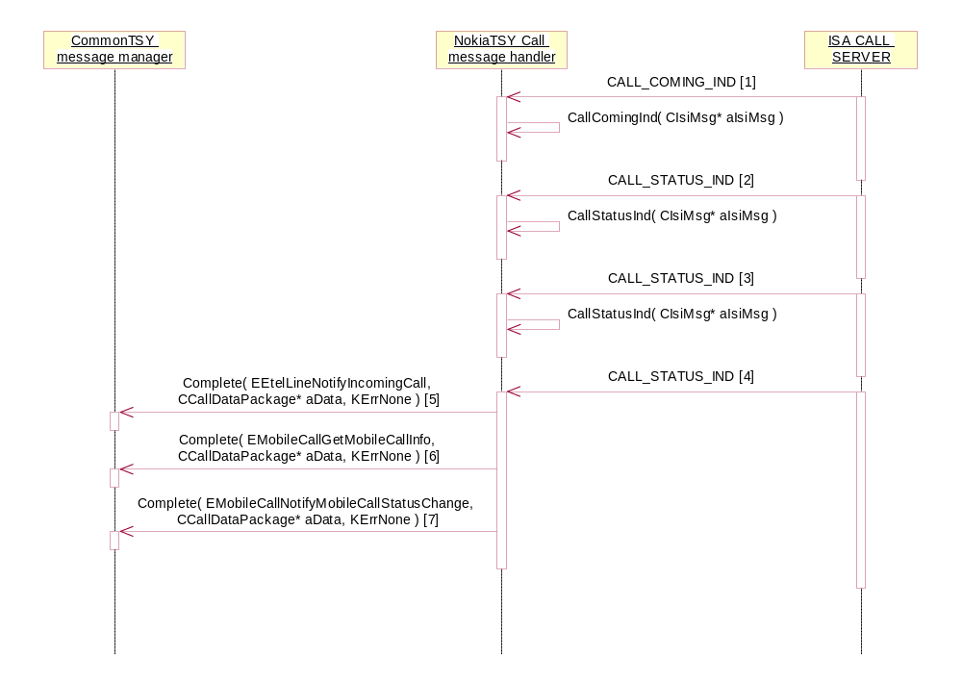
[1] CIsiMsg*
Call Id = y
Sub Block: CALL_MODE = KCallModeSpeech
Sub Block: CALL_ORIGIN_ADDRESS
+ Additional Sub Blocks
[2] CIsiMsg*
Call Id = y
Sub Block: CALL_STATUS = KCallStatusComing
Sub Block: CALL_MODE = KCallModeSpeech
Sub Block: CALL_ORIGIN_ADDRESS
+ Additional Sub Blocks
[3] CIsiMsg*
Call Id = y
Sub Block: CALL_STATUS = KCallStatusProceeding
Sub Block: CALL_MODE = KCallModeSpeech
+ Additional Sub Blocks
[4] CIsiMsg*
Call Id = y
Sub Block: CALL_STATUS = KCallStatusWaiting
Sub Block: CALL_MODE = KCallModeSpeech
+ Additional Sub Blocks
[5] CCallDataPackage*
aData.iCallId: y
aData.iCallMode: RMobilePhone::EVoiceService
aData.iPtr1: RMobileCall::TMobileCallInfoV1*
[6] CCallDataPackage*
aData.iCallId: y
aData.iCallMode: RMobilePhone::EVoiceService
aData.iPtr1: RMobileCall::TMobileCallInfoV1*
[7] CCallDataPackage*
aData.iCallId: y
aData.iCallMode: RMobilePhone::EVoiceService
aData.iPtr1: RMobileCall::TMobileCallStatus* = RMobileCall::EstatusRinging

Holding voice call
Precondition: One voice call is in the connected state.
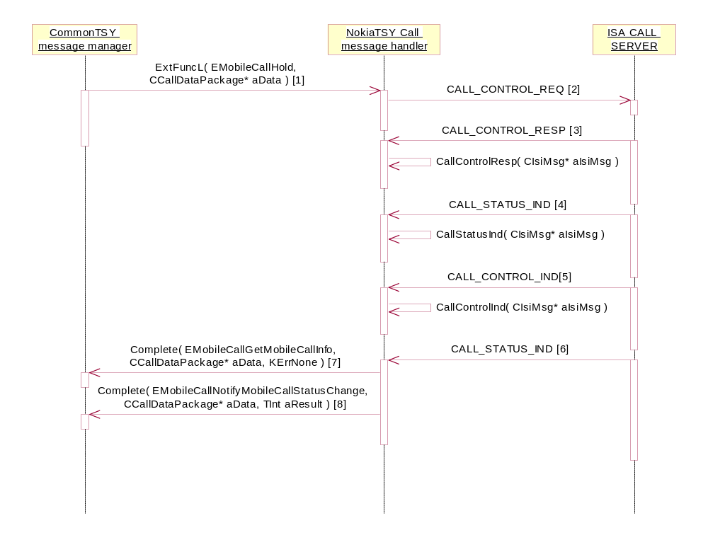
[1] CCallDataPackage*
aData.iCallId: x
aData.iCallMode: RMobilePhone::EVoiceService
[2 & 3] CCallIsiMsg*
Call Id = x
Sub Block: CALL_OPERATION
- CALL_OP_HOLD
[4] CIsiMsg*
Call Id = x
Sub Block: CALL_STATUS = KCallStatusHoldInitiated
Sub Block: CALL_MODE = KCallModeSpeech
[5] CIsiMsg*
Call Id = x
Sub Block: CALL_OPERATION
- CALL_OP_HOLD
[6] CIsiMsg*
Call Id = x
Sub Block: CALL_STATUS = KCallStatusHold
Sub Block: CALL_MODE = KCallModeSpeech
[7] CCallDataPackage*
aData.iCallId: x
aData.iCallMode: RMobilePhone::EVoiceService
aData.iPtr1: RMobileCall::TMobileCallInfoV1*
[8] CCallDataPackage*
aData.iCallId: x
aData.iCallMode: RMobilePhone::EVoiceService
aData.iPtr1: RMobileCall::TMobileCallStatus* = RMobileCall::EStatusHold
- TInt aResult = KerrNone

Resuming voice call
Precondition: One voice call is in the hold state.
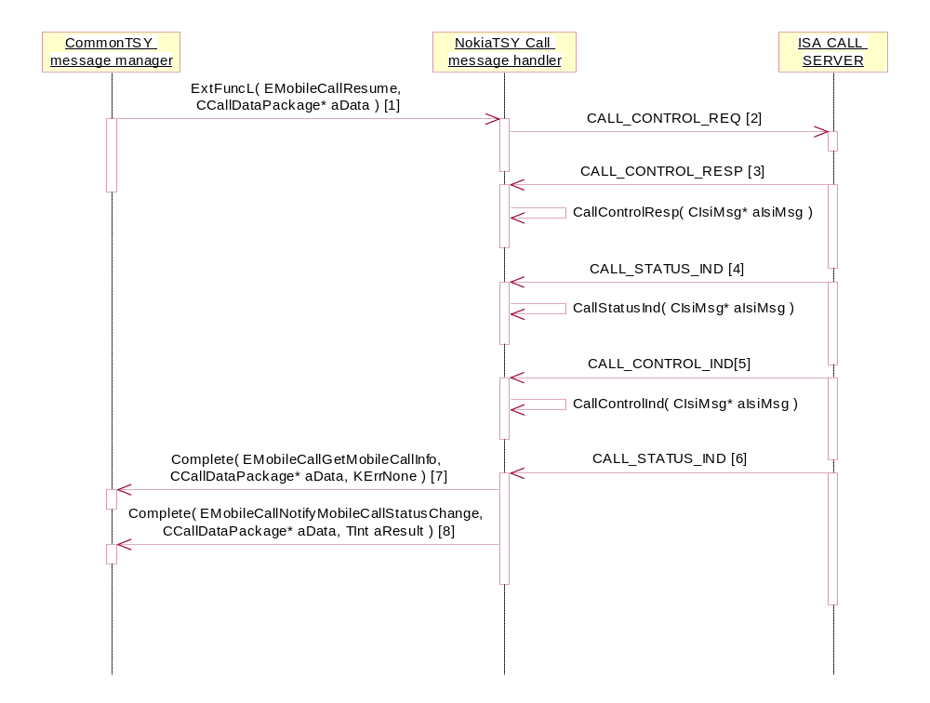
[1] CCallDataPackage*
aData.iCallId: x
aData.iCallMode: RMobilePhone::EVoiceService
[2 & 3] CCallIsiMsg*
Call Id = x
Sub Block: CALL_OPERATION
- CALL_OP_RETRIEVE
[4] CIsiMsg*
Call Id = x
Sub Block: CALL_STATUS = KCallStatusRetrieveInitiated
Sub Block: CALL_MODE = KCallModeSpeech
[5] CIsiMsg*
Call Id = x
Sub Block: CALL_OPERATION
- CALL_OP_RETRIEVE
[6] CIsiMsg*
Call Id = x
Sub Block: CALL_STATUS = KCallStatusActive
Sub Block: CALL_MODE = KCallModeSpeech
[7] CCallDataPackage*
aData.iCallId: x
aData.iCallMode: RMobilePhone::EVoiceService
aData.iPtr1: RMobileCall::TMobileCallInfoV1*
[8] CCallDataPackage*
aData.iCallId: x
aData.iCallMode: RMobilePhone::EVoiceService
aData.iPtr1: RMobileCall::TMobileCallStatus* = RMobileCall::EStatusConnected
- TInt aResult = KErrNone

Swaping voice calls
Precondition: One voice call is in the connected state and one in the hold state.
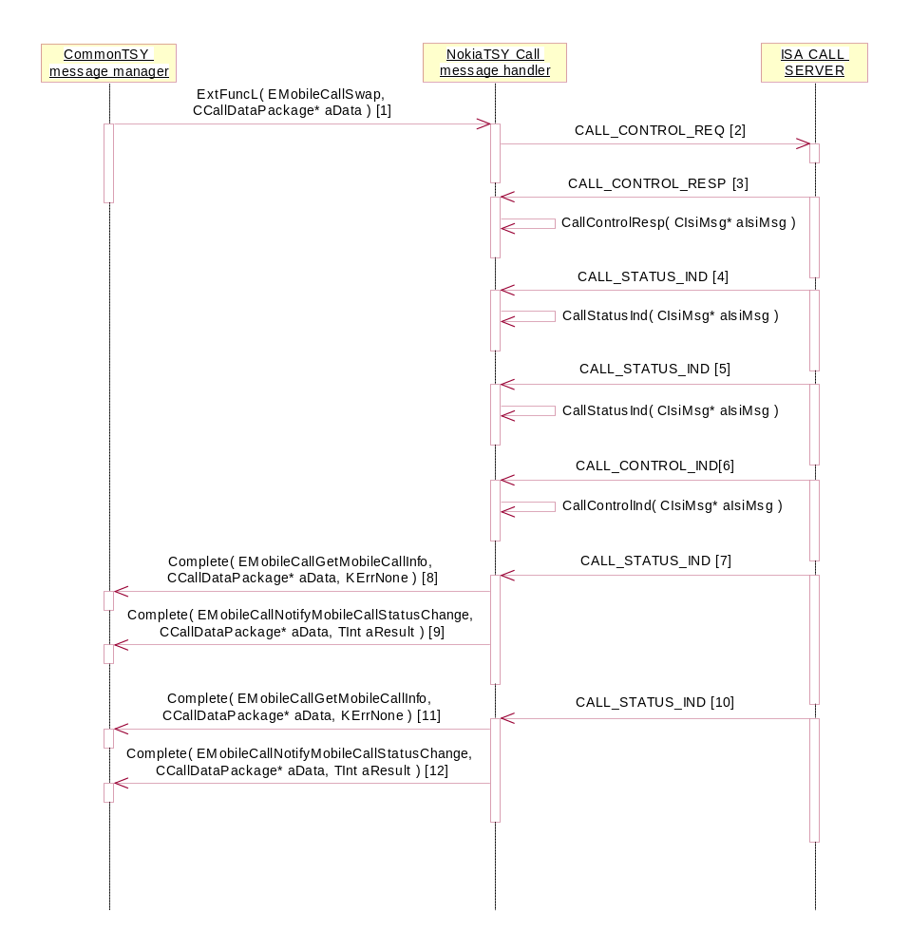
[1] CCallDataPackage*
aData.iCallId: x
aData.iCallMode: RMobilePhone::EVoiceService
[2 & 3] CCallIsiMsg*
Call Id = KCallIdActive
Sub Block: CALL_OPERATION
- CALL_OP_SWAP
[4] CIsiMsg*
Call Id = x
Sub Block: CALL_STATUS = KCallStatusHoldInitiated
Sub Block: CALL_MODE = KCallModeSpeech
[5] CIsiMsg*
Call Id = y
Sub Block: CALL_STATUS = KCallStatusRetrieveInitiated
Sub Block: CALL_MODE = KCallModeSpeech
[6] CIsiMsg*
Call Id = KCallIdActive
Sub Block: CALL_OPERATION
- CALL_OP_SWAP
[7] CIsiMsg*
Call Id = x
Sub Block: CALL_STATUS = KCallStatusHold
Sub Block: CALL_MODE = KCallModeSpeech
[8] CCallDataPackage*
aData.iCallId: x
aData.iCallMode: RMobilePhone::EVoiceService
aData.iPtr1: RMobileCall::TMobileCallInfoV1*
[9] CCallDataPackage*
aData.iCallId: x
aData.iCallMode: RMobilePhone::EVoiceService
aData.iPtr1: RMobileCall::TMobileCallStatus* = RMobileCall::EStatusHold
- TInt aResult = KErrNone
[10] CIsiMsg*
Call Id = y
Sub Block: CALL_STATUS = KCallStatusActive
Sub Block: CALL_MODE = KCallModeSpeech
[11] CCallDataPackage*
aData.iCallId: y
aData.iCallMode: RMobilePhone::EVoiceService
aData.iPtr1: RMobileCall::TMobileCallInfoV1*
[12] CCallDataPackage*
aData.iCallId: y
aData.iCallMode: RMobilePhone::EVoiceService
aData.iPtr1: RMobileCall::TMobileCallStatus* = RMobileCall::EStatusConnected
- TInt aResult = KErrNone

Call transfer
Precondition: One voice call is in the connected state and one in the hold state.
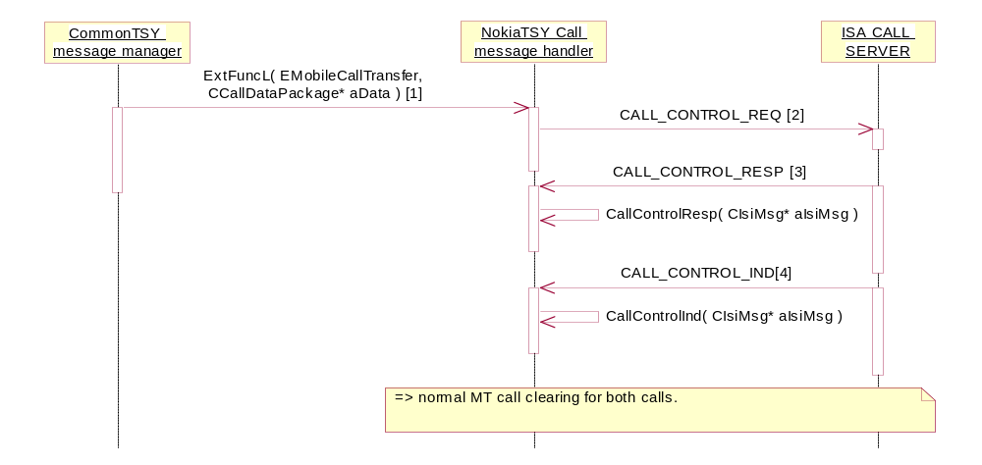
[1] CCallDataPackage*
aData.iCallId: x
aData.iCallMode: RMobilePhone::EVoiceService
[2, 3 & 4] CCallIsiMsg*
Call Id = x
Sub Block: CALL_OPERATION
- CALL_GSM_OP_TRANSFER
=> normal MT call clearing for call x and call y.

Mobile originated call clearing
Precondition: One voice call is in the connected state.
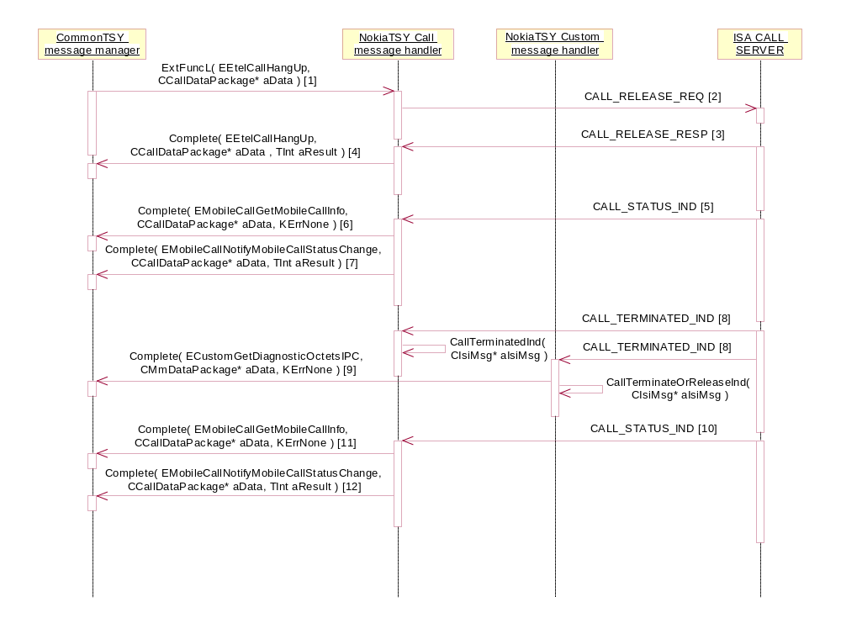
[1] CCallDataPackage*
aData.iCallId: x
aData.iCallMode: RMobilePhone::EVoiceService
aData.iPtr1: Tint*, hangUpCause
aData.iPtr2: TBool*, autoStChangeDisable
[2] CCallIsiMsg*
Sub Block: CALL_CAUSE
+ Additional Sub Block: CALL_STATE_AUTO_CHANGE
[3] CIsiMsg*
Sub Block: CALL_CAUSE
[4] Completed if reseived release cause is different than requested
- CCallDataPackage*
aData.iCallId: x
aData.iCallMode: RMobilePhone::EVoiceService
- TInt aResult = release cause value
[5] CIsiMsg*
Call Id = x
Sub Block: CALL_STATUS = KCallStatusMoRelease
Sub Block: CALL_MODE = KCallModeSpeech
+ Additional Sub Blocks
[6] CCallDataPackage*
aData.iCallId: x
aData.iCallMode: RMobilePhone::EVoiceService
aData.iPtr1: RMobileCall::TMobileCallInfoV1*
[7] CCallDataPackage*
aData.iCallId: x
aData.iCallMode: RMobilePhone::EVoiceService
aData.iPtr1: RMobileCall::TMobileCallStatus* = RMobileCall::EStatusDisconnecting
- TInt aResult = release cause value
[8] CIsiMsg*
Call Id = x
Sub Block: CALL_MODE = KCallModeSpeech
Sub Block: CALL_CAUSE
+ Additional Sub Blocks
[9] CMmDataPackage*
aData.iPtr1: TInt*, call Id
aData.iPtr2: TUint8*, diagnostic octet
[10] CIsiMsg*
Call Id = x
Sub Block: CALL_STATUS = KCallStatusIdle
Sub Block: CALL_MODE = KCallModeSpeech
+ Additional Sub Blocks
[11] CCallDataPackage*
aData.iCallId: x
aData.iCallMode: RMobilePhone::EVoiceService
aData.iPtr1: RMobileCall::TMobileCallInfoV1*
[12] CCallDataPackage*
aData.iCallId: x
aData.iCallMode: RMobilePhone::EVoiceService
aData.iPtr1: RMobileCall::TMobileCallStatus* = RMobileCall::EStatusIdle
- TInt aResult = release cause value

Mobile terminated call clearing
Precondition: One voice call is in the connected state.
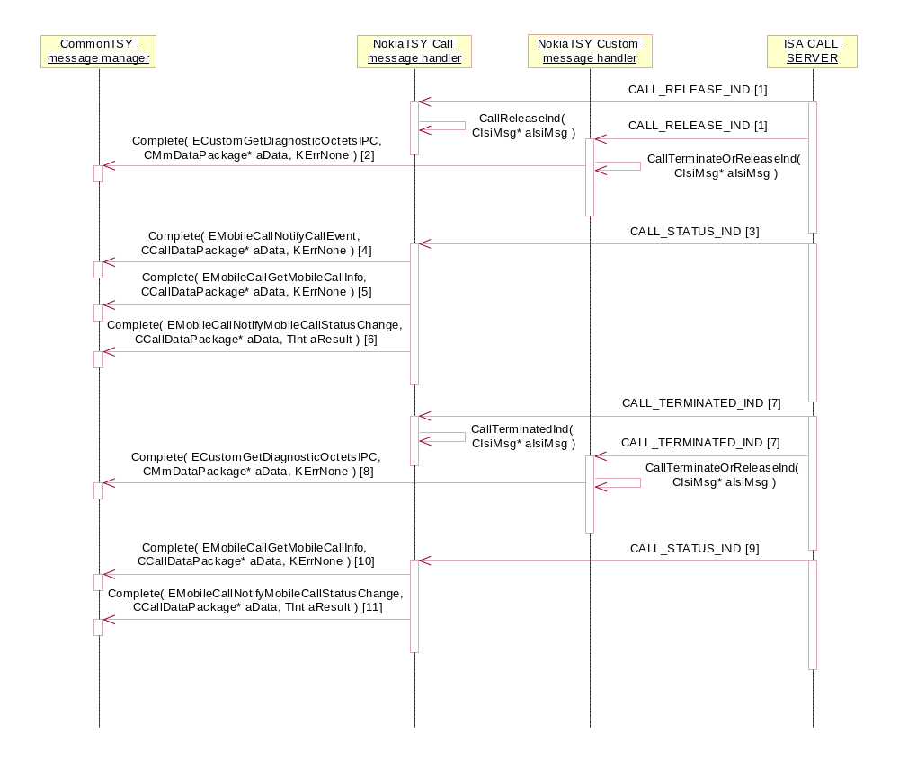
[1] CIsiMsg*
Call Id = x
Sub Block: CALL_CAUSE
Sub Block: CALL_RELEASE_INFO
+ Additional Sub Blocks
[2] CMmDataPackage*
aData.iPtr1: TInt*, call Id
aData.iPtr2: TUint8*, diagnostic octet
[3] CIsiMsg*
Call Id = x
Sub Block: CALL_STATUS = KCallStatusMtRelease
Sub Block: CALL_MODE = KCallModeSpeech
Sub Block: CALL_CAUSE
[4] CCallDataPackage*
aData.iCallId: x
aData.iCallMode: RMobilePhone::EVoiceService
aData.iPtr1: RMobileCall::TMobileCallEvent* = RMobileCall::ERemoteTerminated
[5] CCallDataPackage*
aData.iCallId: x
aData.iCallMode: RMobilePhone::EVoiceService
aData.iPtr1: RMobileCall::TMobileCallInfoV1*
[6] CCallDataPackage*
aData.iCallId: x
aData.iCallMode: RMobilePhone::EVoiceService
aData.iPtr1: RMobileCall::TMobileCallStatus* = RMobileCall::EStatusDisconnecting
- TInt aResult = release cause value
[7] CIsiMsg*
Call Id = x
Sub Block: CALL_MODE = KCallModeSpeech
Sub Block: CALL_CAUSE
+ Additional Sub Blocks
[8] CMmDataPackage*
aData.iPtr1: TInt*, call Id
aData.iPtr2: TUint8*, diagnostic octet
[9] CIsiMsg*
Call Id = x
Sub Block: CALL_STATUS = KCallStatusIdle
Sub Block: CALL_MODE = KCallModeSpeech
Sub Block: CALL_CAUSE
[10] CCallDataPackage*
aData.iCallId: x
aData.iCallMode: RMobilePhone::EVoiceService
aData.iPtr1: RMobileCall::TMobileCallInfoV1*
[11] CCallDataPackage*
aData.iCallId: x
aData.iCallMode: RMobilePhone::EVoiceService
aData.iPtr1: RMobileCall::TMobileCallStatus* = RMobileCall::EStatusIdle
- TInt aResult = release cause value

Video call interface
Creating a video call
Precondition: The phone MS is in the Idle state and connected to a network. There are no other calls.

GPRS and CSD operations

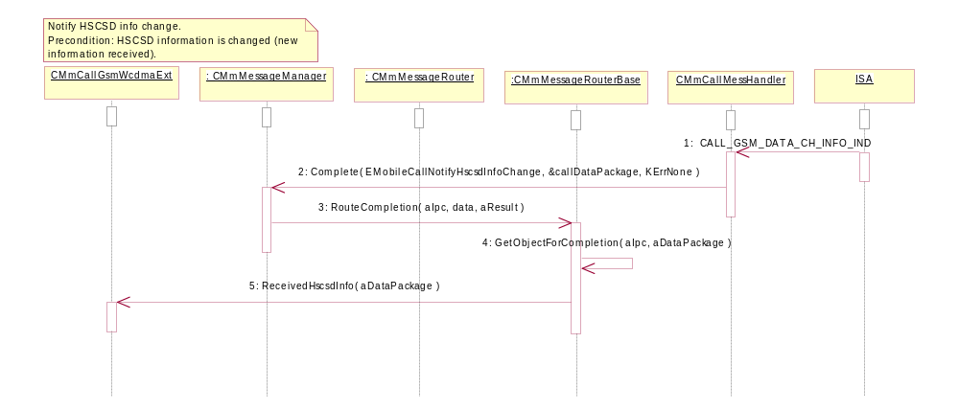
Figure Notify HSCSD info change

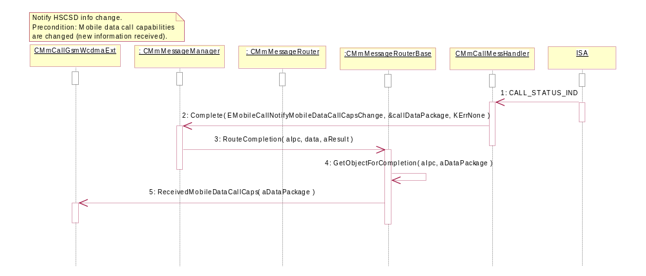
Figure Notify Mobile Data Call Caps Change

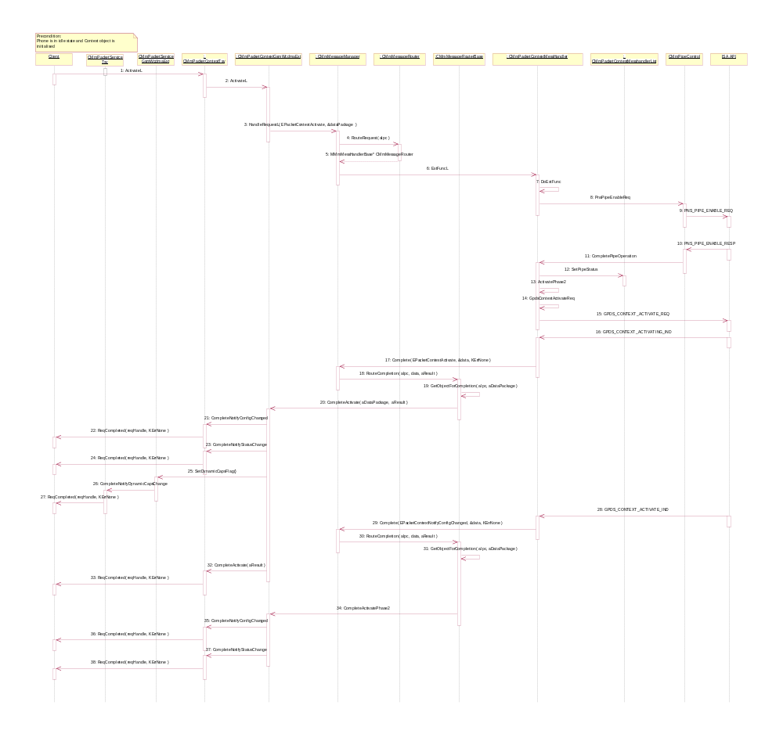
Figure Packet Context Activation

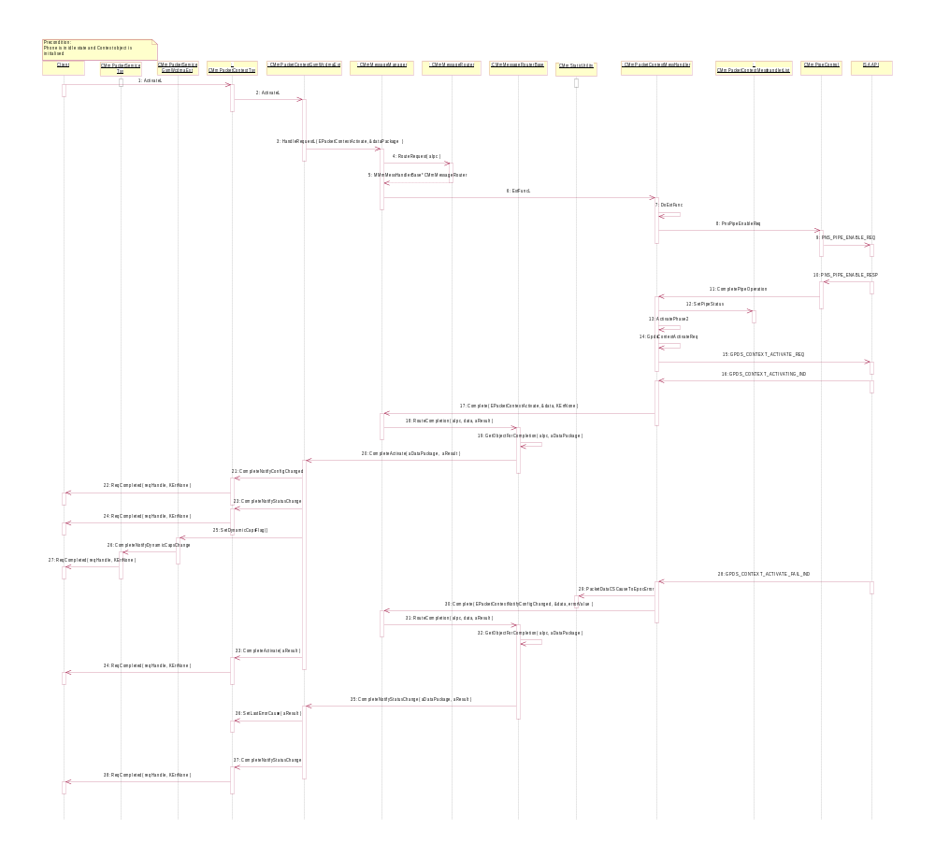
Figure Packet Context Activation Fail
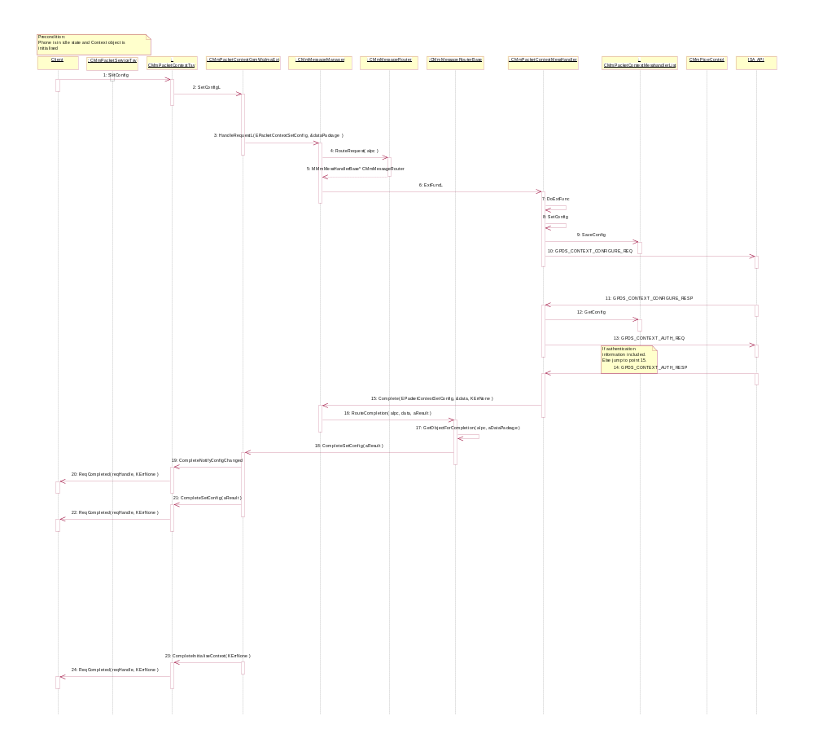
Packet Context Configuration

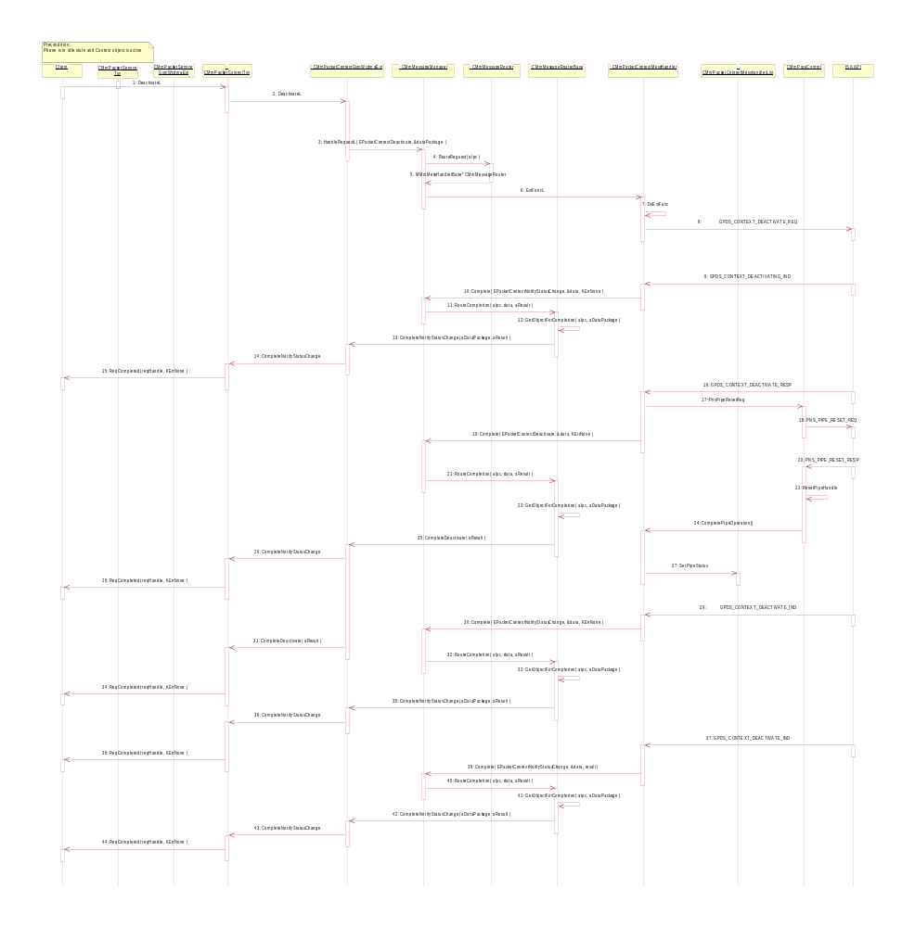
Figure Packet Context Deactivation

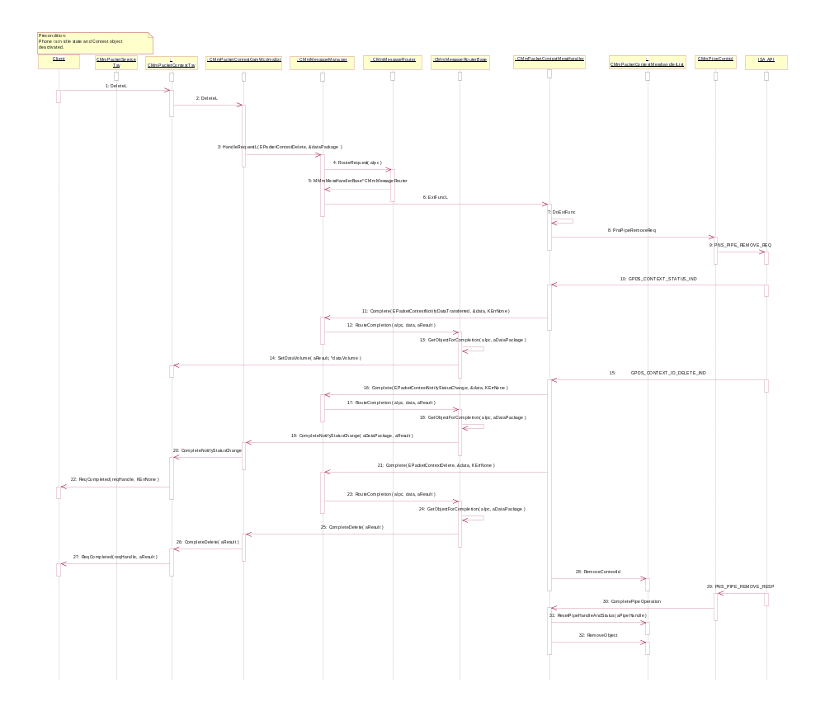
Figure Packet Context Deletion

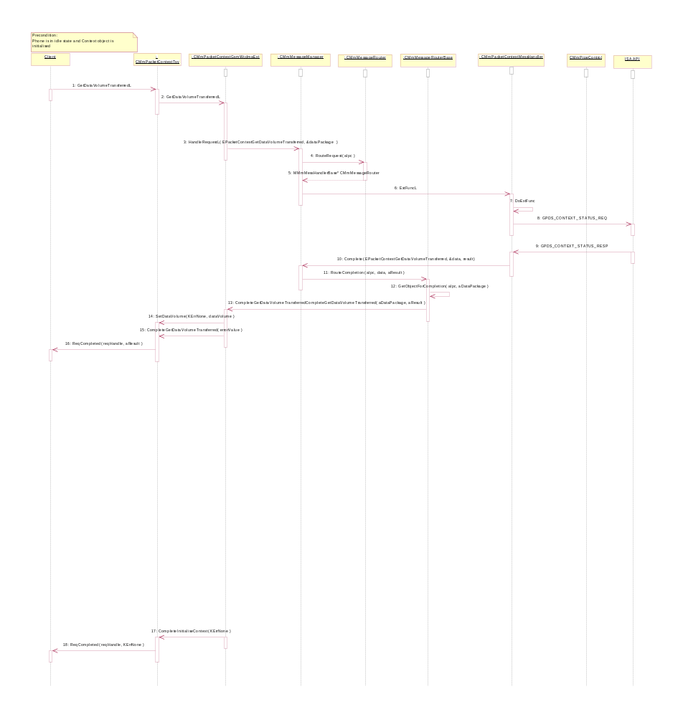
Figure Packet Context Get Data Volume Transferred

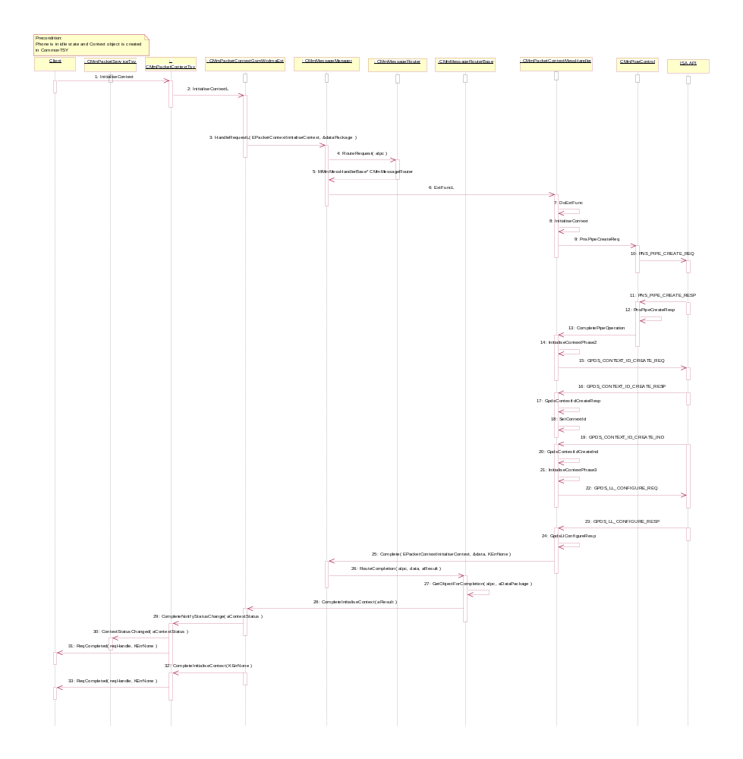
Figure Packet Context initialization

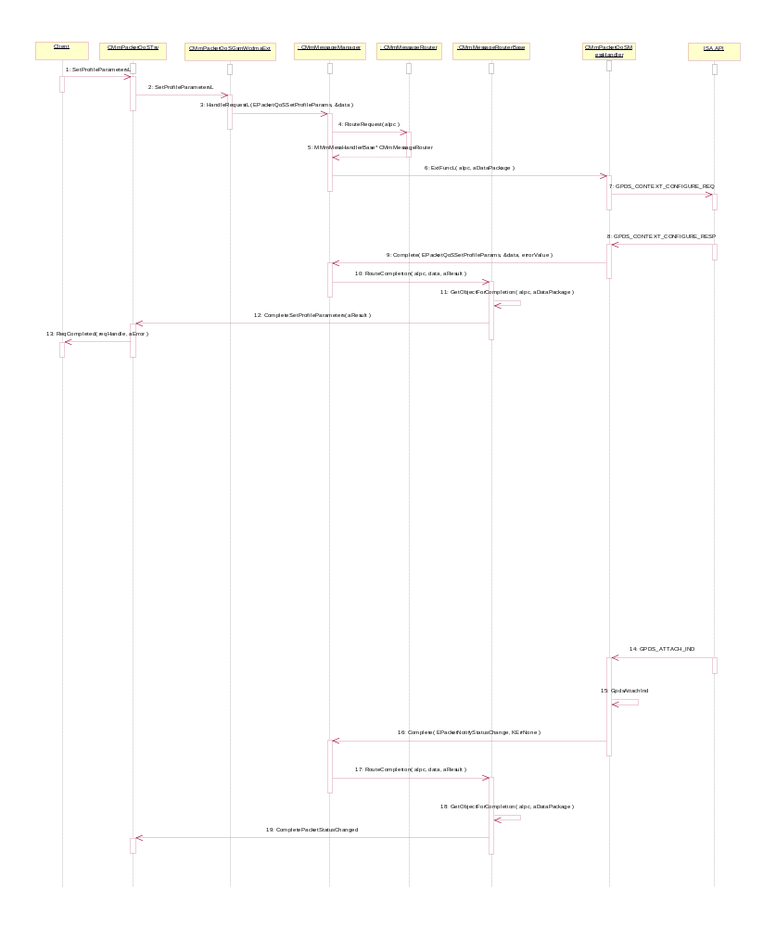
Figure Packet QoS Set Default Parameters

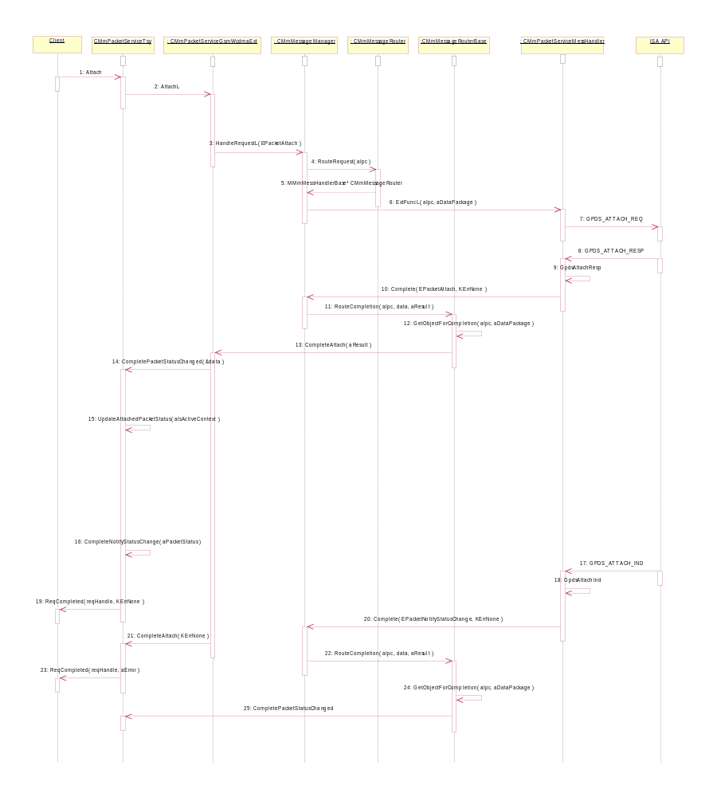
Figure Packet Service Attach

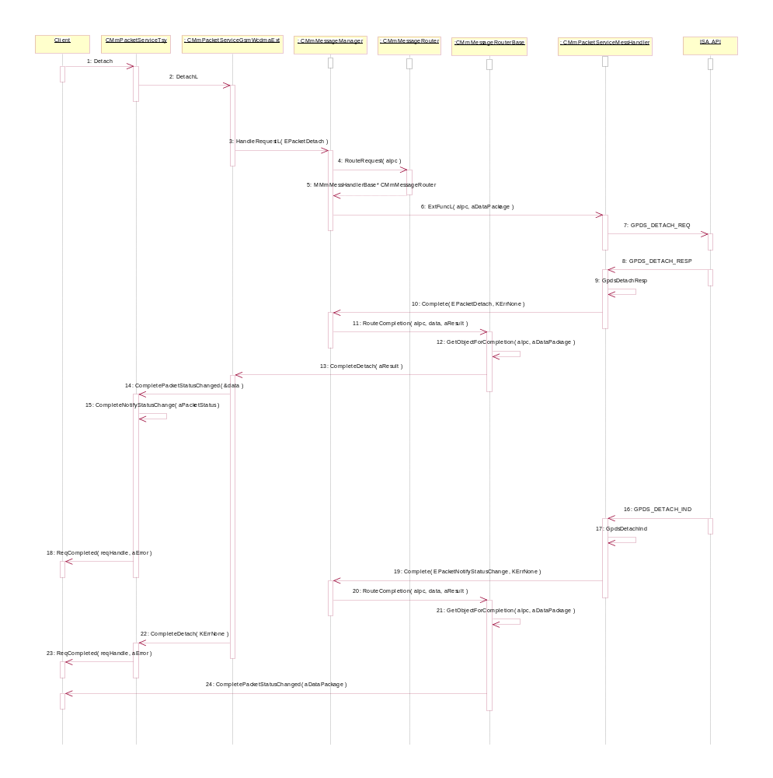
Figure Packet Service Detach

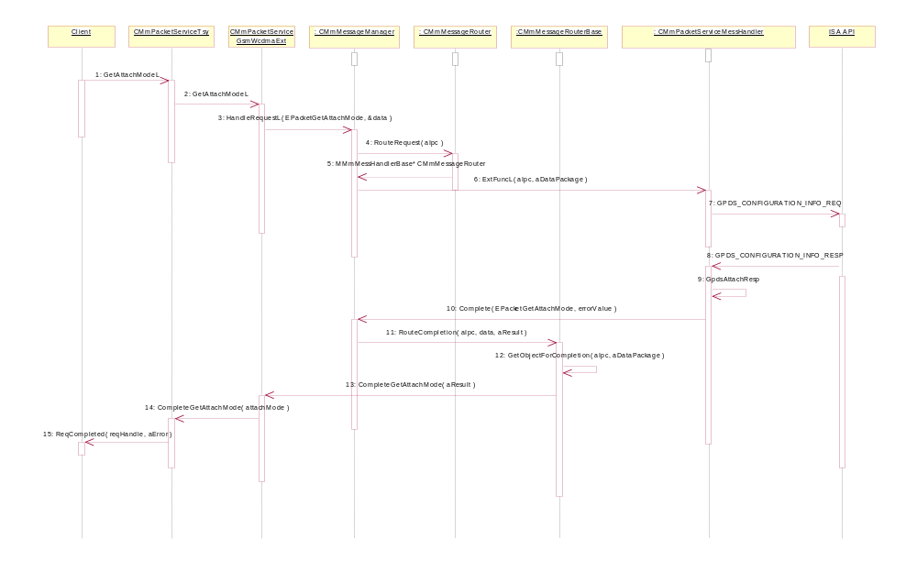
Figure Packet Service Get Attach Mode

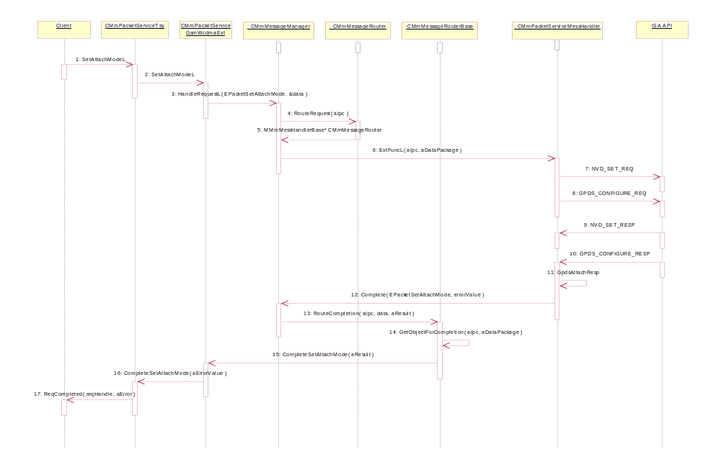
Figure Packet Servce Set Attach Mode

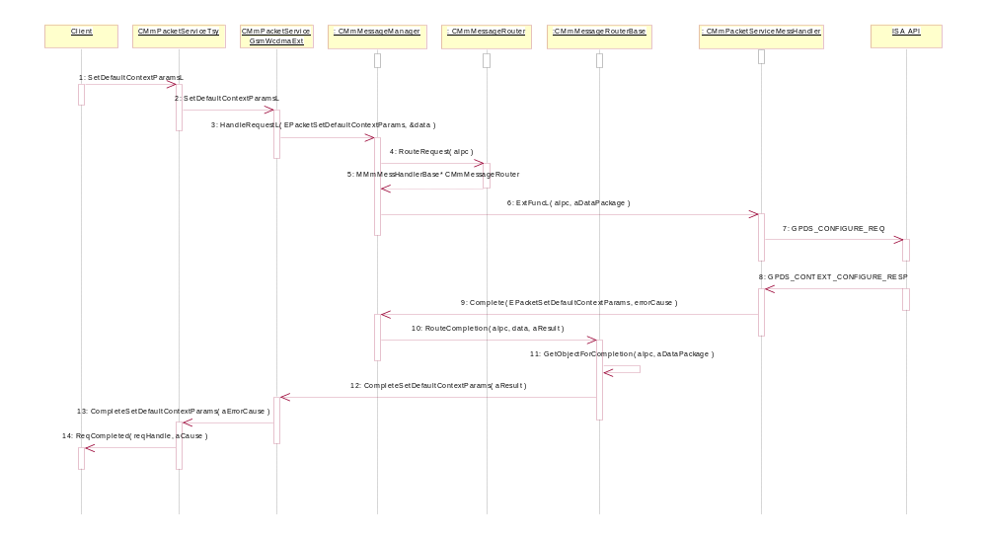
Figure Packet Service Set Default Context Parameters

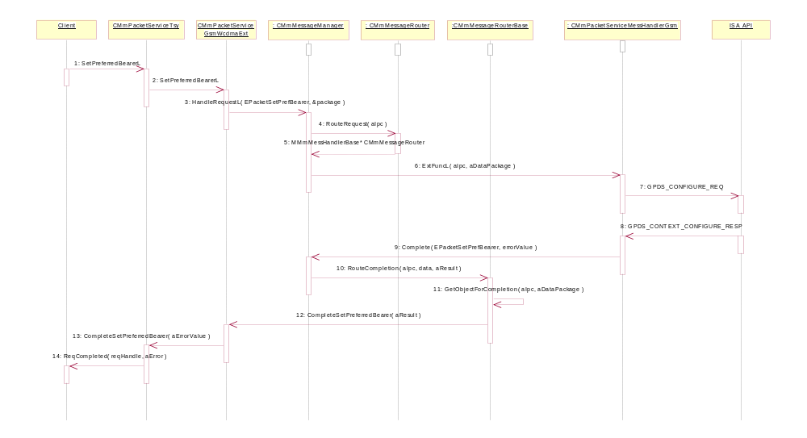
Figure Packet Service Set Preferred Bearer

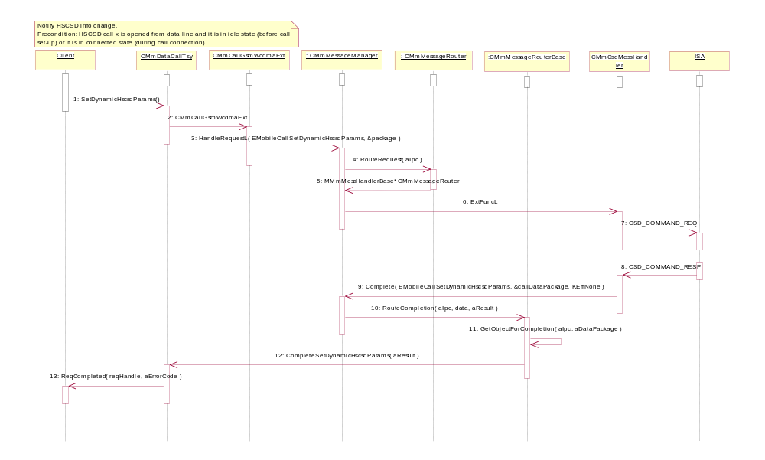
Figure Set Dynamic HSCSD Parameters

Network operations

Sequences for network selection and information handling.

Operation | Serving ETel API Request
Preconditions | TSY is loaded.
Description | There are seven different network request sequences. Most of them are network selection requests, couple canceling requests and network information requests.
Inputs | Here are enumerations for using with Net requests (defined in ETELMMCS.H code file):  EMobilePhoneGetDetectedNetworksV2Phase1  EMobilePhoneGetDetectedNetworksCancel  EMobilePhoneGetHomeNetwork  EMobilePhoneGetNetworkRegistrationStatus  EMobilePhoneSelectNetwork  EMobilePhoneSelectNetworkCancel  EMobilePhoneSetNetworkSelectionSetting
Modifies | NA
Outputs | CMmDataPackage and error code.
Postconditions | Request is served.
Related To | CMmMessageRouter, CMmNetMessHandler, CMmPhonetSender, CMmPhonetReceiver
Related Event | NA
Exceptions | The request fails. Client is notified about this.

Request parameters:

ExtFuncL(TInt aIpc, const CMmDataPackage* aDataPackage );
- TInt aIpc is the IPC value of request
- const CMmDataPackage* aDataPackage is the data package for request

IPC values:
- EMobilePhoneGetDetectedNetworksV2Phase1 is the IPC value for detected available networks. It is defined in Symbian's ETel server's ETELMMCS.H file.
  - aDataPackage: needed request data
- EMobilePhoneGetDetectedNetworksCancel is the IPC value for canceling network detection. It is defined in Symbian's ETel server's ETELMMCS.H file.
  - aDataPackage: cancelation information
- EMobilePhoneGetHomeNetwork is the IPC value for get home network. It is defined in Symbian's ETel server's ETELMMCS.H file.
  - aDataPackage: needed request data
- EMobilePhoneGetNetworkRegistrationStatus is the IPC value for get network registration status information. It is defined in Symbian's ETel server's ETELMMCS.H file.
  - aDataPackage: needed request data
- EMobilePhoneSelectNetwork is the IPC value for network selection operation. It is defined in Symbian's ETel server's ETELMMCS.H file.
  - aDataPackage: selected network information
- EMobilePhoneSelectNetworkCancel is the IPC value for canceling of network selection. It is defined in Symbian's ETel server's ETELMMCS.H file.
  - aDataPackage: cancelation information
- EMobilePhoneSetNetworkSelectionSetting is the IPC value for set network selection settings. It is defined in Symbian's ETel server's ETELMMCS.H file.
  - aDataPackage: networks selection setting information

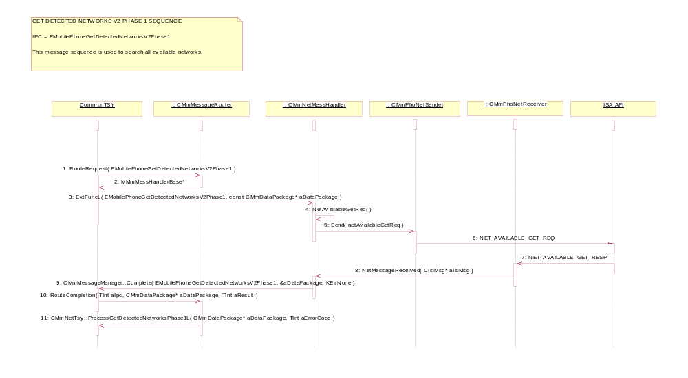
Figure xx Get Detected Networks V2 Phase 1 sequence

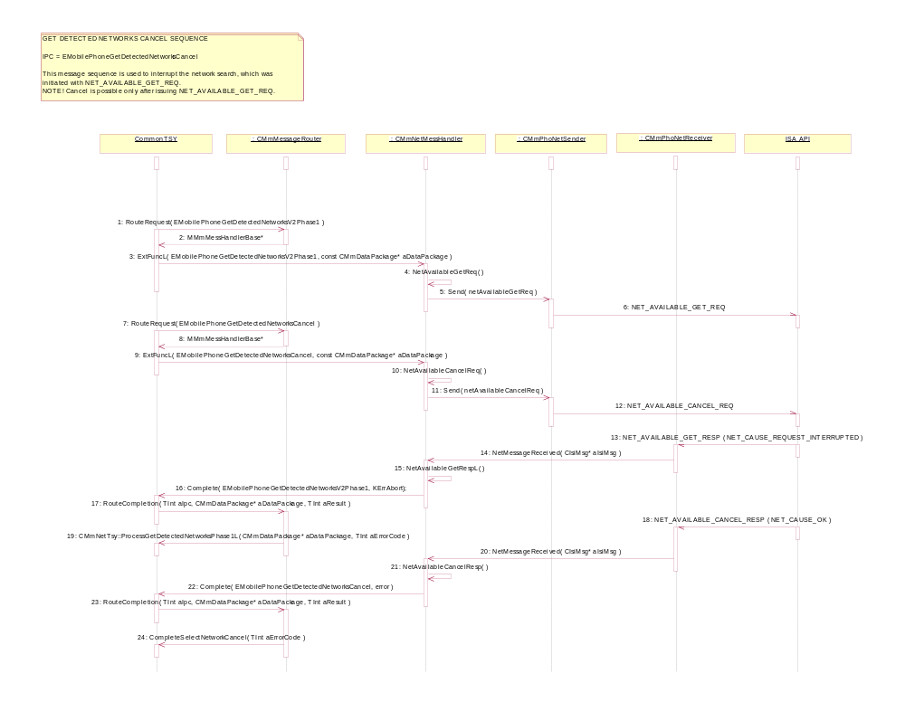
Figure 16 A Get Detected Networks Cancel sequence
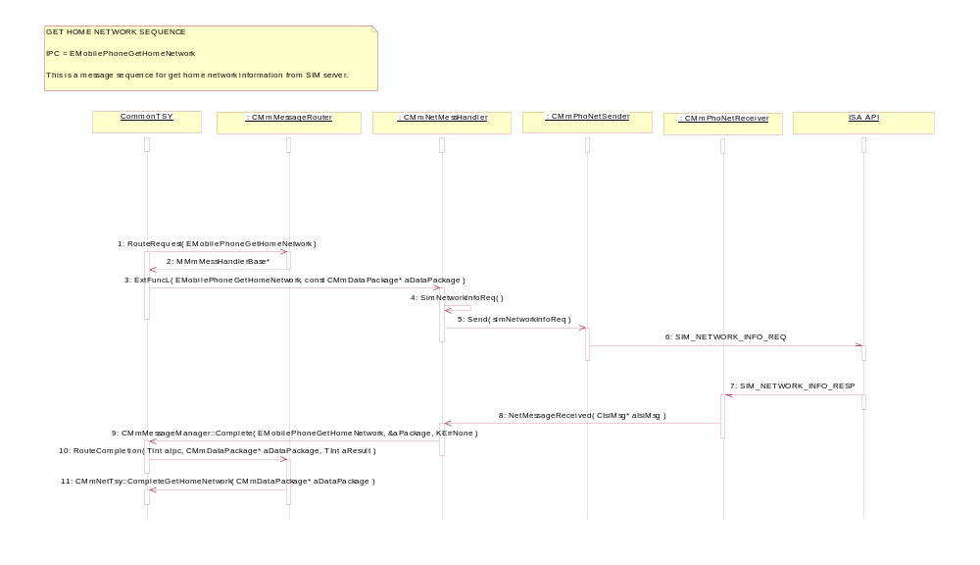
Figure 16 B Get Home Network sequece

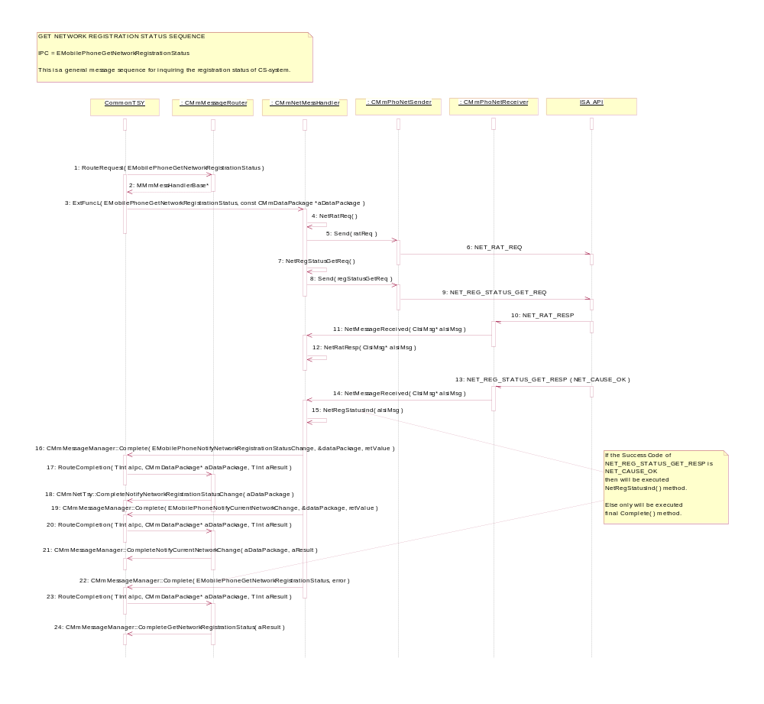
Figure 16 C Get Network Registration Status sequence

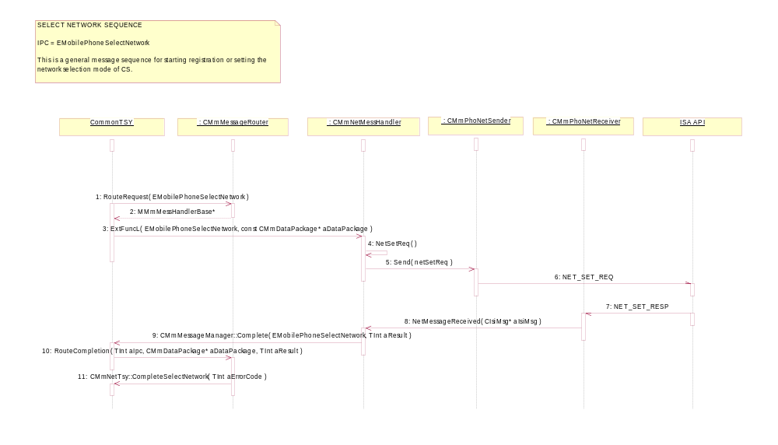
Figure 16 D Select Network sequence

CommonTSY
: CMmMessageRouter
: CMmNetMessHandler
: CMmPhoNetSender
: CMmPhoNetReceiver
ISA API
SELECT NETWORK CANCEL SEQUENCE
IPC = EMobilePhoneSelectNetworkCancel
This message sequence is used to cancel the NET_SET_REQ issued previously.
NOTE! It is possible to cancel only NET_SET_REQ requests where network selection mode is
NET_SELECT_MODE_MANUAL.
1: RouteRequest( EMobilePhoneSelectNetwork )
2: MMmMessHandlerBase*
3: ExtFuncL( EMobilePhoneSelectNetwork, const CMmDataPackage* aDataPackage )
4: NetSetReq( )
7: RouteRequest( EMobilePhoneSelectNetworkCancel )
8: MMmMessHandlerBase*
9: ExtFuncL( EMobilePhoneSelectNetworkCancel, const CMmDataPackage* aDataPackage )
10: NetSetCancelReq( )
5: Send( netSetReq )
6: NET_SET_REQ ( mode = manual )
11: Send( netSetCancelReq )
12: NET_SET_CANCEL_REQ
13: NET_SET_RESP ( NET_CAUSE_REQUEST_INTERRUPTED )
14: NetMessageReceived( CIsiMsg* aIsiMsg )
15: CMmMessageManager::Complete( EMobilePhoneSelectNetwork, NULL, KErrNone )
16: RouteCompletion( TInt aIpc, CMmDataPackage* aDataPackage, TInt aResult )
18: CMmNetTsy::CompleteSelectNetwork( aResult )
17: NET_SET_CANCEL_RESP ( NET_CAUSE_OK )
19: NetMessageReceived( CIsiMsg* aIsiMsg )
21: CMmMessageManager::Complete( EMobilePhoneSelectNetworkCancel, TInt aResult )
22: RouteCompletion( TInt aIpc, CMmDataPackage* aDataPackage, TInt aResult )
23: CMmNetTsy::CompleteSelectNetworkCancel( aResult )
20: NetSetCancelResp( CIsiMsg aIsiMsg )
Figure 16 E Select Network Cancel sequence

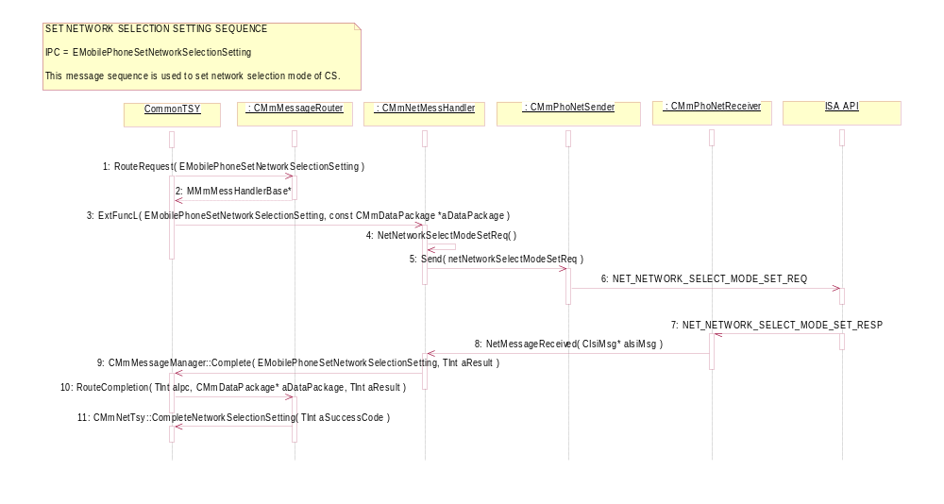
Figure 16 F Select Network Selection Setting sequence

SIM PhoneBook Store operations

Operation | Serving ETel API Request
Preconditions | TSY is loaded.
Description | There are eight different SIM phonebook handling requests. This are including phonebook storage handling and SIM card removal situation sequence is presented also.
Inputs | Here are enumerations for using with SIM phonebook requests:  EMmTsyPhoneBookStoreReadIPC  EMmTsyPhoneBookStoreWriteIPC  EMmTsyPhoneBookStoreGetInfoIPC  EMmTsyPhoneBookStoreDeleteIPC  EMmTsyPhoneBookStoreDeleteAllIPC  EMmTsyPhoneBookStoreCacheIPC  EMmTsyPhoneBookStoreInitIPC  EMmTsyPhoneBookStoreResetCacheIPC
Modifies | NA
Outputs | CMmDataPackage and error code.
Postconditions | Request is served.
Related To | CMmPhoneBookStoreMessHandler, CMmPhoNetSender, CMmPhoNetReceiver
Related Event | NA
Exceptions | The request fails. Client is notified about this.

Request parameters:

ExtFuncL(TInt aIpc, const CMmDataPackage* aDataPackage );
- TInt aIpc is the IPC value of request
- const CMmDataPackage* aDataPackage is the data package for request

IPC values:
- EMmTsyPhoneBookStoreReadIPC is the IPC value for read data from phonebook store. It is defined in Symbian's ETel server's ETELMMCS.H file.
  - aDataPackage: needed request data
- EMmTsyPhoneBookStoreWriteIPC is the IPC value for writing to phonebook store. It is defined in Symbian's ETel server's ETELMMCS.H file.
  - aDataPackage: write information to phonebook store
- EMmTsyPhoneBookStoreGetInfoIPC is the IPC value for get phobebook store info. It is defined in Symbian's ETel server's ETELMMCS.H file.
  - aDataPackage: needed request data
- EMmTsyPhoneBookStoreDeleteIPC is the IPC value for delete entry from phonebook store. It is defined in Symbian's ETel server's ETELMMCS.H file.
  - aDataPackage: deletion information
- EMmTsyPhoneBookStoreDeleteAllIPC is the IPC value for deletion of all entries from phonebook store. It is defined in Symbian's ETel server's ETELMMCS.H file.
  - aDataPackage: deletion information
- EMmTsyPhoneBookStoreCacheIPC is the IPC value for phonebook store caching. It is defined in Symbian's ETel server's ETELMMCS.H file.
  - aDataPackage: caching information
- EMmTsyPhoneBookStoreInitIPC is the IPC value for initialization of phonebook store. It is defined in Symbian's ETel server's ETELMMCS.H file.
  - aDataPackage: initialization information

SIM PhoneBook Indication
Indication completion occurs when SIM card is removed from phone.

Indication complete parametres:

Complete(TInt aIpc, const CMmDataPackage* aDataPackage, Tint aResult );
- TInt aIpc is the IPC value of completation
- const CMmDataPackage* aDataPackage is the data package for completation
- TInt aResult is result error value

IPC values:
- EMmTsyPhoneBookStoreResetCacheIPC is the IPC value for completation when SIM card removal situation. It is defined in Symbian's ETel server's ETELMMCS.H file.
  - aDataPackage: indication information

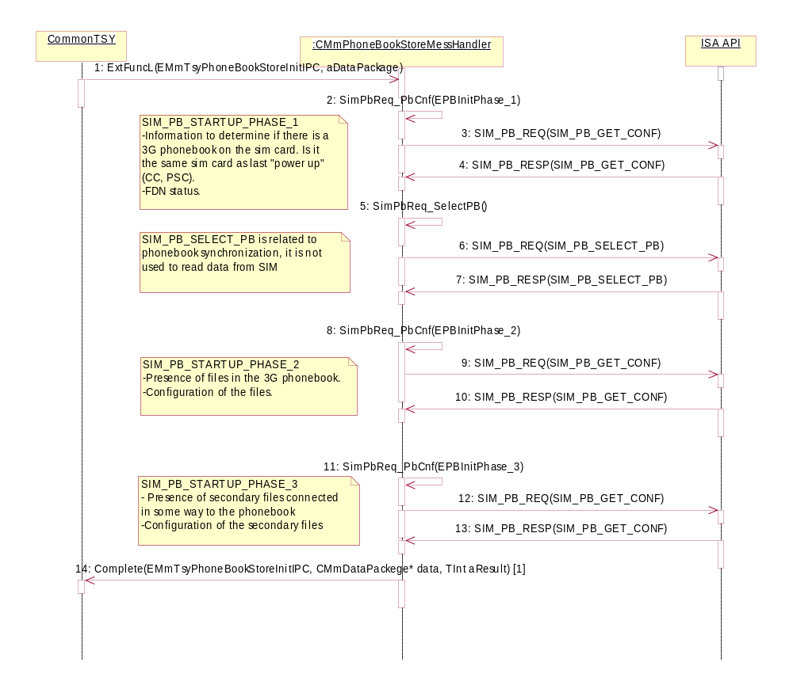
[1] aDataPackage.iPtr: CStorageInfoData*
Figure 17 A PhoneBook Store Init sequence

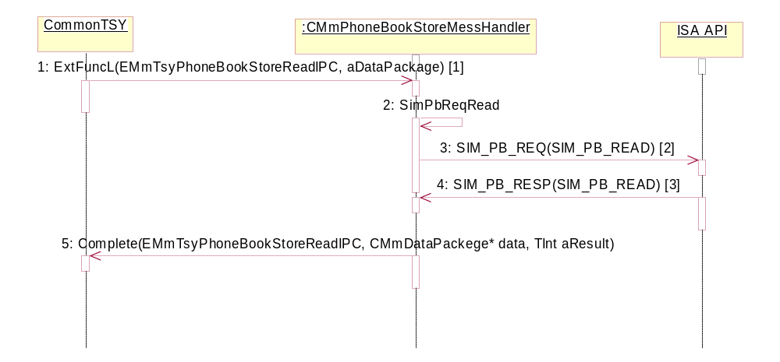
[1] aDataPackage.iPtr: CArrayPtrSeg<CPhoneBookStoreEntry>*
RMobilePhoneBookStore::TPBIndexAndNumEntries*
[2] SubBlocks: SIM_PB_INFO_REQUEST and SIM_PB_LOCATION
[3] SubBlocks: SIM_PB_STATUS and SubBlock for every requested file if it is present on the sim card.
Figure 17 B PhoneBook Store Read sequence

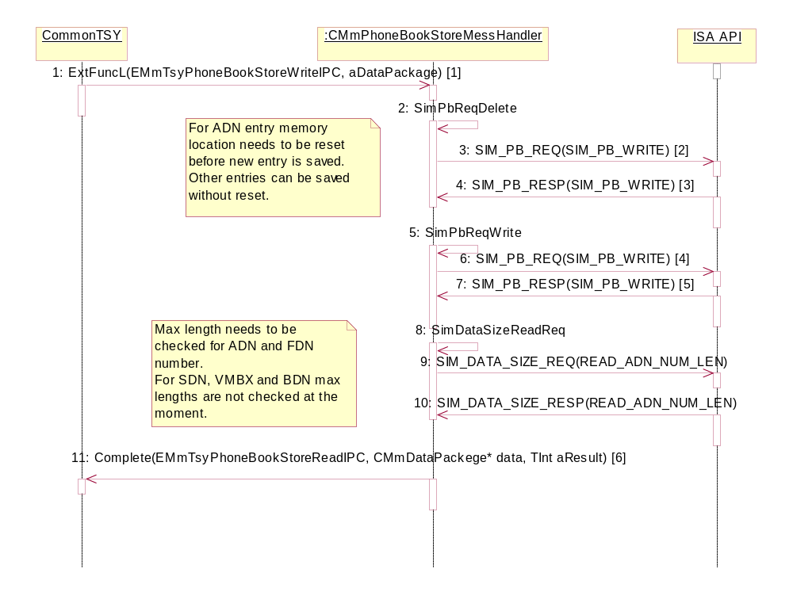
[1] aDataPackage.iPtr: TInt (index)
CPhoneBookStoreEntry*
[2] SubBlock: SIM_PB_DELETE_LOCATION
[3] SubBlock: SIM_PB_STATUS
[4] SubBlock for every file requested to be written to the sim card.
[5] SubBlocks: SIM_PB_STATUS and SIM_PB_LOCATION
[6] data.iPtr: TInt (index)
Figure 17 C PhoneBook Store Write sequence

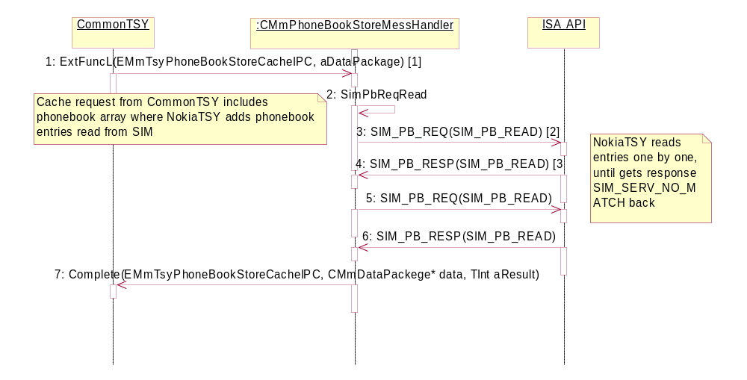
[1] aDataPackage.iPtr: CArrayPtrSeg<CPhoneBookStoreEntry>*
[2] SubBlocks: SIM_PB_INFO_REQUEST and SIM_PB_LOCATION_SEARCH, the key word SIM_PB_FIRST is used as location when first entry is read.
[3] SubBlock: SIM_PB_STATUS and SubBlock for every requested file if it is present on the sim card.
Figure 17 D PhoneBook Store Cache sequence

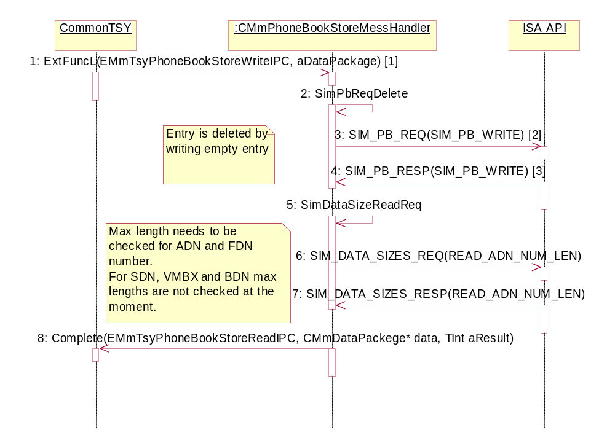
[1] aDataPackage.iPtr: TInt(index)
[2] SubBlock: SIM_PB_DELETE_LOCATION
[3] SubBlock: SIM_PB_STATUS
Figure 17 E PhoneBook Store Delete sequence

[1] SubBlock: SIM_PB_DELETE_ALL
Figure 17 F PhoneBook Store Delete All sequence

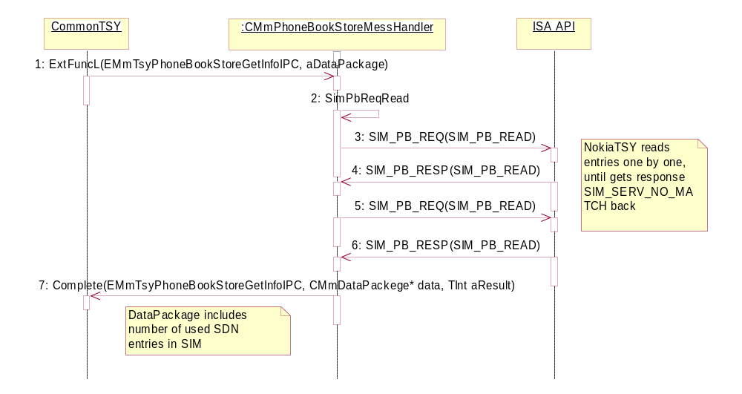
[]data.iPtr: TInt (countedEntries)
Figure 17 G PhoneBook Store Get Info sequence

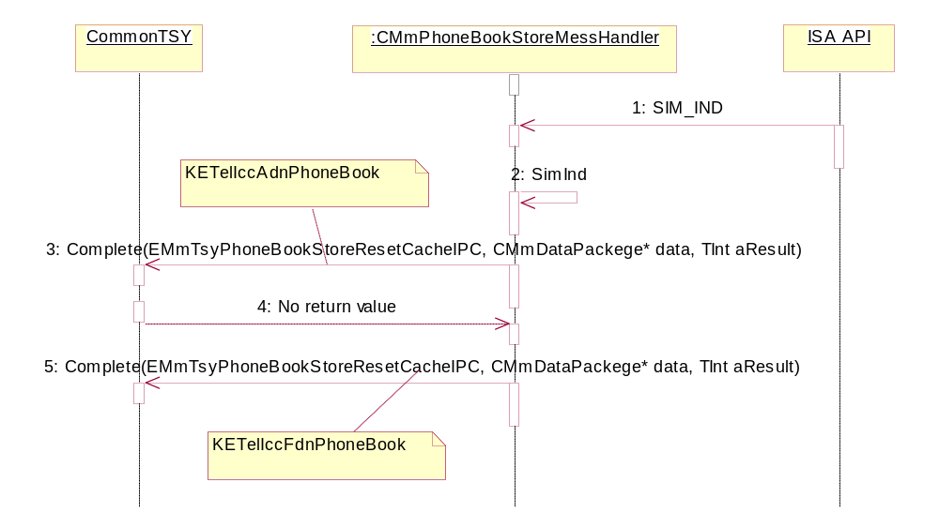

Figure 17 H SIM Card Remove Indication sequence

CustomAPI operations

Operation | Serving CustomAPI Request
Preconditions | RMmCustomAPI subsession is opened and TSY is loaded.
Description | Custom requests are done through CustomAPI. Client calls CustomAPI which in turn calls etel with Set, Get, SetAndGet or Blank function. Etel forwards the request to tsy.  Most of the requests are handled in CmmCustomMessHandler but there are a few exceptions.  Many of below listed operations are available in both synchronous and asynchronous version.
Inputs | ExtFunc(TInt const TTsyReqHandle aTsyReqHandle, const Tint aIpc,const TDataPackage& aPackage);  Tint const TtsyReqHandle aTsyReqHandle is the request handle for the request.  TInt const aIpc is the IPC value of the request.  const CMmDataPackage* aPackage is the data package for the request.
Modifies | NA
Outputs | CMmDataPackage and/or error code.
Postconditions | Request is served.
Related To | CMmMessageRouter, CMmDtmfMessHandler, CmmSmsMessHandler, CMmCustomMessHandler, CMmPhoNetSender, CMmPhoNetReceiver, CMmPhonetSender
Related Event | NA
Exceptions | The request fails. Client is notified about this.

IPC values:
- ECustomNotifyDtmfEventIPC is the IPC value for a function that allows a client to be notified when the DTMF phase of a call has begun and completed. It is defined in CustomAPI’s RMmCustomAPI.h file.
- aPackage. iPtr1: DTMF information
- ECustomGetDiagnosticOctetsIPC is the IPC value of a function that gets the Diagnostics octets of a given call. It is defined in CustomAPI’s RMmCustomAPI.h file.
- aPackage.iPtr1: Name of the Call
- aPackage.iPtr2: Diagnostic octets
- ECustomGetRemoteAlertingToneStatusIPC is the IPC value for a function that reads the remote alerting tone status. It is defined in CustomAPI’s RMmCustomAPI.h
- aTsyReqHandle: Request handle for the request
- aPackage.iPtr1: Status
- ECustomCallOriginIPC is the IPC value for a function that returns the origin of the call, defined by aCallName parameter. It is defined in CustomAPI’s RMmCustomAPI.h
- aTsyReqHandle: Request handle for the request
- aPackage.iPtr1: Name of the Call
- aPackage.iPtr2: Origin of the Call
- ECustomTerminateCallIPC is the IPC value for a function that terminates a given call or all the ongoing calls based in the value of aCallName. It is defined in CustomAPI’s RMmCustomAPI.h
- aTsyReqHandle: Request handle for the request
- aPackage.iPtr1: Name of the Call
- ECustomGetAlsBlockedIPC is the IPC value for a function that returns the alternating line service block status. It is defined in CustomAPI’s RMmCustomAPI.h
- aTsyReqHandle: Request handle for the request
- aPackage.iPtr1: Status of ALS Block
- ECustomSetAlsBlockedIPC is the IPC value for for a function that sets the ALS block status. It is defined in CustomAPI’s RMmCustomAPI.h
- aTsyReqHandle: Request handle for the request
- aPackage.iPtr1: Status of ALS Block
- ECustomNotifyAlsBlockedChangedIPC is the IPC value for a function that informs client of changed ALS blocked status. It is defined in CustomAPI’s RMmCustomAPI.h
- aPackage.iPtr1: Status of ALS Block
- ECustomCheckAlsPpSupportIPC is the IPC value for a function that returns ALS Pp support state. It is defined in CustomAPI’s RMmCustomAPI.h
- aTsyReqHandle: Request handle for the request
- aPackage.iPtr1: ALS Support Status
- ECustomGetCipheringInfoIPC is the IPC value for a function that gets the ciphering info. It is defined in CustomAPI’s RMmCustomAPI.h
- aTsyReqHandle: Request handle for the request
- aPackage.iPtr1: Ciphering information
- ECustomNotifyCipheringInfoChangeIPC is the IPC value for a function that notifies client of ciphering info change. It is defined in CustomAPI’s RMmCustomAPI.h
- aPackage.iPtr1: Ciphering information
- ECustomNotifyNSPSStatusIPC is the IPC value for a function that notifies client of a change in No Service Power Save status. It is defined in CustomAPI’s RMmCustomAPI.h
- aPackage.iPtr1: Network Service Status
- ECustomNetWakeupIPC is the IPC value for a function that wakes up the net from No Service Power Save state. It is defined in CustomAPI’s RMmCustomAPI.h
- aTsyReqHandle: Request handle for the request.
Figure 18 A ECustomNetWakeupIPC request sequence as an example of ‘Blank’ function.
CustomAPI
Etel
CMmCusto
mTsy
CMmMessa
geRouter
CMmMessa
geRouter
CMmMessa
geManager
CMmMessa
geManager
CMmCustomMes
sHandler
CMmCustomMes
sHandler
CMmCustomMes
sHandler
CMmCustomMes
sHandler
CMmPhonet
Sender
CMmPhonet
Reciver
ISA API
2: NetWakeup()
3: RouteRequest( const TInt )
4: return MMmMessHandlerBase*
5: ExtFuncL( TInt , const CMmDataPackage* )
6: NetCsWakeupReq( TUint8 aTransId )
7: Send( CNetIsiMsg )
8: NET_CS_WAKEUP_REQ
9: return TInt
10: return TInt
11: return TInt
12: return KErrNone
13: NET_CS_WAKEUP_RESP
14: SpecificCustomMessageReceivedL( CIsiMsg* )
15: NetCsWakeupResp( CIsiMsg* )
1: Blank()
16: Complete( TUint8, TInt )
17: Complete( TUint8, CMmDataPackage*, TInt)
18: RouteCompletion(TUint8, CMmDataPackage*, TInt)
19: CompleteNetWakeup(TInt)
20: ReqCompleted(TTsyReqHandle, TInt)
- ECustomClearCallBlackListIPC is the IPC value for a function that clears call blacklist. It is defined in CustomAPI’s RMmCustomAPI.h
- aTsyReqHandle: Request handle for the request.
- ECustomSsAdditionalInfoNotificationIPC is the IPC value for a function that requests additionalinfo message. It is defined in CustomAPI’s RMmCustomAPI.h
- aPackage.iPtr1: SS additional information
- ECustomGetAirTimeDurationIPC is the IPC value for a function that gets air time duration. It is defined in CustomAPI’s RMmCustomAPI.h
- aTsyReqHandle: Request handle for the request.
- aPackage.iPtr1: Air duration time
- ECustomCheckEmergencyNumberIPC is the IPC value for a function that checks if a number is an emergency number with given method . It is defined in CustomAPI’s RMmCustomAPI.h
- aTsyReqHandle: Request handle for the request.
- aPackage.iPtr1: Number and check mode
- aPackage.iPtr2: Result of check
- ECustomGetNetworkProviderNameIPC is the IPC value for a function that gets the network name for sim card. It is defined in CustomAPI’s RMmCustomAPI.h
- aTsyReqHandle: Request handle for the request.
- aPackage.iPtr1: Network Operator Name
- ECustomCheckTwoDigitDialSupportIPC is the IPC value for a funtcion that checks two digit dialing support from Product Profile. It is defined in CustomAPI’s RMmCustomAPI.h
- aTsyReqHandle: Request handle for the request.
- aPackage.iPtr1: Two digit dialing support status
- ECustomNotifyPndCacheReadyIPC is the IPC value for a function that notifies client when phonebook caching is ready. It is defined in CustomAPI’s RMmCustomAPI.h
- aTsyReqHandle: Request handle for the request.
- aPackage.iPtr1: Phonebookname
- ECustomGetPndCacheStatusIPC is the IPC value for a function that gets the current status of caching. It is defined in CustomAPI’s RMmCustomAPI.h
- aTsyReqHandle: Request handle for the request.
- aPackage.iPtr1: Caching status
- aPackage.iPtr2: Phonebookname
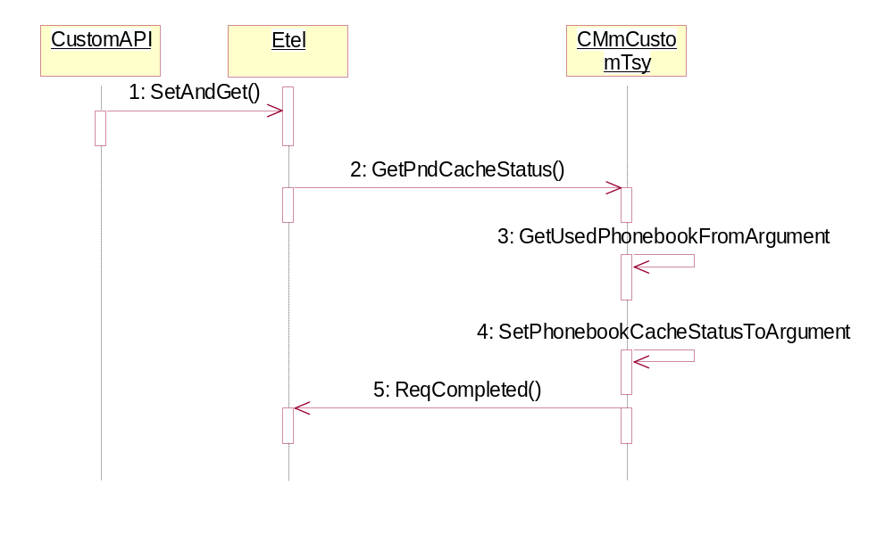Figure 18 B ECustomGetPndCacheStatusIPC request sequence as an example of ‘SetAndGet’ function.
- ECustomGetOperatorNameIPC is the IPC value for a function that gets the operator name of the current network. It is defined in CustomAPI’s RMmCustomAPI.h
- aTsyReqHandle: Request handle for the request.
- aPackage.iPtr1: Name type
- aPackage.iPtr2: Operator name info
- ECustomNotifySsNetworkEventIPC is the IPC value for a function that notifies client of different network generated SS events. It is defined in CustomAPI’s RMmCustomAPI.h
- aPackage.iPtr1: SS type and Mode
- aPackage.iPtr2: SS information
- ECustomGetProgrammableOperatorLogoIPC is the IPC value for a function that gets the programmable operator logo and operator id of the current network. It is defined in CustomAPI’s RMmCustomAPI.h
- aTsyReqHandle: Request handle for the request.
- aPackage.iPtr1: Operator info
- aPackage.iPtr2: Logo Info
- ECustomSatRefreshCompleteNotificationIPC is the IPC value for a function that notifies client of SAT refresh. It is defined in CustomAPI’s RMmCustomAPI.h
- No parameters.
- ECustomResetNetServerIPC is the IPC value for a function that resets net server. It is defined in CustomAPI’s RMmCustomAPI.h
- aTsyReqHandle: Request handle for the request.
- ECustomNotifyNetworkConnectionFailureIPC is the IPC value for a function that notifies of a network connection failure. It is defined in CustomAPI’s RMmCustomAPI.h
- No parameters.
- ECustomGetSystemNetworkModesIPC is the IPC value for a funftion that reads all network system modes. It is defined in CustomAPI’s RMmCustomAPI.h
- aTsyReqHandle: Request handle for the request.
- aPackage.iPtr1: Network modes
- ECustomSetSystemNetworkModeIPC is the IPC value for a function that sets network mode. It is defined in CustomAPI’s RMmCustomAPI.h
- aTsyReqHandle: Request handle for the request.
- aPackage.iPtr1: Network mode caps.
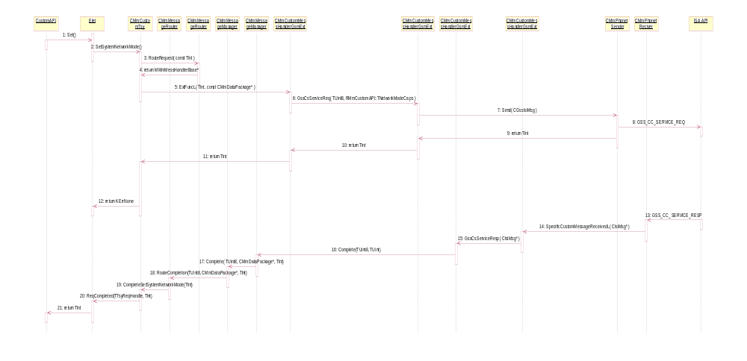 Figure 18 C ECustomSetSystemNetworkModeIPC request sequence as an example of‘Set’ function.
- ECustomGetCurrentSystemNetworkModesIPC is the IPC value for a function that reads current network system modes. It is defined in CustomAPI’s RMmCustomAPI.h
- aTsyReqHandle: Request handle for the request.
- aPackage.iPtr1: Network mode
- ECustomNotifySsRequestCompleteIPC is the IPC value for a function that notifies client of the success of the sended SS command. It is defined in CustomAPI’s RMmCustomAPI.h
- aPackage.iPtr1: SS status
- ECustomGetLifeTimeIPC is the IPC value for a function that gets Life Time. It is defined in CustomAPI’s RMmCustomAPI.h
- aTsyReqHandle: Request handle for the request.
- aPackage.iPtr1: Life timer information Pckg
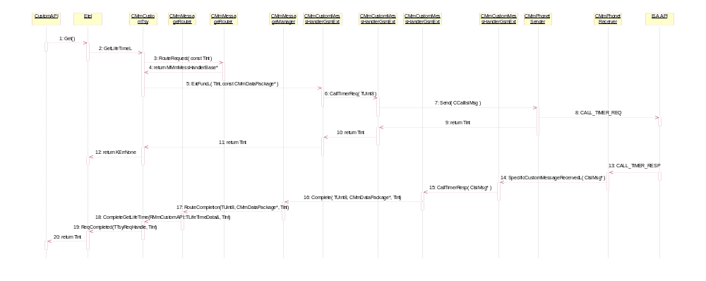 Figure 18 D ECustomGetLifeTimeIPC request sequence as an example of ‘Get’ function.
- ECustomReadSimFileIPC is the IPC value for a function that reads information from the SIM file specified in aPackage.iPtr2. It is defined in CustomAPI’s RMmCustomAPI.h
- aTsyReqHandle: Request handle for the request.
- aPackage.iPtr1: Packaged sim file information
- aPackage.iPtr2: Buffer to hold the sim file info
- EGet3GPBInfoIPC is the IPC value for a function that gets next Cell Broadcast Id. It is defined in CustomAPI’s RMmCustomAPI.h
- aTsyReqHandle: Request handle for the request.
- aPackage.iPtr1: 3G phonebook info
- ECustomSetSimMessageStatusReadIPC is the IPC value for a function that sets SIM SMS storage status to “read”. It is defined in CustomAPI’s RMmCustomAPI.h
- aTsyReqHandle: Request handle for the request.
- aPackage.iPtr1: Time
- aPackage.iPtr2: Timezone difference

CustomApiExt operations
CustomAPIExt implementation is implemented in NokiaTSY class CMmCustomNokiaExt class. CommonTSY side CustomAPI object routes all unkown IPCs in custom IPC range to NokiaTSY CMmCustomNokiaExt, which may implement them.

Operation | Serving CustomApiExt Request
Preconditions | CustomApiExt subsession is opened and TSY is loaded.
Description | CustomApiExt requests are done through CustomApiExt. As the name implies CustomApiExt is an extension to CustomAPI so the functionality is same when using CustomAPI.
Inputs | ExtFunc(TInt const TTsyReqHandle aTsyReqHandle, const Tint aIpc,const TDataPackage& aPackage);  - Tint const TtsyReqHandle aTsyReqHandle is the request handle for the request.  TInt const aIpc is the IPC value of the request.  const CMmDataPackage* aPackage is the data package for the request.
Modifies | NA
Outputs | CMmDataPackage and/or error code.
Postconditions | Request is served.
Related To | CustomAPI, CMmMessageRouter, CMmCustomMessHandler, CMmPhonetReceiver, CMmPhonetSender
Related Event | NA
Exceptions | The request fails. Client is notified about this.

IPC values:
- ECustomNotifySmsMessageArrivedIPC is the IPC value for a function that notifies client when SMS message is received from network. It is defined in RMmCustomApiExt.h.
- aTsyReqHandle: Request handle for the request.
- ECustomNotifySimSmsMemoryWarningIndIPC is the IPC value for a function that notifies client that free space left in SIM SMS memory has dropped below warning level. It is defined in RMmCustomApiExt.h.
- No parameters.
- ECustomNotifySimSmsMemoryCapacityExceededIndIPC is the IPC value for a function that notifies client that SIM SMS memory is full. It is defined in RMmCustomApiExt.h.
- No parameters.
- ECustomNotifySimSmsEraseIndIPC is the IPC value for a function that notifies client that Class2 SMS message has been deleted from SIM card. It is defined in RMmCustomApiExt.h.
- No parameters.
- ECustomSetSimConnectionIPC is the IPC value for a function that sends SIM connection or disconnection request to DOS. It is defined in RMmCustomApiExt.h.
- aTsyReqHandle: Request handle for the request.
- aPackage. iPtr1: Sim connection status.
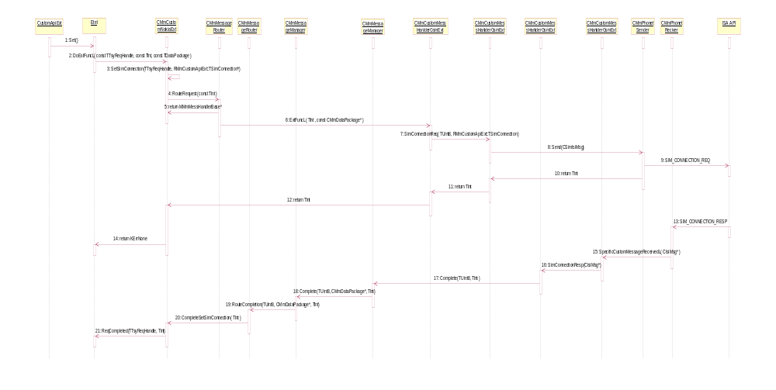
Figure 19 A ECustomSetSimConnectionIPC sequence as an example of ‘Set’ function done through CustomApiExt.
- ECustomNotifyMultimediaDataRateChangeIPC is the IPC value for a function that notifies client when multimedia call data range changes message is received from CSD. It is defined in RMmCustomApiExt.h.
- aPackage.iPtr1: Data rate in bits/s.

Network Detection and Operator Namelist handling

Operation | Serving ETel API Request
Preconditions | TSY is loaded.
Description | There are three different network detection handling requests and one indication concerning current network change. All these requests and indication are having some kind of operator information too. Information can be the actual operator information or data which can be used to send a query to NET Server to get the desired information.
Inputs | Here are enumerations for using with network detection requests:  EMobilePhoneGetDetectedNetworksV2Phase1 and CMmDataPackage  EMobilePhoneGetNetworkRegistrationStatus and CMmDataPackage  EMobilePhoneGetHomeNetwork and CMmDataPackage  ECustomGetOperatorNameIPC and CMmDataPackage
Modifies | NA
Outputs | EMobilePhoneGetDetectedNetworksV2Phase1 and CMmDataPackage  EMobilePhoneGetNetworkRegistrationStatus  EMobilePhoneNotifyNetworkRegistrationStatusChange and CMmDataPackage  EMobilePhoneNotifyNetworkSelectionSettingChange and CMmDataPackage  EMobilePhoneNotifyCurrentNetworkChange and CMmDataPackage  EMobilePhoneGetHomeNetwork and CMmDataPackage  ECustomGetOperatorNameIPC and CMmDataPackage
Postconditions | Request is served.
Related To | NA
Related Event | NA
Exceptions | The request fails. Client is notified about this.

Request parameters:

ExtFuncL(TInt aIpc, const CMmDataPackage* aDataPackage );
- TInt aIpc is the IPC value of request
- const CMmDataPackage* aDataPackage is the data package for request

IPC values:
- EMobilePhoneGetDetectedNetworksV2Phase1 is the IPC value to get the detected networks. It is defined in Symbian's ETel server's ETELMMCS.H file.
  - aDataPackage: needed request data
- EMobilePhoneGetNetworkRegistrationStatus is the IPC value to get the network registration status. It is defined in Symbian's ETel server's ETELMMCS.H file.
  - aDataPackage: write information to phonebook store
- EMobilePhoneGetHomeNetwork is the IPC value to get home network. It is defined in Symbian's ETel server's ETELMMCS.H file.
  - aDataPackage: needed request data
- ECustomGetOperatorNameIPC is the IPC value to get operator name. It is defined in Symbian's ETel server's ETELMMCS.H file.
  - aDataPackage: needed request data

Indication complete parametres:

Complete(TInt aIpc, const CMmDataPackage* aDataPackage, Tint aResult );
- TInt aIpc is the IPC value of completation
- const CMmDataPackage* aDataPackage is the data package for completation
- TInt aResult is result error value

IPC values:
- EMobilePhoneGetDetectedNetworksV2Phase1 is the IPC value for completation detected networks getting. It is defined in Symbian's ETel server's ETELMMCS.H file.
  - aDataPackage: indication information

- EMobilePhoneGetNetworkRegistrationStatus is the IPC value for completation network registration status getting. It is defined in Symbian's ETel server's ETELMMCS.H file.
- EMobilePhoneNotifyNetworkRegistrationStatusChange is the IPC value for completation network registration status change. It is defined in Symbian's ETel server's ETELMMCS.H file.
  - aDataPackage: indication information
- EMobilePhoneNotifyNetworkSelectionSettingChange is the IPC value for completation network selection setting change. It is defined in Symbian's ETel server's ETELMMCS.H file.
  - aDataPackage: indication information
- EMobilePhoneNotifyCurrentNetworkChange is the IPC value for completation network selection setting change. It is defined in Symbian's ETel server's ETELMMCS.H file.
  - aDataPackage: indication information
- EMobilePhoneGetHomeNetwork is the IPC value for completation home network getting. It is defined in Symbian's ETel server's ETELMMCS.H file.
  - aDataPackage: indication information
- ECustomGetOperatorNameIPC is the IPC value for completation operator name getting. It is defined in Symbian's ETel server's ETELMMCS.H file.
  - aDataPackage: indication information

Operator Namelist query / Manual Search fig. 20 A

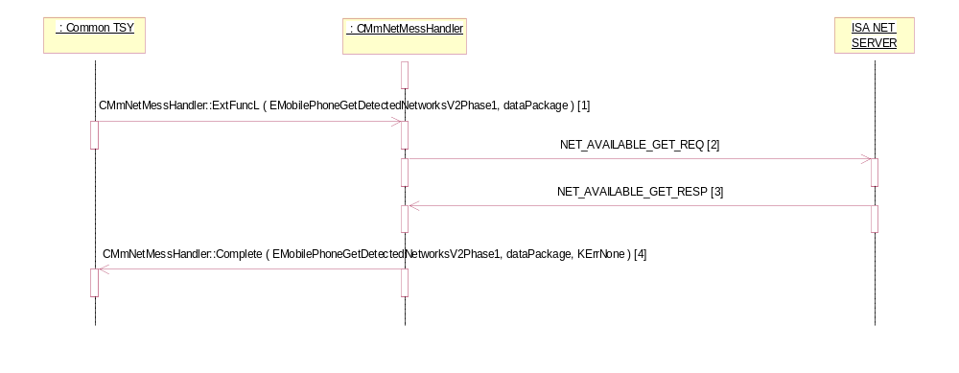
Figure 20 A Operator Namelist query / Manual Search

[1] EMobilePhoneGetDetectedNetworksV2Phase1 request received
[2] NET_AVAILABLE_GET_REQ is sent to NET Server
[3] NET_AVAILABLE_GET_RESP is received including operator name. If phone language setting is APAC the USC2 type operator name will be taken from the message if it exists.
[4] Completed with EMobilePhoneGetDetectedNetworksV2Phase1

Operator Namelist / Get Operator Name (network registration status) / NET_REG_STATUS_GET_REQ fig. 20 B
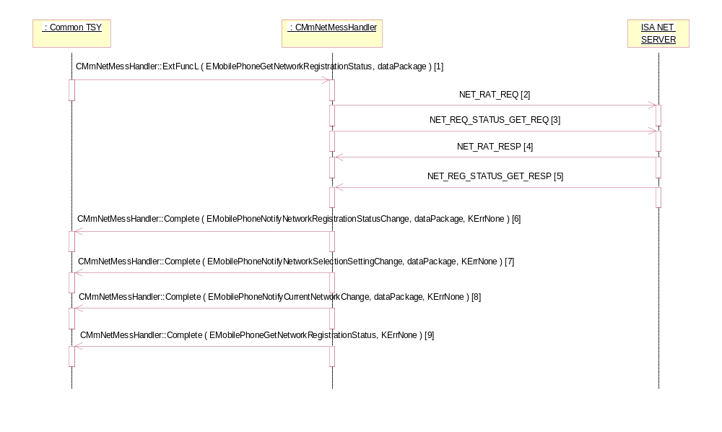Figure 20 B Operator Namelist / Get Operator Name (network registration status) / NET_REG_STATUS_GET_REQ
[1] EMobilePhoneGetNetworkRegistrationStatus request received
[2] NET_RAT_REQ sent to NET Server
[3] NET_REG_STATUS_GET_REQ is sent to NET Server
[4] NET_RAT_RESP is received.
[5] NET_REQ_STATUS_GET_RESP is received including operator name. If phone language setting is APAC the USC2 type operator name will be taken from the message if it exists.
[6]…[9] Completing.

Operator Namelist / Get Operator Name (custom get operator name) / NET_REG_STATUS_GET_REQ fig. 20 C
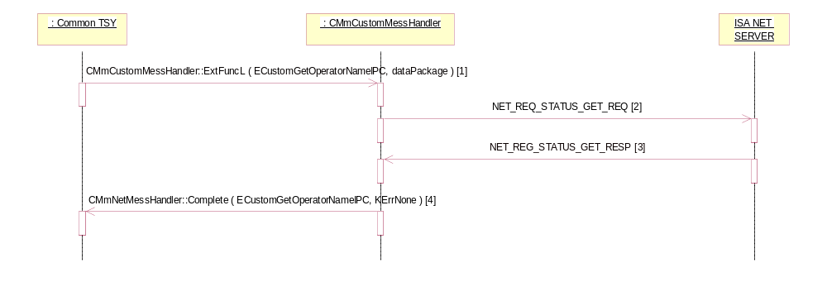
Figure 20 C Operator Namelist / Get Operator Name (custom get operator name) / NET_REG_STATUS_GET_REQ

[1] ECustomGetOperatorNameIPC request received
[2] NET_REG_STATUS_GET_REQ is sent to NET Server
[3] NET_REQ_STATUS_GET_RESP is received including operator name. If phone language setting is APAC the USC2 type operator name will be taken from the message if it exists.
[4] Completing.

Operator Namelist / Get Operator Name / NET_REG_STATUS_IND fig. 20 D

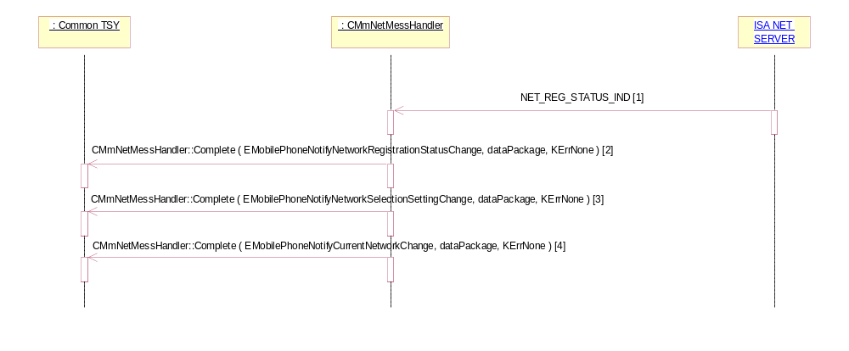
Figure 20 D Operator Namelist / Get Operator Name / NET_REG_STATUS_IND

[1] NET_REG_STATUS_IND is received including operator name. If phone language setting is APAC the USC2 type operator name will be taken from the message if it exists.
[2]…[4] Completing.

Operator Namelist/ Get Home NW + others fig. 20 E

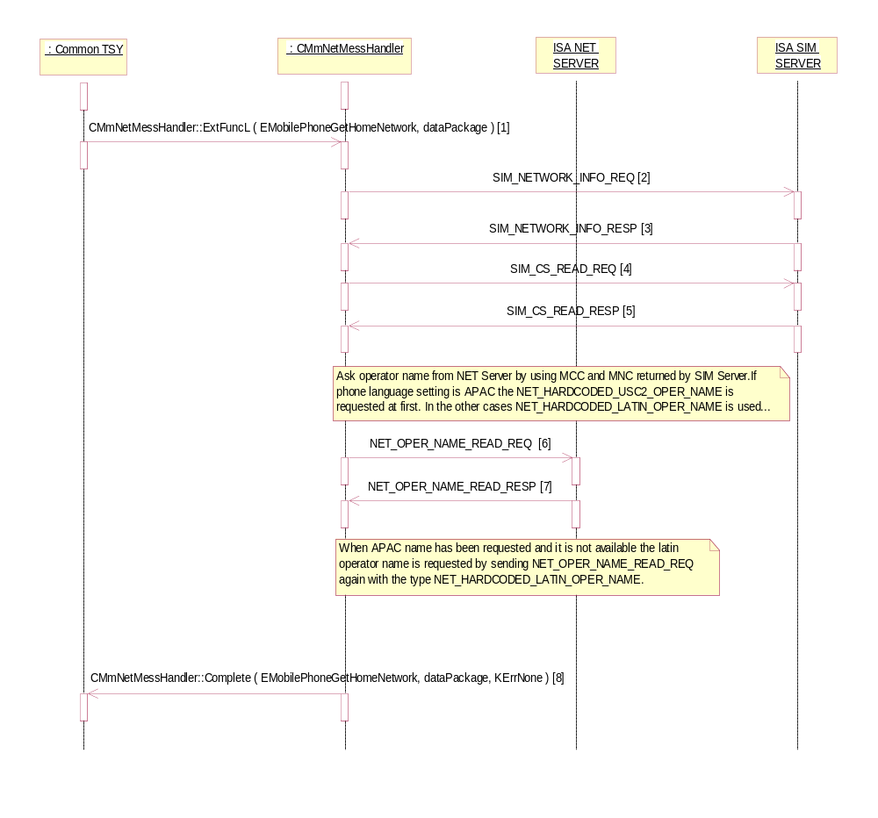
Figure 20 E Operator Namelist / Get Home NW + others

[1] EMobilePhoneGetHomeNetwork request received
[2] MCC and MNC codes of home network queried from SIM Server by sending SIM_NETWORK_INFO_REQ
[3] MCC and MNC codes returned in SIM_NETWORK_INFO_RESP
[4] Check whether the READ_HPLMN (Home network) information is available on SIM by sending SIM_CS_READ_REQ
[5] If home network is available it is returned in SIM_CS_READ_RESP
[6] Operator names read using NET_OPER_NAME_READ_REQ (NET_HARDCODED_LATIN_OPER_NAME or NET_HARDCODED_USC2_OPER_NAME depending on variant in use). This request will be done twice when phone language setting is APAC and NET_HARDCODED_USC2_OPER_NAME has been requested and there is no usc2 hardcoded operator name available. In that case the latin oper name is requested.
[7] NET_OPER_NAME_READ_RESP is received including operator name.
[8] Completing.

Operator Namelist / Network Selection fig. 20 F

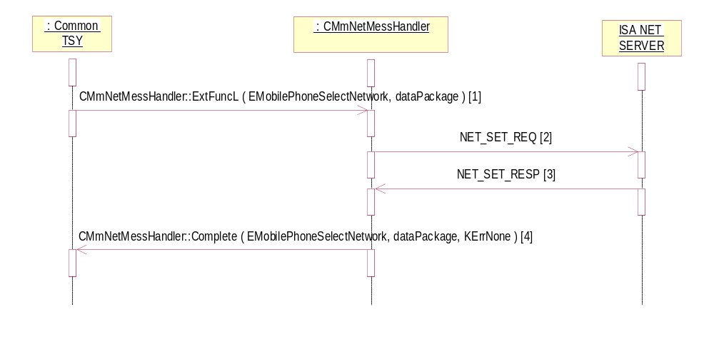
Figure 20 F Operator Namelist / Network Selection

[1] EMobilePhoneSelectNetwork request received
[2] NET_SET_REQ sent to NET Server
[3] NET_SET_RESP RESP is received including operator name. If phone language setting is APAC the USC2 type operator name will be taken from the message if it exists.
[4 Completing.

System resource usage

Files
NokiaTSY owns files operinfo.txt and operinfo_apac.txt. These files are used to map MCC and MNC to operator name.
Nokia TSY is using file writing capabities for test log writing purposes.

Databases
NokiaTSY does not contain databases.

Memory consumption
Memory consumption has been taken into consideration and kept to minimum in the implementation of this application/component. The data copying between layers has been kept to the mininum, also the data types has been carefully choosen to be the optimum one for each case. Nokia TSY reserves most of its memory in boot-up phase.

Task allocation
The Nokia TSY, CommonTSY and ETel server run in the same thread that belongs to the communications process of the Symbian OS.

Performance
The most performance critical phase for Nokia TSY is the boot-up phase. This phase should not take too long as the boot-up time is critical feature for mobile phone. Common TSY has been designed to make as few time consuming actions (such as file reading etc.) as possible in the boot-up phase to minimize the time taken to boot up the device.

Timers
Nokia TSY has no timers.

Exception handling
Symbian OS TRAP macros are used for controlled recovery from out-of-memory situation. If the NokiaTSY runs out of memory the code execution leaves to the latest TRAP before the place where out-of-memory state is detected. Memory allocated after TRAP is released and request is completed to Etel server/client if possible. TRAPs are memory consuming and also quite heavy in performance. Because of this these macros are placed only to few certain central places to minimize overhead caused by them.

MaintainanceUsage

Building
NokiaTSY is built together with CommonTSY, see instructions from CommonTSY release notes.

User's Guide

References
/1/ Series 60 Platform 2.6 – Common TSY Design Document
Author | : | Information not available
Version | : | Information not available
Doc ID | : | Information not available
Source | : | Information not available

/2/ Multimode ETel API Design Document
Author | : | Information not available
Version | : | Information not available
Doc ID | : | Information not available
Source | : | Information not available

/3/ Series 60 Platform 2.6 – Lisencee TSY Implementation Guideline
Author | : | Information not available
Version | : | Information not available
Doc ID | : | Information not available
Source | : | Information not available

/4/ Common TSY Plug-in API Specification Document
Author | : | Information not available
Version | : | Information not available
Doc ID | : | Information not available
Source | : | Information not available

/5/ Series 60 Platform - SIM ATK TSY Design Document
Author | : | Information not available
Version | : | Information not available
Doc ID | : | Information not available
Source | : | Information not available

/6/ 3GPP TS 23.041 Technical realization of Cell Broadcast Service (CBS)
Author | : | 3GPP
Version | : | 6.2.0
Doc ID | : | Information not available
Source | : | Information not available

/7/ 3GPP TS 23.040 Technical realization of Short Message Service (SMS)
Author | : | 3GPP
Version | : | 6.7.0
Doc ID | : | Information not available
Source | : | Information not available

/8/ 3GPP TS 23.038 Alphabets and language-specific information
Author | : | 3GPP
Version | : | 6.1.0
Doc ID | : | Information not available
Source | : | Information not available

/9/ 3GPP TS 31.102 Characteristics of the USIM application
Author | : | 3GPP
Version | : | 6.14.0
Doc ID | : | Information not available
Source | : | Information not available

/10/ Common PCN Handset Specification (CPHS) Phase 2
Author | : | PCN Association
Version | : | 4.2
Doc ID | : | Information not available
Source | : | Information not available

/1/ <Document title – Example of a Document stored in Lotus Notes>
Author | : | <Author>
Version | : | <Version number and status>
Doc ID | : | <Doc ID>
Source | : | SPP DocMan, eslns43/SRV/Nokia, TP\SPP\sppdm.nsf

Appendixes

Change History

Version | : | 0.1
Editor | : | Not available
Status | : | Draft
Date | : | 11-Oct-2004
Comments | : | Initial draft version of the document

Version | : | 0.2
Editor | : | Not available
Status | : | Draft
Date | : | 1-Jan-05
Comments | : | Updated to reflect 3.0 changes

Version | : | 0.3
Editor | : | Sari Järvenpää
Status | : | Draft
Date | : | 16-Jun-06
Comments | : | Changed to coreSW template. Document stored into Synergy.

Version | : | 0.4
Editor | : | Ext-Martti Piirainen
Status | : | Draft
Date | : | 15-Sep-06
Comments | : | Short Messaging-related updates in section 3.3 “Operations”.

Version | : | 0.5
Editor | : | Ext-Susanna Ollonen
Status | : | Draft
Date | : | 20-Sep-06
Comments | : | Updated SIM phonebook Store sequenses in section 3.3.7.

Version | : | 4
Editor | : | Martti Suvanne
Status | : | Draft
Date | : | 10-Jan-07
Comments | : | Added Network Detection and Operator Namelist handling. Section 3.3.11

